Galway Bay (Dr. Arthur Colahan, c. 1927) (C)

Intro (first line) C G G7 C G7  C G G7 C  If you ever go across the sea to Ireland, then maybe at the closing of your day,  C C7 F Cdim7  You can sit and watch the moon rise over Claddagh, (area where the River  G G7 F D7 Corrib meets Galway Bay)  And see the sun go down on Galway Bay.  C G  Just to hear again the ripple of the trout stream,  G7 C  The women in the meadow making hay,  C C7 F Cdim7  Just to sit beside the turf fire in a cabin,  G G7 C G7  And watch the barefoot gosoons as they play. (boys or lads)  C G  For the breezes blowing o'er the seas from Ireland  G7 C  Are perfumed by the heather as they blow,  C C7 F Cdim7  And the women in the uplands digging praties (Irish potatoes)  G G7 C G7  Speak a language that the strangers do not know.  C G  Yet the strangers came and tried to teach us their ways  G7 C  And they scorned us just for being what we are  C C7 F Cdim7  But they might as well go chasin' after moonbeams  G G7 C G7  Or light a penny candle from a star. (A small, inexpensive candle)  C G G7 C  And if there's gonna be a life here after, and somehow I feel sure there's gonna be,  C F Cdim7 G G7 C  I will ask my God to let me make my Heaven, in that dear land across the Irish sea.  C F Cdim7 G G7 C  I will ask my God to let me make my Heaven, in that dear land across the Irish sea. |  |  |  |  |  |  | 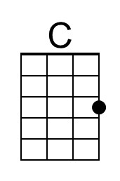
 |  |  |  |  |  |  | 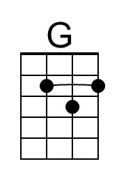
 |  |  |  |  |  |  | 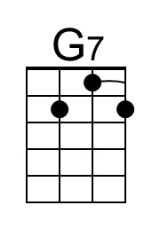
 |  |  |  |  |  |  | 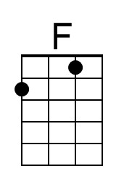
 |  |  |  |  |  |  | 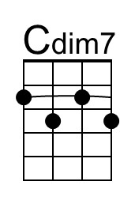
 |  | Bari | 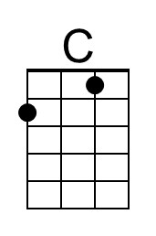 | 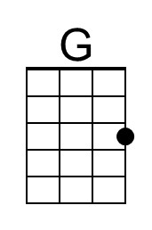 | 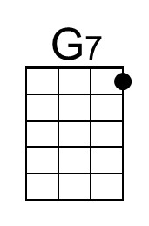 | 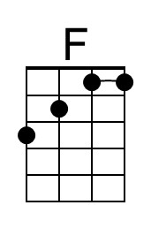 | 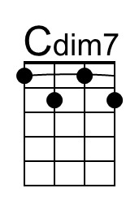

Galway Bay (Dr. Arthur Colahan, c. 1927) (G)

Intro (first line) G D D7 G D7

G D D7 G
If you ever go across the sea to Ireland, then maybe at the closing of your day,
G G7 C Gdim7
You can sit and watch the moon rise over Claddagh, (area where the River
A A7 D A7 Corrib meets Galway Bay)
And see the sun go down on Galway Bay.

G D
Just to hear again the ripple of the trout stream,
D7 G
The women in the meadow making hay,
G G7 C Gdim7
Just to sit beside the turf fire in a cabin,
D D7 G D7
And watch the barefoot gosoons as they play. (boys or lads}

G D
For the breezes blowing o'er the seas from Ireland
D7 G
Are perfumed by the heather as they blow,
G G7 C Gdim7
And the women in the uplands digging praties (Irish potatoes)
D D7 G D7
Speak a language that the strangers do not know.

G D
Yet the strangers came and tried to teach us their ways
D7 G
And they scorned us just for being what we are
G G7 C Gdim7
But they might as well go chasin' after moonbeams
D D7 G D7
Or light a penny candle from a star. (A small, inexpensive candle)

G D D7 G
And if there's gonna be a life here after, and somehow I feel sure there's gonna be,
G C Gdim7 D D7 G
I will ask my God to let me make my Heaven, in that dear land across the Irish sea.
G C Gdim7 D D7 G
I will ask my God to let me make my Heaven, in that dear land across the Irish sea.

 |  |  |  |  |  |  | 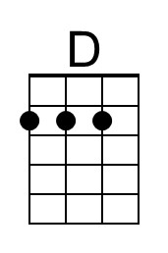
 |  |  |  |  |  |  | 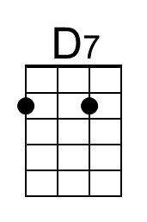
 |  |  |  |  |  |  | 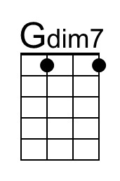
 |  | Bari |  | 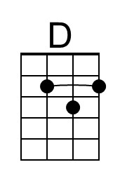 | 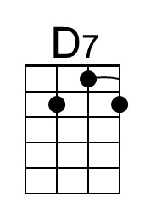 |  | 