Galway Girl (Steve Earle, 2000) (C)
Galway Girl by Steve Earle
C F  Well I took a stroll on the old long walk of a day-I-ay- ay  Am G F C G C  I met a little girl and we stopped to talk on a fine, soft day-I-ay  C F C F C  And I ask you friend what's a fellah to do  Am G F C  Cause her hair was black her eyes were blue  C F C F C  And I knew right then I'd taking a whirl  Am G F C  Round the Salthill prom with the Galway girl  Instrumental C F C Am G F C G G7 C  C F  We were half way there when the rain came down, of a day I ay I ay  Am G F C G C  And she asked me up to her flat down-town, of a fine soft day I ay  C F C F C  And I ask you friend what's a fellah to do  Am G F C  Cause her hair was black, her eyes were blue  F C F C  So I took her hand and I gave her a twirl  Am G F C  And I lost my heart to a Galway girl  Instrumental C F C Am G F C G G7 C  C F  When I woke up I was all alone (spoken) - of a day I ay  Am G F C G C  With a broken heart and a ticket home (spoken) - of a fine soft day I ay  F C F C  And I ask you now tell me what would you do  Am G F C  If her hair was black and her eyes were blue  F C F C  I've travelled around I've been all over this world,  Am G F C  Boys, I ain't never seen nothing like a Galway girl. |  |  |  |  |  |  | 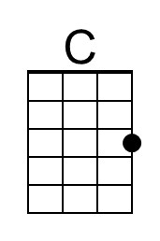
 |  |  |  |  |  |  | 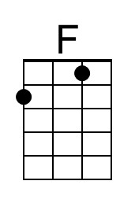
 |  |  |  |  |  |  | 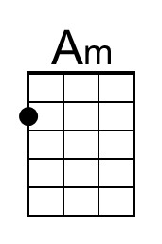
 |  |  |  |  |  |  | 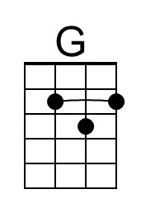
 |  |  |  |  |  |  | 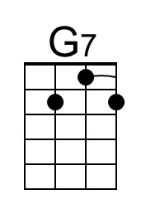
 |  | Bari | 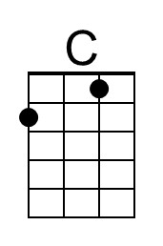 | 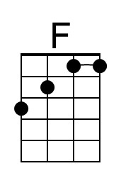 | 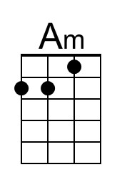 | 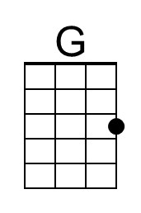 | 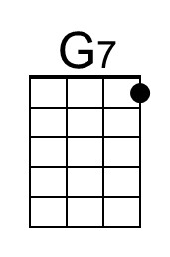

Galway Girl (Steve Earle, 2000) (G)

G C
Well I took a stroll on the old long walk of a day-I-ay- ay
Em D C G D G
I met a little girl and we stopped to talk on a fine, soft day-I-ay
G C G C G
And I ask you friend what's a fellah to do
Em D C G
Cause her hair was black her eyes were blue
G C G C G
And I knew right then I'd taking a whirl
Em D C G
Round the Salthill prom with the Galway girl

Instrumental G C G Em D C G D D7 G

G C
We were half way there when the rain came down, of a day I ay I ay
Em D C G D G
And she asked me up to her flat down-town, of a fine soft day I ay
G C G C G
And I ask you friend what's a fellah to do
Em D C G
Cause her hair was black, her eyes were blue
C G C G
So I took her hand and I gave her a twirl
Em D C G
And I lost my heart to a Galway girl

Instrumental G C G Em D C G D D7 G

G C
When I woke up I was all alone (spoken) - of a day I ay
Em D C G D G
With a broken heart and a ticket home (spoken) - of a fine soft day I ay
C G C G
And I ask you now tell me what would you do
Em D C G
If her hair was black and her eyes were blue
C G C G
I've travelled around I've been all over this world,
Em D C G
Boys, I ain't never seen nothing like a Galway girl.

 |  |  |  |  |  |  | 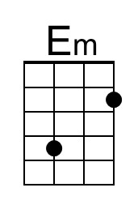
 |  |  |  |  |  |  | 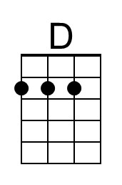
 |  |  |  |  |  |  | 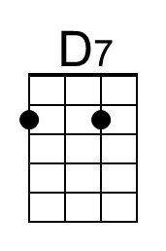
 |  | Bari |  |  | 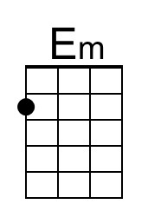 | 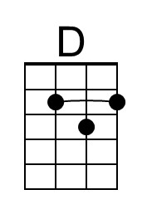 | 