**Garden Party (Ricky Nelson) Key C**

**C F**

Went to a garden party

**C F**

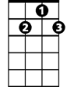

G7

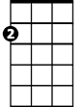

Am

F



C

To reminisce with my old friends

**C Am**

A chance to share old memories

**F G7 C**

And play our songs again

**C F**

When I got to the garden party,

**C F**

They all knew my name

**C Am**

But no one recognized me,

**F G7 C**

I didn't look the same

**Chorus:**

**F G7 C**

But it's all right now,

**F G7 C**

I learned my lesson well.

**F C**

You see, ya can't please everyone,

**F G7 C**

So ya - got to please yourself

**C F**

People came from miles around,

**C F**

Everyone was there

**C Am**

Yoko brought her walrus,

**F G7 C**

There was magic in the air

**C F**

And over in the corner,

**C F**

Much to my surprise

**C Am**

Mr. Hughes hid in Dylan's shoes

**F G7 C**

Wearing his disguise

**(Chorus)**

**C F**

Played them all the old songs,

**C F**

Thought that's why they came

**C Am**

No one heard the music,

**F G7 C**

We didn't look the same

**F**

I said hello to "Mary Lou",

**C F**

She belongs to me

**C Am**

When I sang a song about a honky-tonk,

**F G7 C**

It was time to leave

**(Chorus)**

**BARITONE**

**C F**

Someone opened up a closet door

**C F**

And out stepped Johnny B. Goode

**C Am**

Playing guitar like a-ringin' a bell

**F G7 C**

And lookin' like he should

**C F**

If you gotta play at garden parties,

**C F**

I wish you a lotta luck

**C Am**

But if memories were all I sang,

**F G7 C**

I’d rather drive a truck

**(Chorus)**



F

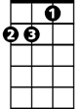

Am

C

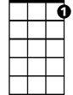

G7

**Garden Party (Ricky Nelson) Key D**

**D G**

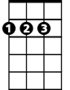

D



G

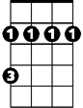

Bm

Went to a garden party

**D G**

To reminisce with my old friends

**D Bm**

A chance to share old memories

**G A7 D**

And play our songs again

**D G**

When I go t to the garden party,

**D G**

They all knew my name

**D Bm**

But no one recognized me,

**G A7 D**

I didn't look the same

**Chorus:**

**G A7 D**

But it's all right now,

**G A7 D**

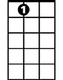

A7

I learned my lesson well.

**G D**

You see, ya can't please everyone,

**G A7 D**

So ya - got to please yourself

**D G**

People came from miles around,

**D G**

Everyone was there

**D Bm**

Yoko brought her walrus,

**G A7 D**

There was magic in the air

**D G**

And over in the corner,

**D G**

Much to my surprise

**BARITONE**

**D Bm**



D

Mr. Hughes hid in Dylan's shoes

**G A7 D**

Wearing his disguise

**(Chorus)**

**D G**

Played them all the old songs,

**D G**

Thought that's why they came

**D Bm**

No one heard the music,

**G A7 D**

We didn't look the same

**G**

I said hello to "Mary Lou",

**D G**

She belongs to me

**D Bm**

When I sang a song about a honky-tonk,

**G A7 D**

It was time to leave

**(Chorus)**

**D G**

Someone opened up a closet door

**D G**

And out stepped Johnny B. Goode

**D Bm**

Playing guitar like a-ringin' a bell

**G A7 D**

And lookin' like he should

**D G**

If you gotta play at garden parties,

**D G**

I wish you a lotta luck

**D Bm**

But if memories were all I sang,

**G A7 D**

I’d rather drive a truck

**(Chorus)**

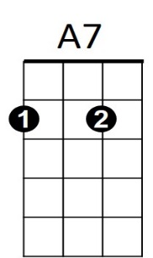



G

Bm

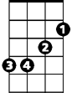

**Garden Party (Ricky Nelson) Key G**

**G C**

Went to a garden party

**G C**

To reminisce with my old friends

**G Em**

A chance to share old memories



G

**C D7 G**

And play our songs again

**G C**

When I got to the garden party,

**G C**

They all knew my name



C

**G Em**

But no one recognized me,

**C D7 G**

I didn't look the same

**Chorus:**

**C D7 G**

Em



But it's all right now,

**C D7 G**

I learned my lesson well.

**C G**

You see, ya can't please everyone,

**C D7 G**

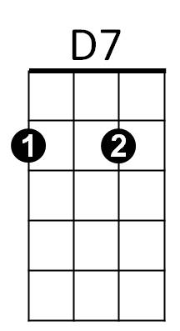So ya - got to please yourself

**G C**

People came from miles around,

**G C**

Everyone was there

**G Em**

Yoko brought her walrus,

**C D7 G**

There was magic in the air

**G C**

And over in the corner,

**G C**

Much to my surprise

**BARITONE**

**G Em**

Mr. Hughes hid in Dylan's shoes



G

**C D7 G**

Wearing his disguise

**(Chorus)**

**G C**

Played them all the old songs,

**G C**

Thought that's why they came

**G Em**

No one heard the music,

**C D7 G**

We didn't look the same

**C**

I said hello to "Mary Lou",

**G C**

She belongs to me

**G Em**

When I sang a song about a honky-tonk,

**C D7 G**

It was time to leave

**(Chorus)**

**G C**

Someone opened up a closet door

**G C**

And out stepped Johnny B. Goode

**G Em**

Playing guitar like a-ringin' a bell

**C D7 G**

And lookin' like he should

**G C**

If you gotta play at garden parties,

**G C**

I wish you a lotta luck

**G Em**

But if memories were all I sang,

**C D7 G**

I’d rather drive a truck

**(Chorus)**

C



Em



D7