Gaudeamus Igitur for Ukulele
An Excerpt From Wikipedia, the free encyclopedia
https://en.wikipedia.org/wiki/Gaudeamus_igitur
"De Brevitate Vitae" (Latin: "On the Shortness of Life"), more commonly known as "Gaudeamus Igitur" ("So Let Us Rejoice") or just "Gaudeamus", is a popular academic commencement song in many Western countries, mainly sung or performed at university graduation ceremonies. Despite its use as a formal graduation hymn, it is a jocular, light-hearted composition that pokes fun at university life. The song is thought to originate in a Latin manuscript from 1287. It is in the tradition of carpe diem ("seize the day") with its exhortations to enjoy life. It was known as a beer-drinking song in many early universities – as depicted by Sigmund Romberg in "The Student Prince," set at the University of Heidelberg – and is the official song of many schools, colleges, universities, institutions, student societies and is the official anthem of the International University Sports Federation.
Content
The lyrics reflect an endorsement of the bacchanalian mayhem of student life while simultaneously retaining the grim knowledge that one day we will all die. The song contains humorous and ironic references to sex and death, and many versions have appeared following efforts to bowdlerise this song for performance in public ceremonies. In private, students will typically sing ribald words.
The song is sometimes known by its opening words, "Gaudeamus igitur" or simply "Gaudeamus". In the UK, it is sometimes affectionately known as "The Gaudie". The centuries of use have given rise to numerous slightly different versions.
Lyrics
The proposition that the lyrics originate in 1287 is based on a manuscript held in the Bibliothèque nationale de France in Paris. A poem starting with the words Subscribere proposui ("I have suggested signing (it)") has two verses that closely resemble the later Gaudeamus igitur verses, although neither the first verse nor the actual words Gaudeamus igitur appear. The music accompanying this poem bears no relation to the melody which is now associated with it. A German translation of these verses was made in about 1717 and published in 1730 without music. A Latin version in a handwritten student songbook, dating from some time between 1723 and 1750, is preserved in the Berlin State Library (formerly located at Marburg); however, this differs considerably from the modern text. The current Latin lyrics with a German translation were published by Halle in 1781 in Studentenlieder ("Students' Songs") written by Christian Wilhelm Kindleben (1748-1785), who admitted to making important changes to the text.
Music
The first appearance in print of the present melody was in Lieder für Freunde der Geselligen Freude ("Songs for Friends of Convivial Joy"), published in Leipzig in 1782, together with Kindleben's German lyrics; however, the tune was evidently well known before this date. The first publication of the present Latin text together with the present melody was probably in Ignaz Walter's 1797 operatic setting of Doktor Faust. It is also heard in Berlioz' Damnation of Faust, and works by Johannes Brahms, Johann Strauss II, Franz von Suppé, Franz Liszt, and other classical and popular works.
Gaudeamus Igitur for Ukulele
English Lyrics by J. Mark Sugars, 1997, alt.

             | 1. [C] Gaudeamus [F] igitur,  [G7] Juvenes dum [C] sumus;  [C] While we're young, let [F] us rejoice,  [G7] Singing out in [C] gleeful tones;  [G] Ring our ukes so [C] mel- [G] odic,  [G] Not the others, [C] idi- [G] otic,  [C] Nos ha- [F] be- [Dm] bit [C-E7] hu- [Am] mus!  [C] Sing with [F] U- [Dm] ku- [C-G7] le- [C] les.  2. Vivat academia,  Vivant professores,  Long live our academy,  Teachers whom we cherish;  Long live tenors and sopranos,  And the concerts, baritones;  Semper sint in flore!  May our Ukes forever flourish.  3. Alma Mater floreat,  Quae nos educavit;  May our Alma Mater thrive,  A fount of education;  May our ukes be ever tuneful.  And our voices stay delightful.  Sparsos, congregavit;  Join the U-ku-le-le chorus.

Chords from FreeNotes, http://www.free-notes.net/cgi-bin/noten_Song.pl?song=Gaudeamus+igitur&profile=null&low=55&lang=en&db=Main

Also transposed to key of G at the same site and URL.

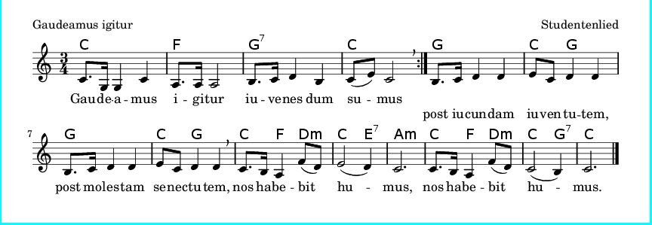
Gaudeamus Igitur for Ukulele
English Lyrics by J. Mark Sugars, 1997, alt.

  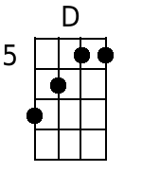     | 1. [G] Gaudeamus [C] igitur,  [D7] Juvenes dum [G] sumus;  [G] While we're young, let [C] us rejoice,  [D7] Singing out in [G] gleeful tones;  [D] Ring our ukes so [G] mel- [D] odic,  [D] Not the others, [G] idi- [D] otic,  [G] Nos ha- [C] be- [Am] bit [G-A7] hu- [Em] mus!  [G] Sing with [C] U- [Am] ku- [G-D7] le- [G] les.  2. Vivat academia,  Vivant professores,  Long live our academy,  Teachers whom we cherish;  Long live tenors and sopranos,  And the concerts, baritones;  Semper sint in flore!  May our Ukes forever flourish.  3. Alma Mater floreat,  Quae nos educavit;  May our Alma Mater thrive,  A fount of education;  May our ukes be ever tuneful.  And our voices stay delightful.  Sparsos, congregavit;  Join the U-ku-le-le chorus.

Chords from FreeNotes, http://www.free-notes.net/cgi-bin/noten_Song.pl?song=Gaudeamus+igitur&profile=null&low=55&lang=en&db=Main

Also transposed to key of G at the same site and URL.

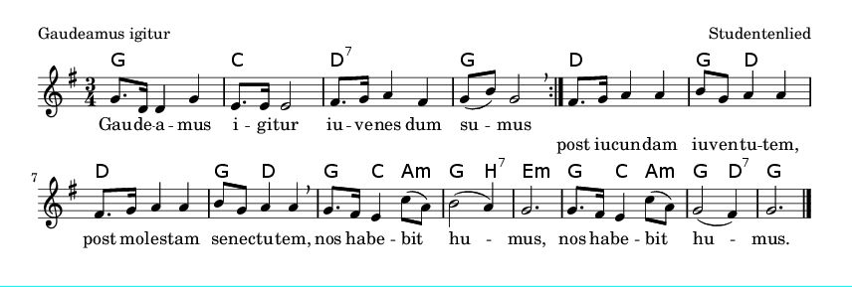
Gaudeamus Igitur for Ukulele
English Lyrics by J. Mark Sugars, 1997, alt.

1. Gau_de_a_mus ig_i_tur,
Ju_ven_es dum su_mus;
While we're young, let us rejoice,
Singing out in gleeful tones;
Ring our ukuleles so melodic,
Not the others, idiotic,
Nos ha_be_bit hu_mus!
|Sing with sweet U-ku-le-les.

2. Vi_vat a_ca_dem_ia,
Vi_vant pro_fess_or_es,
Long live our academy,
Teachers whom we cherish;
Long live tenors and sopranos,
And the concerts, baritones;
Sem_per sint in flo_re!
May our Ukes forever flourish.

3. Al_ma Ma_ter flor_e_at,
Quae nos e_du_ca_vit;
May our Alma Mater thrive,
A font of education;
May our ukes be ever tuneful.
And our voices stay delightful.
Spar_sos, con_gre_ga_vit;
Join the U-ku-le-le chorus.

Gaudeamus Igitur for Ukulele
English Lyrics by J. Mark Sugars, 1997, alt.

1. Gaudeamus igitur,
Juvenes dum sumus;
While we're young, let us rejoice,
Singing out in gleeful tones;
Ring our ukuleles so melodic,
Not the others, idiotic,
Nos habebit humus!
|Sing with sweet U-ku-le-les.

2. Vivat academia,
Vivant professores,
Long live our academy,
Teachers whom we cherish;
Long live tenors and sopranos,
And the concerts, baritones;
Semper sint in flore!
May our Ukes forever flourish.

3. Alma Mater floreat,
Quae nos educavit;
May our Alma Mater thrive,
A font of education;
May our ukes be ever tuneful.
And our voices stay delightful.
Sparsos, congregavit;
Join the U-ku-le-le chorus.

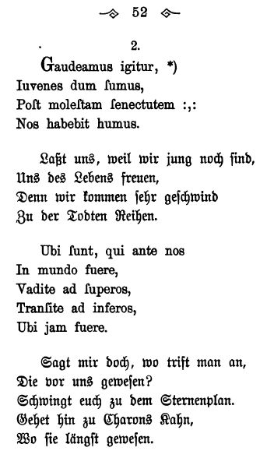

The first two verses, in Latin and German, from the 1781student songbook Studentenlieder
compiled by Christian Wilhelm Kindleben (1748-1785).
Five additional Latin and German lyrics occur on pages 53 & 54.

