Georgia On My Mind (Hoagy Carmichael & Stuart Gorrell, 1930) (A)
Georgia On My Mind by Ray Charles (1960) (G @ 94) – Official Video
Georgia on My Mind by Hoagy Carmichael & His Orchestra, with Bix Beiderbecke (1930)
Ella Fitzgerald (1962) (G @ 76) – Willie Nelson (Db @ 68) from “Stardust” (1978)

Time Signature: 2/2

Intro
C A7 | Dm G7#5 |

A C#7 F#m D - Dm
__ Georgia, __ Georgia, __ the whole day through,
A F#7 Bm E7 A F#7 | Bm E7#5
Just an old sweet song keeps Georgia on my mind.
A C#7 F#m D - Dm
__ Georgia, __ Georgia, ___ a song of you
A F#7 Bm E7 A F#m | Bm C#7
Comes sweet and clear as moonlight through the pines.

Chorus
F#m Bm F#m Dm F#m Bm F#m B7
Other arms reach out to me, other eyes smile tender-ly
F#m Bm A G#7 C#m A#dim7 Bm - E7
Still in peaceful dreams I see the road leads back to you.

A C#7 F#m D - Dm
__ Georgia, __ Georgia, ___ no peace I find.
A F#7 Bm E7 A F#m | Bm C#7
Just an old sweet song keeps Georgia on my mind. Chorus

A C#7 F#m D - Dm
__ Georgia, __ Georgia, ___ no peace I find.
A F#7 Bm E7 A F#7 | Bm E7#5
Just an old sweet song keeps Georgia on my mind.
A F#7 Bm E7 A F#m | Bm D | A
Just an old sweet song ___ keeps Georgia on my mind.

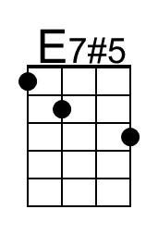 | 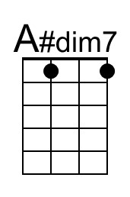 |  | Baritone | 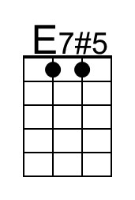 | 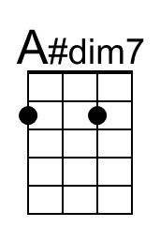

Georgia On My Mind (Hoagy Carmichael & Stuart Gorrell, 1930) (C)
Georgia On My Mind by Ray Charles (1960) (G @ 94) – Official Video
Georgia on My Mind by Hoagy Carmichael & His Orchestra, with Bix Beiderbecke (1930)
Ella Fitzgerald (1962) (G @ 76) – Willie Nelson (Db @ 68) from “Stardust” (1978)

Time Signature: 2/2

Intro
C A7 | Dm G7#5 |

C E7 Am F - Fm
__ Georgia, __ Georgia, __ the whole day through,
C A7 Dm G7 C A7 | Dm G7#5
Just an old sweet song keeps Georgia on my mind.
C E7 Am F - Fm
__ Georgia, __ Georgia, ___ a song of you
C A7 Dm G7 C Am | Dm E7
Comes sweet and clear as moonlight through the pines.

Chorus
Am Dm Am Fm Am Dm Am D7
Other arms reach out to me, other eyes smile tender-ly,
Am Dm C B7 Em C#dim7 Dm - G7
Still in peaceful dreams I see the road leads back to you.

C E7 Am F - Fm
__ Georgia, __ Georgia, ___ no peace I find.
C A7 Dm G7 C Am | Dm E7
Just an old sweet song keeps Georgia on my mind. Chorus

C E7 Am F - Fm
__ Georgia, __ Georgia, ___ no peace I find.
C A7 Dm G7 C A7 | Dm G7#5
Just an old sweet song keeps Georgia on my mind.
C A7 Dm G7 C Am | Dm F | C
Just an old sweet song ___ keeps Georgia on my mind.

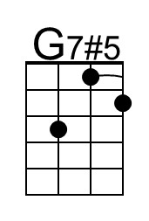 | 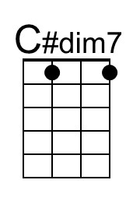 |  | Bari | 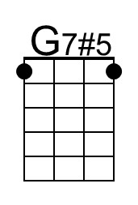 | 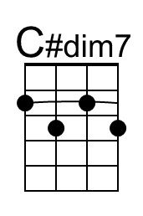

Georgia On My Mind (Hoagy Carmichael & Stuart Gorrell, 1930) (D)
Georgia On My Mind by Ray Charles (1960) (G @ 94) – Official Video
Georgia on My Mind by Hoagy Carmichael & His Orchestra, with Bix Beiderbecke (1930)
Ella Fitzgerald (1962) (G @ 76) – Willie Nelson (Db @ 68) from “Stardust” (1978)

Time Signature: 2/2

Intro
D B7 | Em A7#5 |

D F#7 Bm G - Gm
__ Georgia, __ Georgia, __ the whole day through,
D B7 Em A7 D B7 | Em A7#5
Just an old sweet song keeps Georgia on my mind.
D F#7 Bm G - Gm
__ Georgia, __ Georgia, ___ a song of you
D B7 Em A7 D Bm | Em F#7
Comes sweet and clear as moonlight through the pines.

Chorus
Bm Em Bm Gm Bm Em Bm E7
Other arms reach out to me, other eyes smile tender-ly
Bm Em D C#7 F#m D#dim7 Em - A7
Still in peaceful dreams I see the road leads back to you.

D F#7 Bm G - Gm
__ Georgia, __ Georgia, ___ no peace I find.
D B7 Em A7 D Bm | Em F#7
Just an old sweet song keeps Georgia on my mind. Chorus

D F#7 Bm G - Gm
__ Georgia, __ Georgia, ___ no peace I find.
D B7 Em A7 D B7 | Em A7#5
Just an old sweet song keeps Georgia on my mind.
D B7 Em A7 D Bm | Em G | D
Just an old sweet song ___ keeps Georgia on my mind.

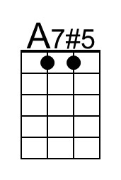 | 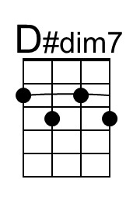 |  | Baritone | 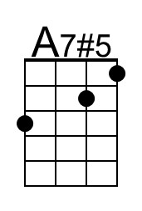

Georgia On My Mind (Hoagy Carmichael & Stuart Gorrell, 1930) (E)
Georgia On My Mind by Ray Charles (1960) (G @ 94) – Official Video
Georgia on My Mind by Hoagy Carmichael & His Orchestra, with Bix Beiderbecke (1930)
Ella Fitzgerald (1962) (G @ 76) – Willie Nelson (Db @ 68) from “Stardust” (1978)

Time Signature: 2/2

Intro
E C#7 | F#m B7#5 |

E G#7 C#m A - Am
__ Georgia, __ Georgia, __ the whole day through,
E C#7 F#m B7 E C#7 | F#m B7#5
Just an old sweet song keeps Georgia on my mind.
E G#7 C#m A - Am
__ Georgia, __ Georgia, ___ a song of you
E C#7 F#m B7 E C#m | F#m G#7
Comes sweet and clear as moonlight through the pines.

Chorus
C#m F#m C#m Am C#m F#m C#m F#7
Other arms reach out to me, other eyes smile tender-ly
C#m F#m E D#7 G#m Fdim7 F#m - B7
Still in peaceful dreams I see the road leads back to you.

E G#7 C#m A - Am
__ Georgia, __ Georgia, ___ no peace I find.
E C#7 F#m B7 E C#m | F#m G#7
Just an old sweet song keeps Georgia on my mind. Chorus

E G#7 C#m A - Am
__ Georgia, __ Georgia, ___ no peace I find.
E C#7 F#m B7 E C#7 | F#m B7#5
Just an old sweet song keeps Georgia on my mind.
E C#7 F#m B7 E C#m | F#m A | E
Just an old sweet song ___ keeps Georgia on my mind.

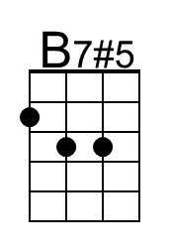 | 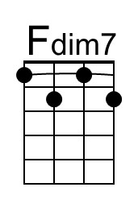 |  | Baritone | 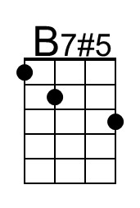 | 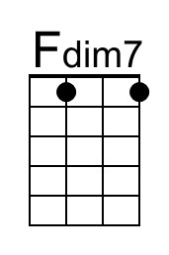

Georgia On My Mind (Hoagy Carmichael & Stuart Gorrell, 1930) (F)
Georgia On My Mind by Ray Charles (1960) (G @ 94) – Official Video
Georgia on My Mind by Hoagy Carmichael & His Orchestra, with Bix Beiderbecke (1930)
Ella Fitzgerald (1962) (G @ 76) – Willie Nelson (Db @ 68) from “Stardust” (1978)

Time Signature: 2/2

Intro
F D7 | Gm C7#5 |

F A7 Dm Bb - Bbm
__ Georgia, __ Georgia, __ the whole day through,
F D7 Gm C7 F D7 | Gm C7#5
Just an old sweet song keeps Georgia on my mind.
F A7 Dm Bb - Bbm
__ Georgia, __ Georgia, ___ a song of you
F D7 Gm C7 F Dm | Gm A7
Comes sweet and clear as moonlight through the pines.

Chorus
Dm Gm Dm Bbm Dm Gm Dm G7
Other arms reach out to me, other eyes smile tender-ly
Dm Gm F E7 Am Gbdim7 Gm - C7
Still in peaceful dreams I see the road leads back to you.

F A7 Dm Bb - Bbm
__ Georgia, __ Georgia, ___ no peace I find.
F D7 Gm C7 F Dm | Gm A7
Just an old sweet song keeps Georgia on my mind. Chorus

F A7 Dm Bb - Bbm
__ Georgia, __ Georgia, ___ no peace I find.
F D7 Gm C7 F D7 | Gm C7#5
Just an old sweet song keeps Georgia on my mind.
F D7 Gm C7 F Dm | Gm Bb | F
Just an old sweet song ___ keeps Georgia on my mind.

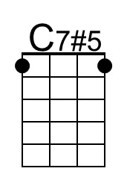 | 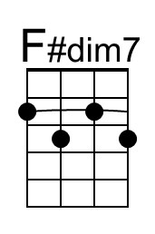 |  | Baritone | 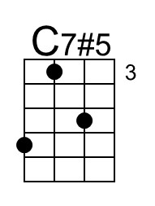

Georgia On My Mind (Hoagy Carmichael & Stuart Gorrell, 1930) (G)
Georgia On My Mind by Ray Charles (1960) (G @ 94) – Official Video
Georgia on My Mind by Hoagy Carmichael & His Orchestra, with Bix Beiderbecke (1930)
Ella Fitzgerald (1962) (G @ 76) – Willie Nelson (Db @ 68) from “Stardust” (1978)

Time Signature: 2/2

Intro
G E7 | Am D7#5 |

G B7 Em C - Cm
__ Georgia, __ Georgia, __ the whole day through,
G E7 Am D7 G E7 | Am D7#5
Just an old sweet song keeps Georgia on my mind.
G B7 Em C - Cm
__ Georgia, __ Georgia, ___ a song of you
G E7 Am D7 G Em | Am B7
Comes sweet and clear as moonlight through the pines.

Chorus
Em Am Em Cm Em Am Em A7
Other arms reach out to me, other eyes smile tender-ly
Em Am G F#7 Bm G#dim7 Am - D7
Still in peaceful dreams I see the road leads back to you.

G B7 Em C - Cm
__ Georgia, __ Georgia, ___ no peace I find.
G E7 Am D7 G Em | Am B7
Just an old sweet song keeps Georgia on my mind. Chorus

G B7 Em C - Cm
__ Georgia, __ Georgia, ___ no peace I find.
G E7 Am D7 G E7 | Am D7#5
Just an old sweet song keeps Georgia on my mind.
G E7 Am D7 G Em | Am C | G
Just an old sweet song ___ keeps Georgia on my mind.

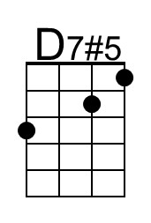 | 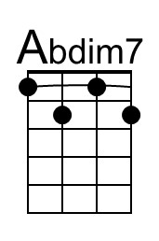 |  | Baritone | 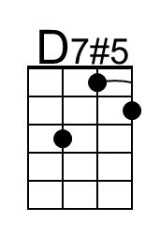 | 