Georgia On My Mind (Hoagy Carmichael & Stuart Gorrell, 1930) (C)
Georgia On My Mind by Ray Charles (1960) (G @ 94) – Official Video
Georgia on My Mind by Hoagy Carmichael & His Orchestra, with Bix Beiderbecke (1930)
Ella Fitzgerald (1962) (G @ 76) – Willie Nelson (Db @ 68) from “Stardust” (1978)

Time Signature: 2/2

Intro
C A7 | Dm G7#5 |

C E7 Am F - Fm
__ Georgia, __ Georgia, __ the whole day through,
C A7 Dm G7 C A7 | Dm G7#5
Just an old sweet song keeps Georgia on my mind.
C E7 Am F - Fm
__ Georgia, __ Georgia, ___ a song of you
C A7 Dm G7 C Am | Dm E7
Comes sweet and clear as moonlight through the pines.

Chorus
Am Dm Am Fm Am Dm Am D7
Other arms reach out to me, other eyes smile tender-ly,
Am Dm C B7 Em C#dim7 Dm - G7
Still in peaceful dreams I see the road leads back to you.

C E7 Am F - Fm
__ Georgia, __ Georgia, ___ no peace I find.
C A7 Dm G7 C Am | Dm E7
Just an old sweet song keeps Georgia on my mind. Chorus

C E7 Am F - Fm
__ Georgia, __ Georgia, ___ no peace I find.
C A7 Dm G7 C A7 | Dm G7#5
Just an old sweet song keeps Georgia on my mind.
C A7 Dm G7 C Am | Dm F | C
Just an old sweet song ___ keeps Georgia on my mind.

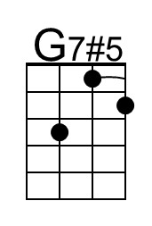 | 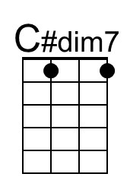 |  | Bari | 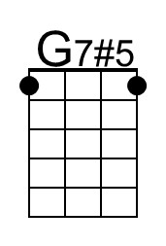 | 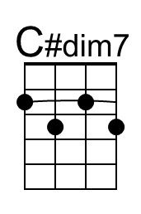

Georgia On My Mind (Hoagy Carmichael & Stuart Gorrell, 1930) (G)
Georgia On My Mind by Ray Charles (1960) (G @ 94) – Official Video
Georgia on My Mind by Hoagy Carmichael & His Orchestra, with Bix Beiderbecke (1930)
Ella Fitzgerald (1962) (G @ 76) – Willie Nelson (Db @ 68) from “Stardust” (1978)

Time Signature: 2/2

Intro
G E7 | Am D7#5 |

G B7 Em C - Cm
__ Georgia, __ Georgia, __ the whole day through,
G E7 Am D7 G E7 | Am D7#5
Just an old sweet song keeps Georgia on my mind.
G B7 Em C - Cm
__ Georgia, __ Georgia, ___ a song of you
G E7 Am D7 G Em | Am B7
Comes sweet and clear as moonlight through the pines.

Chorus
Em Am Em Cm Em Am Em A7
Other arms reach out to me, other eyes smile tender-ly
Em Am G F#7 Bm G#dim7 Am - D7
Still in peaceful dreams I see the road leads back to you.

G B7 Em C - Cm
__ Georgia, __ Georgia, ___ no peace I find.
G E7 Am D7 G Em | Am B7
Just an old sweet song keeps Georgia on my mind. Chorus

G B7 Em C - Cm
__ Georgia, __ Georgia, ___ no peace I find.
G E7 Am D7 G E7 | Am D7#5
Just an old sweet song keeps Georgia on my mind.
G E7 Am D7 G Em | Am C | G
Just an old sweet song ___ keeps Georgia on my mind.

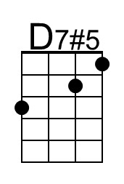 | 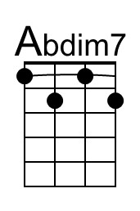 |  | Baritone | 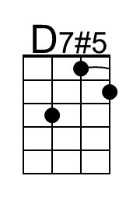 | 