**Georgia On My Mind**

F



C

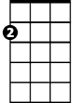

Am

E7

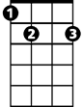

**C E7 Am F Fm**

Georgia, Georgia, the whole day through

**C A7 Dm7 G7 E7**

Just an old sweet song keeps Georgia on my mind

**A7 D7 G G7**

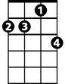

Dm7

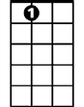

A7

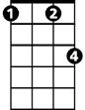

Fm

**C E7 Am F Fm**

Georgia, Georgia, A song of you

**C A7 Dm7 G7 C**

Comes as sweet and clear as moonlight through the pines

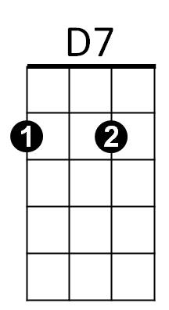**C F C E7**

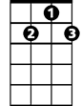

G7

Em

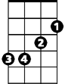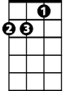

Dm



G

**Chorus:**

**Am Dm Am F**

Other arms reach out to me

**Am Dm7 Am D7**

Other eyes smile, tenderly

**Am F C B7 (hold)**

**BARITONE**



E7

C



Still in peaceful dreams I see

**Am Em Dm7 G G7**

The road leads back to you

**C E7 Am F Fm**

Georgia, Georgia, no pe ace I find



F

**C A7 Dm7 G C**



Am

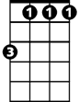

Fm

Just an old sweet song keeps Georgia on my mind

**C F C E7**

**(Chorus)**

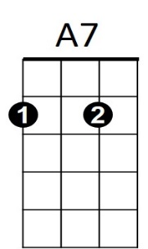

**C E7 Am F Fm**

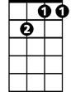

Dm7

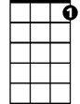

G7

Georgia, Georgia, no peace I find

**C A7 Dm7 G7 E7**

Just an old sweet song keeps Georgia on my mind

**E7 A7 Am**

**Dm7**



Em



D7

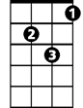

Dm



G

B7



Just and old sweet song keeps

**G G7 C C F C**

Georgia on my mind