**Getting to Know You (Richard Rogers / Oscar Hammerstein)**

**C Cmaj7**

Getting to know you,

**C Cmaj7 Dm G7 Dm G7**

Getting to know all about you.

**G7 Dm G7**

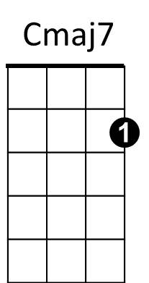Getting to like you,



C

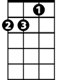

Dm

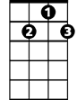

G7



G

**Dm G7 C G**

Getting to hope you like me.

**C Cmaj7**

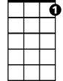

C7

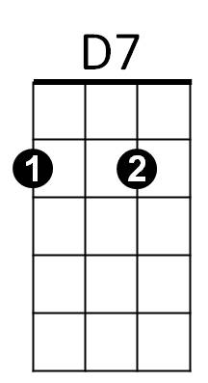Getting to know you,

F

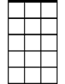

Am7

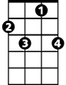

F7

**C C7 F**

Putting it my way, but nicely,

**Am7 D7**

You are precisely,

**Dm G7**

My cup of tea.

**C Cmaj7**

Getting to know you,

**BARITONE**

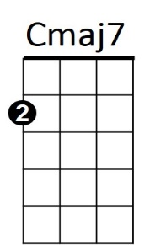**C Cmaj7 Dm G7 Dm G7**

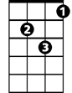

Dm



G7

C



Getting to feel free and ea - sy

**G7 Dm G7**

When I am with you,

**Dm G7 C C7**

Getting to know what to say



G



C7



F

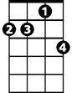

Am7

**F F7**

Haven't you no - ticed

**Dm G7 Cmaj7 C7 F**

Suddenly I'm bright and bree - zy?

**Cmaj7 Dm G7**

Because of all the beautiful and new



D7

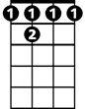

F 7

**C Am7 D7**

Things I'm learning about you

**Dm G7 C (play G7 to start from the top)**

Day by day.

**Getting to Know You (Richard Rogers / Oscar Hammerstein)**

**G Gmaj7**

Getting to know you,

**G Gmaj7 Am D7 Am D7**

Getting to know all about you.



G

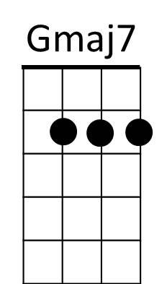**D7 Am D7**

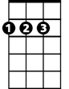

D

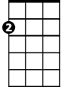

Am

Getting to like you,

**BARITONE**

**Am D7 G D**

Getting to hope you like me.

**G Gmaj7**



C7



G7

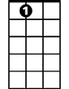

A7

Em7

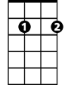

C

Getting to know you,

**G G7 C**

Putting it my way, but nicely,

**Em7 A7**

You are precisely,

**Am D7**

My cup of tea.

**G Gmaj7**

Getting to know you,

**G Gmaj7 Am D7 Am D7**

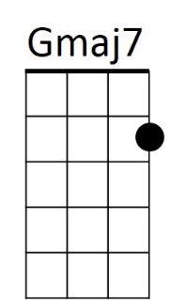Getting to feel free and ea - sy

C



G7



Am



G



C7



Em7



D7

**D7 Am D7**

When I am with you,

**Am D7 G G7**

Getting to know what to say

**C C7**



D

Haven't you no - ticed

**Am D7 Gmaj7 G7 C**

Suddenly I'm bright and bree - zy?

**Gmaj7 Am D7**

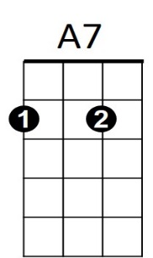Because of all the beautiful and new

**G Em7 A7**

Things I'm learning about you

**Am D7 G (play D7 to start from the top)**

Day by day.