Ghost Ukers in the Sky - Arr. Charles Umiker and Pete McCarty (Am)

Intro (2 Measures): Am  Am C  An old man playing uke was out one dark and windy day,  Am C E7  Up-on a ridge he rested as he began to play.  Am  When all at once a ghosty group of old ukers he saw  F Am  Playing through the ragged skies and up a cloudy draw .  Chorus  C Am F Am  Kum-by yahhhh, Kum-by yahhh-ahhh, ghost ukers in the sky.  Am C  Their ukes were all on fire and their strings were made of steel  Am C E7  Their kazoos were black and shiny and their hot breath he could feel  Am  A bolt of fear went through him as they thundered through the sky  F Am  For he saw the ukers coming hard and he heard their mournful cry. Chorus  Am C  Their faces gaunt, their eyes were blurred and Hawiian shirts soaked with sweat  Am C E7  They're playin hard across that sky and they'll keep on playing yet  Am  Cause they've got to play forever on that range up in the sky  F Am  On ukes of blazing fire you can hear their mournful cry. Chorus  Am C  As the ukers played on by him, he heard one call his name  Am C E7  If you want to save your soul from hell a-playin on our range  Am  Then uker change your ways today or with us you will fly  F Am  Playing with our ghostly crew a-cross these endless skies. Chorus  Outro:  F Am F Am | Am (Hold)  Ghost ukers in the sky, Ghost ukers in the sky. | 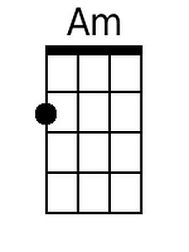
 | 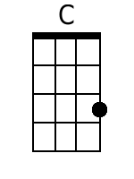
 | 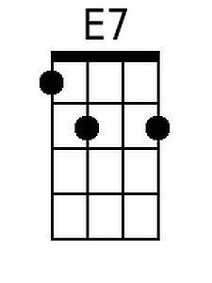
 | 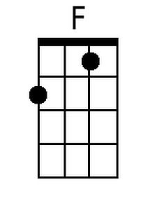
 | Baritone
 | 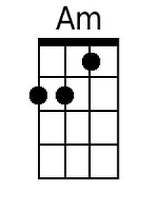
 | 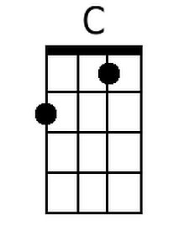
 | 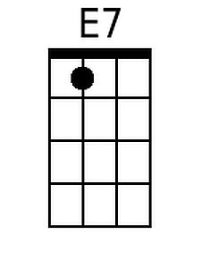
 | 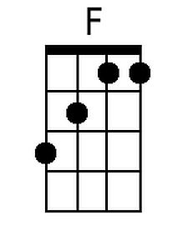

Ghost Ukers in the Sky - Arr. Charles Umiker and Pete McCarty (Dm)

Intro (2 Measures): Dm  Dm F  An old man playing uke was out one dark and windy day,  Dm F A7  Up-on a ridge he rested as he began to play.  Dm  When all at once a ghosty group of old ukers he saw  Bb Dm  Playing through the ragged skies and up a cloudy draw .  Chorus  F Dm A# Dm  Kum-by yahhhh, Kum-by yahhh-ahhh, ghost ukers in the sky.  Dm F  Their ukes were all on fire and their strings were made of steel  Dm F A7  Their kazoos were black and shiny and their hot breath he could feel  Dm  A bolt of fear went through him as they thundered through the sky  Bb Dm  For he saw the ukers coming hard and he heard their mournful cry. Chorus  Dm F  Their faces gaunt, their eyes were blurred and Hawiian shirts soaked with sweat  Dm F A7  They're playin hard across that sky and they'll keep on playing yet  Dm  Cause they've got to play forever on that range up in the sky  Bb Dm  On ukes of blazing fire you can hear their mournful cry. Chorus  Dm F  As the ukers played on by him, he heard one call his name  Dm F A7  If you want to save your soul from hell a-playin on our range  Dm  Then uker change your ways today or with us you will fly  Bb Dm  Playing with our ghostly crew a-cross these endless skies. Chorus  Outro:  F Dm F Dm | Dm (Hold)  Ghost ukers in the sky, Ghost ukers in the sky. | 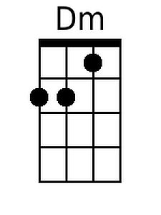
 | 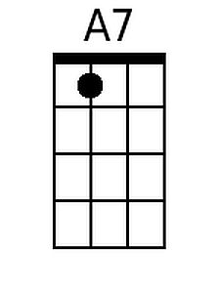
 | 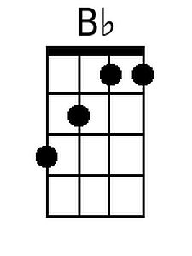
 | Baritone
 | 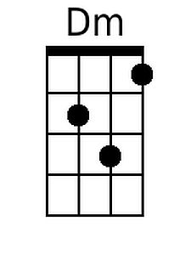
 | 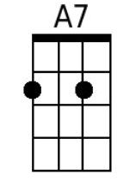
 | 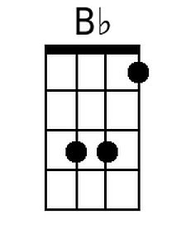

Ghost Ukers in the Sky - Arr. Charles Umiker and Pete McCarty (Em)

Intro (2 Measures): Em  Em G  An old man playing uke was out one dark and windy day,  Em G B7  Up-on a ridge he rested as he began to play.  Em  When all at once a ghosty group of old ukers he saw  C Em  Playing through the ragged skies and up a cloudy draw .  Chorus  G Em C Em  Kum-by yahhhh, Kum-by yahhh-ahhh, ghost ukers in the sky.  Em G  Their ukes were all on fire and their strings were made of steel  Em G B7  Their kazoos were black and shiny and their hot breath he could feel  Em  A bolt of fear went through him as they thundered through the sky  C Em  For he saw the ukers coming hard and he heard their mournful cry. Chorus  Em G  Their faces gaunt, their eyes were blurred and Hawiian shirts soaked with sweat  Em G B7  They're playin hard across that sky and they'll keep on playing yet  Em  Cause they've got to play forever on that range up in the sky  C Em  On ukes of blazing fire you can hear their mournful cry. Chorus  Em G  As the ukers played on by him, he heard one call his name  Em G B7  If you want to save your soul from hell a-playin on our range  Em  Then uker change your ways today or with us you will fly  C Em  Playing with our ghostly crew a-cross these endless skies. Chorus  Outro:  F Em F Em | Em (Hold)  Ghost ukers in the sky, Ghost ukers in the sky. | 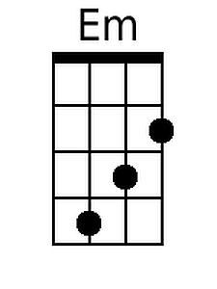
 | 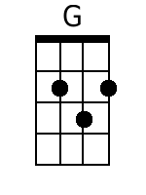
 | 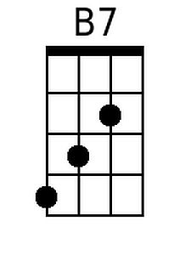
 | Baritone
 | 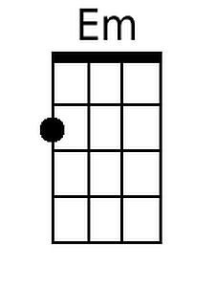
 | 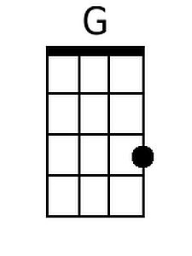
 | 