**Give A Little Bit - Supertramp**

**Intro: G7 C...G7 C...F G...F G...F C... (repeat twice)**

**C G7 C**

Give a little bit,

**F G F G F**

Give a little bit of your love to me

**C G7 C**

I'll give a little bit,

**F G F G F**

I'll give a little bit of my love to you

**Am Dsus4 D**

There's so much that we need to share

**F Am G C G**

Send a smile and show you care

**C G7 C**

I'll give a little bit,

**F G**  **F G F**

I'll give a little bit of my life for you

**C G7 C**

So give a little bit,

**F G F G F**

Give a little bit of your time to me

**Am Dsus4 D**

See the man with the lonely eyes

**F Am G C G**

Oh, Take his hand, you'll be surprised

**E7 Am / E7 Am / E7 Bb / F Bb F G7 / C 6x / - C**

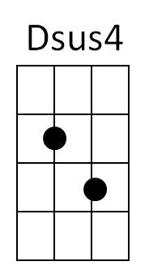**C G7 C**

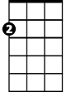

Am

Give a little bit,

**F G F G F**

Give a little bit of your love to me

**C G7 C**

Give a little bit,

**F G F G F**

I'll give a little bit of my life to you

**Am Dsus4 D**

**BARITONE**



F

C

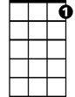

G7

Now's the time that we need to share

**Bb F Bb F G C G7**

So find yourself, we're on our way back home

**C G7 C**

...oh going home

**G7 C G7 C**

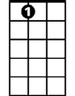

E7

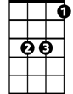

Bb

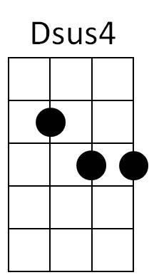don't you need, don't you need to feel at home



D

**G7 C F G F C**

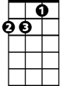

Am

.. oh yeah, we gotta sing

**Bb F**

Ooo You gotta get a feeling

**C**

Ooo You come along, too

**Bb F**

You talk about doin’ it

**C**

Come-a, come-a, come-a, come along

**Bb F**

Cha cha Doin’ it

**C**

Ooooooooo you come along too

**Bb F**

Yeah come along do it

**C**

Tag a looooooooooooooooo

**Bb F**

Come along too, While I’m all right

**C Bb G7 C**

Come a long way, oooooooh sing it tonight

**C F G F C**



Bb

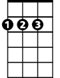

D

E7

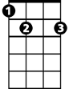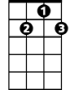

G7



C



G

F



G