Give My Regards to Broadway (George M. Cohan, 1904) (C)

C Dm7 G7  Give my regards to Broad-way  Dm7 G7 C F#º7 G7  Re-member me to Herald Square  C G D G  Tell all the gang at For-ty-Second Street  Am7 D7 Dm7 G7  That I will soon be there  C Dm7 G7  Whisper of how I'm yearn - ing  Dm7 G7 C C7  To mingle with the old time throng  A7 Dm A7 Dm7  Give my regards to old Broad-way  C D7 G7 C  And say that I'll be there e'er long  Repeat from top |  |  |  |  |  |  | 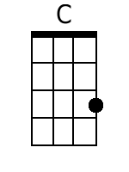 |  | 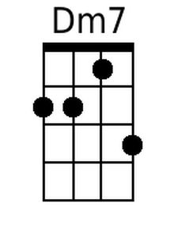
 |  |  |  |  |  |  | 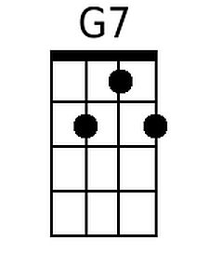 |  | 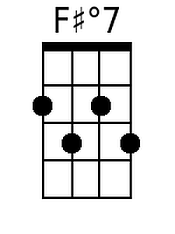
 |  |  |  |  |  |  | 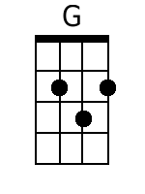 |  | 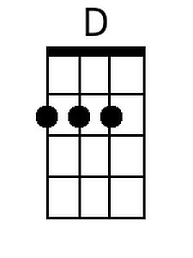
 |  |  |  |  |  |  | 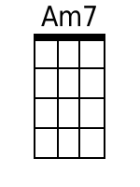 |  | 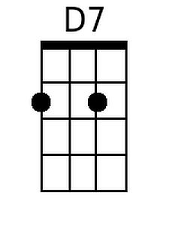
 |  |  |  |  |  |  | 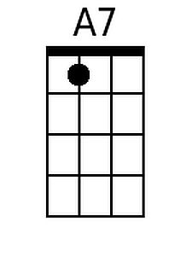
Baritone
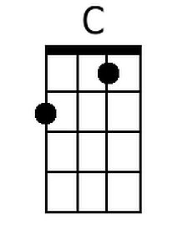 | 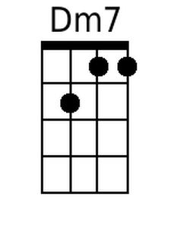 | 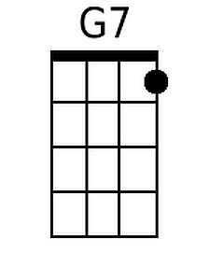 | 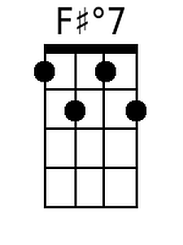 | 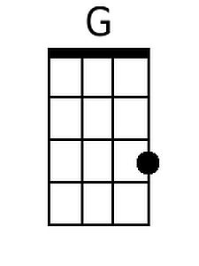
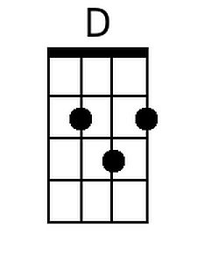 | 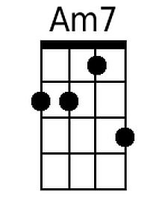 | 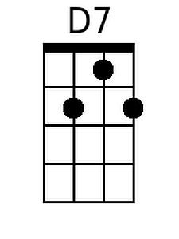 | 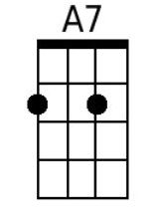

Give My Regards to Broadway (George M. Cohan, 1904) (G)

G Am7 D7
Give my regards to Broad-way
Am7 D7 G C#º7 D7
Re-member me to Herald Square
G D A D
Tell all the gang at For-ty-Second Street
Em7 A7 Am7 D7
That I will soon be there
G Am7 D7
Whisper of how I'm yearn - ing
Am7 D7 G G7
To mingle with the old time throng
E7 Am E7 Am7
Give my regards to old Broad-way
G A7 D7 G
And say that I'll be there e'er long

Repeat from top

 |  |  |  |  |  |  |  |  | 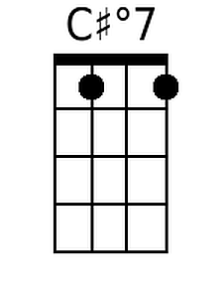
 |  |  |  |  |  |  |  |  | 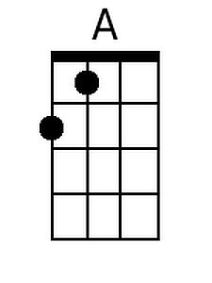
 |  |  |  |  |  |  | 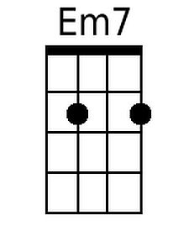
 |  |  |  |  |  |  | 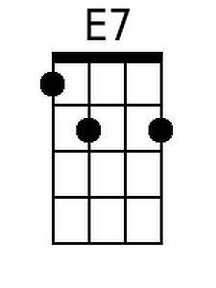
Baritone
 |  |  | 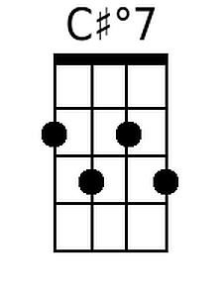
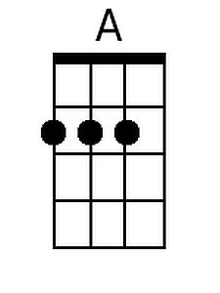 | 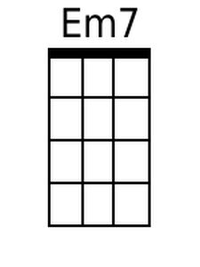 |  | 