Go Where You Want To Go (Mamas And The Papas)
Key of G – 4/4 Time – Version 1

Intro (4 measures plus the pickup): G C G C  Chorus  G C  You gotta go where you wanna go,  G C  __ Do - what you wanna do.  G C G C  With whomever _ you wanna do it with.  G C  You gotta go where you wanna go,  G C  __ Do - what you wanna do.  G C G C  With whomever _ you wanna do it with.  BRIDGE:  G Em  You don't under-stand  C Am D D7  That a girl like me can lo.-.ve just one man.  G F Em D  1. Three thousand miles - that's how far you'll go.  Em C D G Em D D7  And you said to me..eee...'Ple...ase don't fol-low'.  (Chorus & Bridge) |  |  |  |  |  |  | 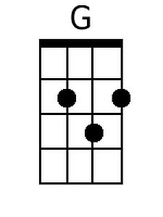 | 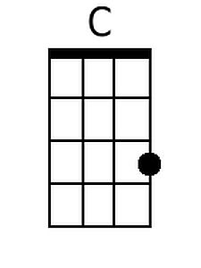
 |  |  |  |  |  |  | 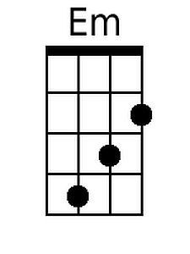 | 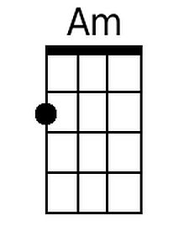
 |  |  |  |  |  |  | 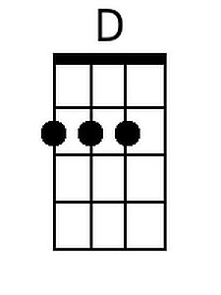 | 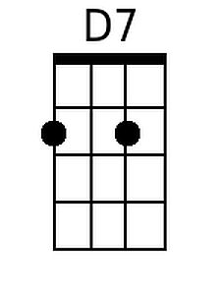
 |  |  |  |  |  |  | 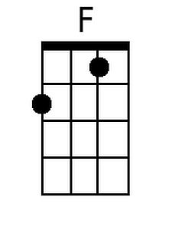 | 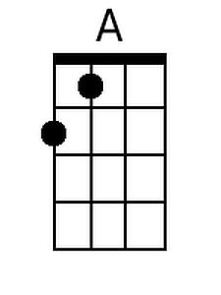
Bari
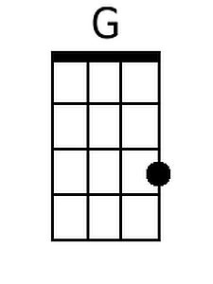 | 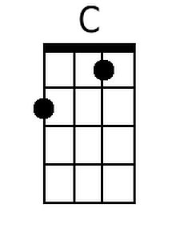 | 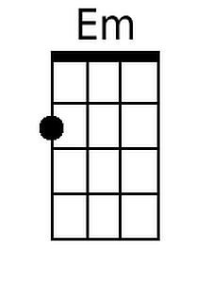 | 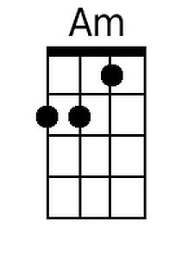 | 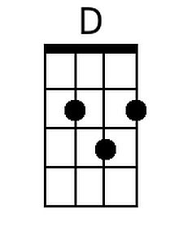 | 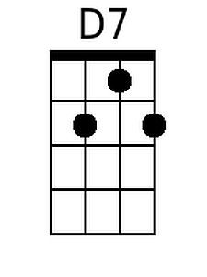 | 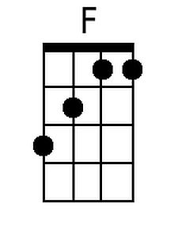 | 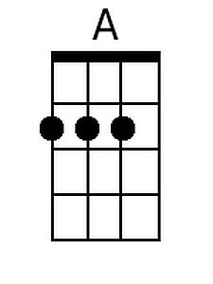

Go Where You Want To Go – Page 2

G F Em D
2. You've been gone a week __ and I tried so hard,
Em C D
__ Not to be the crying kind...
G Em A D
__ Not to be the girl you left be..hind.

Chorus
G C
You gotta go where you wanna go,
G C
__ Do - what you wanna do.
G C G C
With whomever _ you wanna do it with.

Outro (Repeat 3x)
G C
You gotta go - where you want.
G C (End on) G
And do - what you wanna do.

