Go Where You Want To Go (John Phillips, 1965)
Go Where You Wanna Go by The Mamas and the Papas (1965)
4/4 Time – Tempo 104 bpm

Intro (4 measures) G C | G C  Chorus  G C  You gotta go where you wanna go,  G C  __ Do what you wanna do.  G C G C  __ With who-ever _ you wanna do it.  G C  __ Go where you wanna go,  G C  __ Do what you wanna do.  G C G C  __ With who-ever _ you wanna do it.  Bridge  G D Em  You don't under-stand  C Am D | D7  That a girl like me can love just one man.  G F Em A D  __ Three thousand miles __ that's how far you'll go.  Em A - D  __ And you said to me …  G . . . | Em . . . . | . . . .| D - D7  'Ple …... ase , don't fol - low'. |  |  |  |  |  | 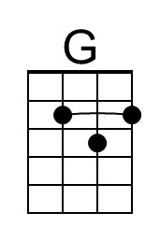 | 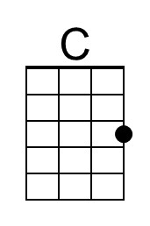
 |  |  |  |  |  | 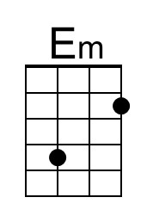 | 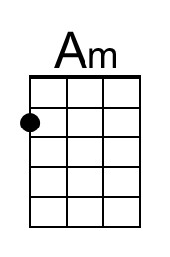
 |  |  |  |  |  | 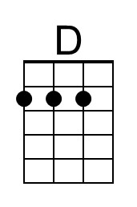 | 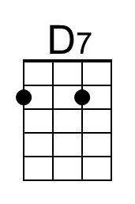
 |  |  |  |  |  | 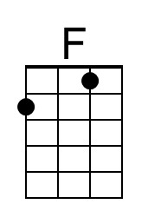 | 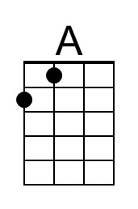
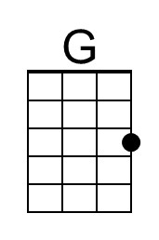 | 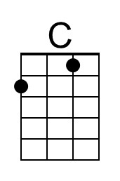 | 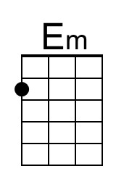 | 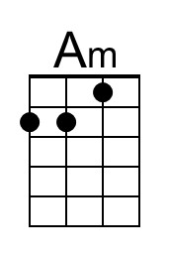 | 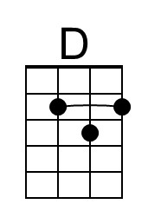 | 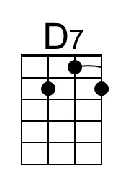 | 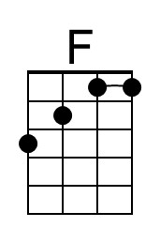 | 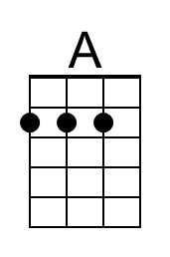

Go Where You Want To Go – Page 2

Chorus
G C
You gotta go where you wanna go,
G C
__ Do what you wanna do.
G C G C
__ With who-ever _ you wanna do it
G C
__ Go where you wanna go,
G C
__ Do what you wanna do.
G C G C
__ With who-ever _ you wanna do it.

Bridge
G D Em
You don't under-stand
C Am D | D7
That a girl like me can love just one man.

G F Em A D
__ You've been gone a week __ and I tried so hard,
Em A D G Em A | D | D7
__ Not to be the cryin’ kind...__ Not to be the girl you left be-hind.

Chorus 3
G C G C
You gotta go where you wanna go, __ Do what you wanna do.
G C G C
_ With who-ever _ you wanna do it.

Outro (Repeat 3x)
| G . . C | G . . C | (End on) G C | G
__Go where you want. __Do what you want.

