**God Bless America (Irving Berlin) Key C**

**Intro: Chords for last 2 lines**



G



C

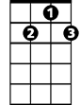

G7

**C G**

God Bless America

**G7 C**

F

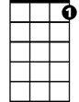

C7

Land that I lo ve

**C7 F C**

Stand beside her, and guide her

**G7 C**

Thru the night wi th a light from above

**G G7 C**

From the mountains, to the prairies

**G G7 C C7**

To the oceans, white with foam

**F G7 C**

God bless America

**F C G C**

My home sweet home

**F G7 C**

God bless America

**F C G C**

My home sweet home -- **REPEAT FROM TOP**

**BARITONE**

**F G7 C**



G7



G

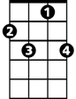

C7



F

C



God bless America

**F C G F C**

My home sweet ho -me

**God Bless America (Irving Berlin)**

**Intro: Chords for last 2 lines**

F



C7



C

**BARITONE**

**F C**

God Bless America

**C7 F**

Land that I love

**F7 Bb F**



Bb



F7

Stand beside her, and guide her

**C7 F**

Thru the night with a light from above

**C C7 F**

From the mountains, to the prairies

**C C7 F F7**

To the oceans, white with foam

**Bb C7 F**

God bless America

**Bb F C F**

My home sweet home

**Bb C7 F**

God bless America

**Bb F C F**

My home sweet home -- **REPEAT FROM TOP**

**Bb C7 F**

God bless America

**Bb F C Bb F**

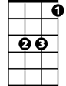

Bb

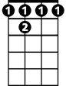

F 7



C7

C



F

My home sweet ho -me

**God Bless America (Irving Berlin)**

**Intro: Chords for last 2 lines**

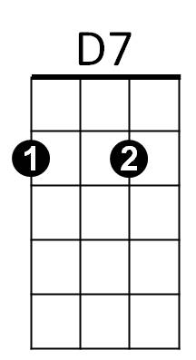

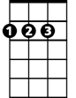

D



G

**G D**

**BARITONE**

God Bless America

**D7 G**

Land that Ilove

**G7 C G**



C



G7

Stand beside her, and guide her

**D7 G**

Thru the night with a light from above

**D D7 G**

From the mountains, to the prairies

**D D7 G G7**

To the oceans, white with foam

**C D7 G**

God bless America

**C G D G**

My home sweet home

**C D7 G**

God bless America

**C G D G**

My home sweet home -- **REPEAT FROM TOP**

**C D7 G**

God bless America

**C G D C G**

My home sweet ho -me



D7



D



G

C



G7