**Proud to be an American (Lee Greenwood)**

**Intro: C Em7 Dm G / C Em7 Dm G**

**C**

If tomorrow all the things were gone



C

**F**

I'd worked for all my life,

**Bb**

And I had to start again

**Dm G**

with just my children and my wife,

**C G**

I'd thank my lucky stars to be livin' here today.

**Dm**

Em7

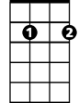

Cause the flag still stands for freedom

**Am F**

And they can't take that away.

**G**

And I'm proud to be an American

**F C**

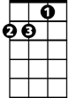

Dm

Where at least I know I'm free

**G**

And I won't forget the men who died

**F C**

Who gave that right to me

**Am C**



G

And I gladly stand up next to you

**F C**

And defend her still today

**F C**

Cause there ain't no doubt I love this land

**F G C**

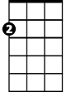

Am

God bless the USA

**C Em7 Dm G / C Em7 Dm G**

**C**

From the lakes of Minnesota

**F**

To the hills of Tennessee



Bb

F



**Bb**

Across the plains of Texas

**Dm G**

From sea to shining sea

**C**

From Detroit down to Houston

**G Am**

And New York to LA

**Dm**

Well there's pride in every American heart

**Am F**

And its time we stand and say

**G**

That I'm proud to be an American

**F C**

Where at least I know I'm free

**G**

And I won't forget the men who died

**F C**

Who gave that right to me

**Am C**

And I gladly stand up next to you

**F C**

And defend her still today

**F C**

Cause there ain't no doubt I love this land

**F G Am F**

God bless the USA

**G**

And I'm proud to be an American

**F C**

Where at least I know I'm free

**G**

And I won't forget the men who died

**F C**

Who gave that right to me

**Am C**

And I gladly stand up next to you

**F C**

And defend her still today

**F C**

Cause there ain't no doubt I love this land

**F G C**

God bless the U – S – A

C



**BARITONE**

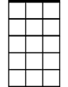

Em7

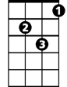

Dm



G



F



Am

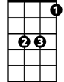

Bb