**God Rest Ye Merry Gentlemen**

C06

**Am F E7**

God rest ye merry gentlemen, let nothing you dismay.

**Am F E7**

Remember Christ our Saviour was born on Christmas Day,

**G7 C Am G7**

To save us all from Satan's power, when we were gone astray.

**C E7 Am G7**

O tidings of comfort and joy, comfort and joy,

**C E7 Am**

O tidings of comfort and joy.

**Am F E7**

From God our heavenly Father, a blessed angel came,

**Am F E7**

And unto certain shepherds brought tidings of the same,

**G7 C Am G7**

How that in Bethlehem was born the Son of God by name,

**C E7 Am G7**

O tidings of comfort and joy, comfort and joy,

**C E7 Am**

O tidings of comfort and joy.

.



C

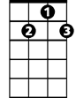

G7

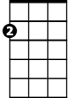

Am

F



E7

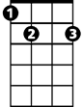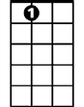

E7

**BARITONE**

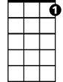

G7

C



F

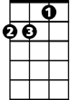

Am