
God Rest Ye Merry, Gentlemen
C06 Am
English Traditional, 16th Century Or Earlier
God Rest Ye Merry, Gentlemen by Nat King Cole (1960)

Intro Chorus  Am F E7  God rest ye merry, gentlemen, let nothing you dismay.  Am F E7  Remember Christ our Saviour was born on Christmas Day,  G7 C Am G7  To save us all from Satan's power, when we were gone as-tray.  Chorus  C E7 Am G7  O tidings of comfort and joy, comfort and joy,  C E7 Am  O tidings of comfort and joy.  Am F E7  From God our heavenly Father, a blessed angel came,  Am F E7  And unto certain shepherds brought tidings of the same,  G7 C Am G7  How that in Bethlehem was born the Son of God by name. Chorus  Optional 3rd Verse  Am F E7  The Shepherds at those tidings re-joiced much in mind,  Am F E7  And left their flocks a feeding, in tempest, storm and wind,  G7 C Am G7  And went to Bethle-hem straightway, this blessed babe to find. Chorus  Am F E7  Now to the Lord sing praises, All you within this place,  Am F E7  And with true love and brotherhood, Each other now em-brace;  G7 C Am G7  This holy tide of Christmas, all other doth de-face. Chorus |  |  |  |  |  |  |  | 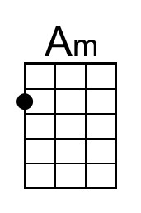
 |  |  |  |  |  |  |  | 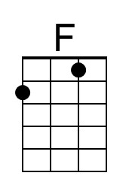
 |  |  |  |  |  |  |  | 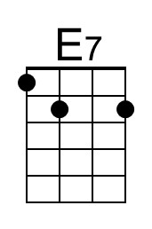
 |  |  |  |  |  |  |  | 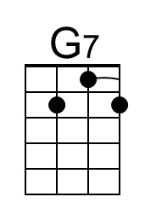
 |  |  |  |  |  |  |  | 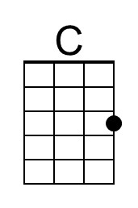
Baritone | 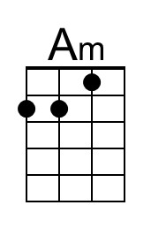 | 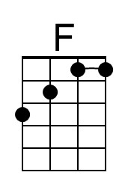 | 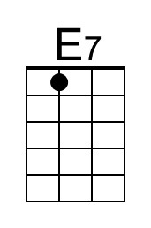 | 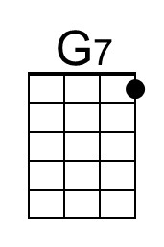 | 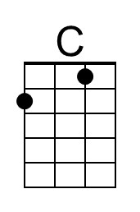

God Rest Ye Merry, Gentlemen
C06 Em
English Traditional, 16th Century Or Earlier
God Rest Ye Merry, Gentlemen by Nat King Cole (1960)

Intro Chorus  Em C B7  God rest ye merry, gentlemen, let nothing you dismay.  Em C B7  Remember Christ our Saviour was born on Christmas Day,  D7 G Em D7  To save us all from Satan's power, when we were gone as-tray.  Chorus  G B7 Em D7  O tidings of comfort and joy, comfort and joy,  G B7 Em  O tidings of comfort and joy.  Em C B7  From God our heavenly Father, a blessed angel came,  Em C B7  And unto certain shepherds brought tidings of the same,  D7 G Em D7  How that in Bethlehem was born the Son of God by name. Chorus  Optional 3rd Verse  Em C B7  The Shepherds at those tidings re-joiced much in mind,  Em C B7  And left their flocks a feeding, in tempest, storm and wind,  D7 G Em D7  And went to Bethle-hem straightway, this blessed babe to find. Chorus  Em C B7  Now to the Lord sing praises, All you within this place,  Em C B7  And with true love and brotherhood, Each other now em-brace;  D7 G Em D7  This holy tide of Christmas, all other doth de-face. Chorus |  |  |  |  |  |  |  | 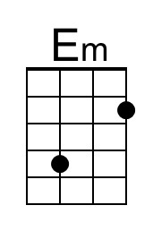
 |  |  |  |  |  |  |  | 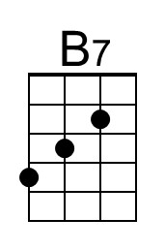
 |  |  |  |  |  |  |  | 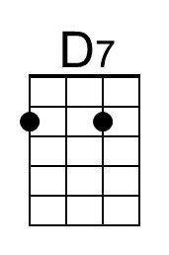
 |  |  |  |  |  |  |  | 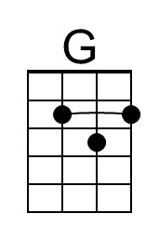
Baritone | 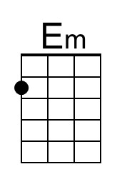 |  | 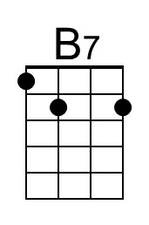 | 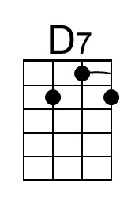 | 