**Golden Slumbers / Carry that Weight / The End (Lennon/McCartney)**

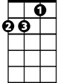

Dm

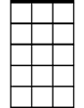

Am7

**Am7 Dm**

Once there was a way____ to get back homeward

**G7 C**

Once, there was a way____to get back home

**Em Am Dm**

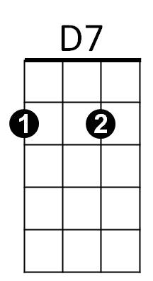Sleep - pretty dar-ling, do not cry,

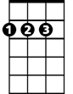

D

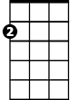

Am

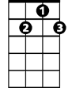

G7



C

E7

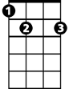

F



G

**G7 C**

Em

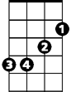

And I will sing a lullaby

**C F C**

Gold - en slumbers fill your eyes

**C F C**

Smiles awake you when you rise

**Em Am Dm**

Sleep - pretty dar-ling, do not cry,

**G7 C**

And I will sing a lullaby

**(Repeat First Verse)**

**C G**

Boy, you're gonna carry that weight

**C**

Carry that weight a long time.

**G**

Boy, you're gonna carry that weight

**C G Am**

Carry that weight a long time.

**Am Dm / G7 F C / Am Dm E7 / Am G**



Bb

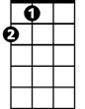

A

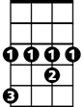

Ab

**Am Dm**

I never give you my pil - low

**G7 F C**

I only send you my in - vitations

**Am Dm E7**

And in the middle of the cele - brations

**Am G**

I break down

**C G**

**BARITONE**

Boy, you're gonna carry that weight

**C**

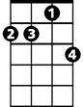

Am7

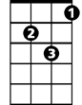

Dm

Carry that weight a long time.

**G**

Boy, you're gonna carry that weight

**C**

Carry that weight a long time.

**C G D / C G D / D F / D G / C D7 C**

**C F D7 G C D7 C**

Oh yeah, all right, are you gonna be in my dreams, tonight?

**(drum solo)**

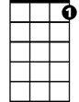

G7

**C F C F (12X)**

Love you, love you, love you, love you

**C //// //// //// ////**

**C Bb Ab D7 G**

And in the end the love you take is equal to the love -

**C A Bb C G**

You make



D

C

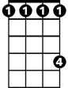

Ab



A

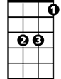

Bb



D7



G

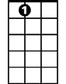

E7



F



Am



Em