**Good Day Sunshine (Lennon/McCartney)**

**Intro: F**

**Chorus:**

**C G C G F F7**

Good day sunshine, good day sunshine, good day sunshine

**Bb G7 C7**

I need to laugh and when the sun is out

F



G



C

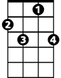

F7

**F Bb**

I've got someting I can laugh about

**G7 C7**

I feel good in a special way

**F Bb**

I'm in love, and it's a sunny day

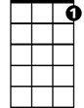

C7

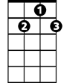

G7



Bb

**(Chorus)**

**Bb G7 C7**

We take a walk, the sun is shining down

**F Bb**

Burns my feet as they touch the ground

**Bb G7 C7 / F Bb (Instrumental last two lines of verse)**

**(Chorus)**

**Bb G7 C7**

**BARITONE**

And then we lie beneath a shady tree



F



G

C



**F Bb**

I love her and she's loving me

**G7 C7**

She feels good, she knows she's looking fine

**F Bb**

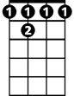

F 7

I'm so proud to know that she is mine



C7

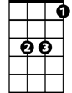

Bb



G7

**(Chorus) 3X**

**F7**

good day sunshine **(repeat and fade)**