**Good Mornin' (Arthur Freed / Nacio Herb Brown) Key C**

**C**

Good Morning, Good Morning

We've talked the whole night through

**F G C**

Good Morning, Good Morning to you

**C**

Good Morning, Good Morning

It's great to stay up late

**F G C**

Good Morning, Good Morning to you

**E7**

When the band began to play

the stars were shining bright

**G**

Now the milkman's on his way

**D7 G** **7**

and it's too late to say good night

**C**

So, Good Morning, Good Morning

Sun beams will soon smile through

**F G C**

Good Morning, Good Morning to you

And you , and you, and you!

**C**

Good Morning, Good Morning

We've gabbed the whole night through

**F G C**

Good Morning, Good Morning to you

**NC**

Nothing could be grander than to be in Louisiana

**C**

In the Morning, In the Morning

It's great to stay up late

**F G C**

Good Morning, Good Morning to you

**N.C.**

I'd be as yippe if it wasn't Mississippi

**E7**

When we left the movie show

the future wasn't bright

**G**

But came the dawn the show goes on

**D7 G7**

and I don't want to say good night

**C**

So say good morning, Good Morning

Rainbows are shining through

**F G C**

Good Morning, Good Morning to you

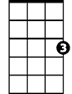

C

F

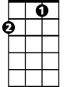

G

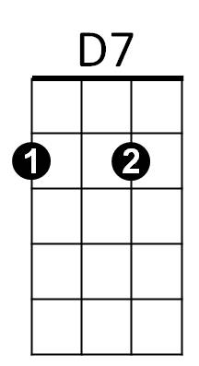

E7

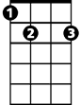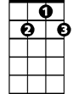

G7

**BARITONE**



G

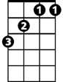

F

C

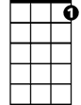

G7



D7

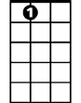

E7

**Good Mornin' (Arthur Freed / Nacio Herb Brown) Key G**

**G**

Good Morning, Good Morning

We've talked the whole night through

**C D G**

Good Morning, Good Morning to you

**G**

Good Morning, Good Morning

It's great to stay up late

**C D G**

Good Morning, Good Morning to you

**B7**

When the band began to play

the stars were shining bright

**D**

Now the milkman's on his way

**A7 D** **7**

and it's too late to say good night

**G**



A7

So, Good Morning, Good Morning

Sun beams will soon smile through

**C D G**

Good Morning, Good Morning to you

And you , and you, and you!

**G**

Good Morning, Good Morning

**BARITONE**



D

C



G

We've gabbed the whole night through

**C D G**

Good Morning, Good Morning to you

**NC**

Nothing could be grander than to be in Louisiana

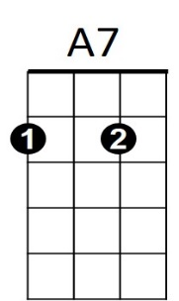



D7

B7



**G**

In the Morning, In the Morning

It's great to stay up late

**C D G**

Good Morning, Good Morning to you

**N.C.**

I'd be as yippe if it wasn't Mississippi

**B7**

When we left the movie show

the future wasn't bright

**D**

But came the dawn the show goes on

**A7 D7**

and I don't want to say good night

**G**

So say good morning, Good Morning

Rainbows are shining through

**C D G**

Good Morning, Good Morning to you





C

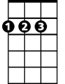

D



G