**Good Morning Starshine**

**G**

Laa dada daa dada, daa dada daa dada,

**Am D7 Am D7**

Daa dada da da daa

**Am D7**

Dadada daa dada,

**Am D7**

Daa daa daa daa daa,

**G**

Dada, daha, daa

**NC C D C**

Good Morning starshine,

**D C D C**

The earth says "Hello",

**D C D C D G Gsus4 D**

You twinkle above us, we twinkle below

**NC C D C**

Good Morning starshine,

**D C D C**

you lead us a long,

**B7 Em B7 C**

my love and me as we sing,

**A7 D7 G**

our early morning singing song

**Chorus:**

**G**

Fliddy glup gloopy,

**Am D7 Am D7**

Nibby nabby noopy, la la la lo lo

**Am D7**

Sabba sibby, sabba,

**Am D7 G G7**

Nooby ab ba nab ba, li li lo lo

**C B7 Em Am**

Tooby ooby, walla, Nooby abba, naba,

**G D7 G**

Early morning singing song

**BARITONE**



D

C

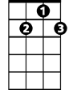

D7

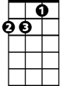

Am



G

**NC C D C**

Good Morning starshine,

**D C D C**

There´s love in your skies,

**D C D C D G D**

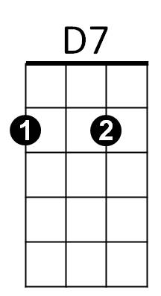Reflecting the sunlight, in my lover´s eyes

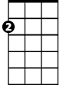

Am



G



C

**NC C D C**

Good Morning starshine,

**D C D C**

So happy to be ,

**B7 Em B7 C**

My love and me as we sing,

**A7 D7 G**

Our early morning singing song

**(Chorus)**

**C D**

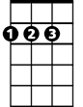

D

Can you hear me?

**G**

Singing a song, humming a song,

**Am D7 Am D7**

Singing a song

**Am D7 Am D** **7**

Loving a song, laughing a song,

Em

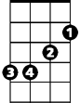

**G G7**

Sing the song

**C B7 Em Am**

Sing the song, song the sing,

**G Em Am D G**

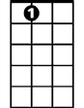

A7

song song song sing, sing sing sing song

**G Em Am D7 G**

Song song song sing, sing sing sing song

**G Am D7 G**

Sing sing song sing song, yea you can

**G Am D7 G**



G7

Sing sing song sing song, yea you can

**G Am D7 G**

Sing sing song sing song,

**G Am D7 G**

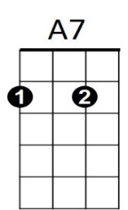Sing sing song sing song, sing

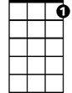

G7



Em

B7

