**Goodbye Yellow Brick Road (Elton John)**

**In** **tro: C Em Am F G7 C**

Em

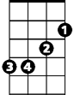

C

**Dm G**

When are you gonna come down?

**C F**

When are you going to learn?

**Bb G7**

I should have strayed on the farm

**C**

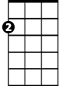

Am

Should have listened to my old man

**Dm G7**

You know you can’t hold me forever

**C F**

I didn’t sign up w ith you

**Bb G7**

I’m not a present for your friends to open

**C**

F



This boy’s too young to be singing -

**Ab Bb7 Eb Ab Fm G7**



Bb

The B lu - es Ah ……. Ah

**C** **E7**

So goodbye yellow brick road

**F C**

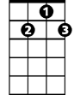

G7

Where the dogs of society howl

**A7 Dm**

You can’t plant me in your penthouse

**G7 C**

I’m going back to my plow

**Am Em**

Back to the howling old owl in the woods

**F Ab**

Hunting the horny back toad

**C Em Am**

Oh I’ve finally decided my future lies

**F G7**

Beyond the yellow brick -

**Ab Bb7 Eb Ab Fm G7 C**

Ro - ad … Ah…..Ah ……Ah

**BARITONE**

**Dm G**

C



What do you think you’ll do then

**C F**

I bet they’ll shoot down your plane

**Bb G7**

It’ll take you a couple of vodka and tonics

**C**

To set you on your feet again

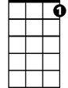

G7

**Dm G7**

Maybe you’ll get a replacement

**C F**

There’s plenty like me to be found

**Bb G7**

Mongrels who ain’t got a penny

**C**

Singing for tit - bits like you - On the-

**Ab Bb7 Eb Ab Fm G7**

Grou - nd ….Ah…..Ah

**C** **E7**

So goodbye yellow brick road

**F C**

Where the dogs of society howl

**A7 Dm**

You can’t plant me in your penthouse

**G7 C**

I’m going back to my plow

**Am Em**

Back to the howling old owl in the woods

**F Ab**

Hunting the horny back toad

**C Em Am**

Oh I’ve finally decided my future lies

**F G7**

Beyond the yellow brick -

**Ab Bb7 Eb Ab Fm G7 C**

Ro - ad … Ah…..Ah ……Ah

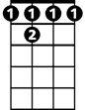

Bb7

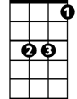

Eb

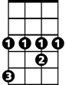

Ab

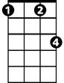

Fm

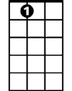

A7

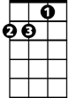

Dm



Em



Bb



Am



F

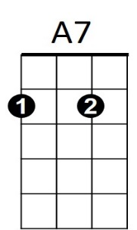

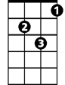

Dm

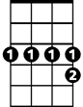

Bb7

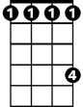

Ab



Eb

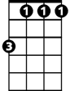

Fm

**Goodbye Yellow Brick Road (Elton John)**



Dm

F



Am

**Intro: F Am Dm Bb C7 F**

**Gm C**

When are you gonna come down?

**F Bb**

When are you going to learn?

**Eb C7**



Bb

I should have strayed on the farm

**F**

Should have listened to my old man

**Gm C7**

You kn ow you can’t hold me forever

**F Bb**



C7

I didn’t sign u p with you

**Eb C7**

I’m not a present for your friends to open

**F**

This boy’s too young to be singing -

**Db Eb7 Ab Db Bbm C7**



Eb

The Blu - es Ah ……. Ah

**F** **A7**



A7

So goodbye yellow brick road

**Bb F**

Where the dogs of society howl

**D7 Gm**

You can’t plant me in your penthouse

**C7 F**

I’m going back to my plow

**Dm Am**

Back to the howling old owl in the woods

**Bb Db**

Hunting the horny back toad

**F Am Dm**

Oh I’ve finally decided my future lies

**Bb C7**

Beyond the yellow brick -

**Db Eb7 Ab Db Bbm C7 F**

**BARITONE**

Ro - ad … Ah…..Ah ……Ah



Am



F

**Gm C**

What do you think you’ll do then

**F Bb**

I bet they’ll shoot down your plane

**Eb C7**

It’ll take you a couple of vodka and tonics



Ab

**F**

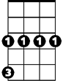

Gm

C



To set you on your feet again

**Gm C7**

Maybe you’ll get a replacement

**F Bb**

There’s plenty like me to be found

**Eb C7**

Mongrels who ain’t got a penny

**F**

Singing for tit - bits like you - On the-

**Db Eb7 Ab Db Bbm C7**

Grou - nd ….Ah…..Ah

**F** **A7**

So goodbye yellow brick road

**Bb F**

Where the dogs of society howl

**D7 Gm**

You can’t plant me in your penthouse

**C7 F**

I’m going back to my plow

**Dm A**

Back to the howling old owl in the woods

**Bb Db**

Hunting the horny back toad

**F Am Dm**

Oh I’ve finally decided my future lies

**Bb C7**

Beyond the yellow brick -

**Db Eb7 Ab Db Bbm C7 F**

Ro - ad … Ah…..Ah ……Ah



Bbm



Gm



Ab



Eb7



Db



C



Eb

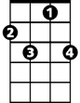

C7



Bb



Dm



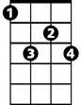

Eb7

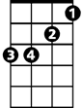

Bbm