
Grandma Got Run Over by a Reindeer
C07 C
(Randy Brooks, 1977) – Grandma Got Run Over By A Reindeer by Elmo & Patsy (E)
4/4 Time – 110 BPM
Intro (Two Measures) C  Chorus  C  Grandma got run over by a reindeer,  F  Walkin' home from our house Christmas Eve.  C  You can say there's no such thing as Santa.  G C Bb Eb C  But as for me and Grandpa, we believe.  Tacet G  She'd been drinkin' too much egg nog,  C  And we'd begged her not to go,  C7 F  But she'd for-got her medi-cation,  G C  And she staggered out the door into the snow.  Am Em  When we found her Christmas mornin,'  G C  At the scene of the attack,  C C7 F  She had hoof prints on her forehead,  G C Bb Eb C  And incriminatin' Claus marks on her back. Chorus  Tacet G  Now we’re all so proud of Grandpa,  C  He’s been takin' this so well,  C7 F  See him in there watchin' football,  G C  Drinkin' beer and playin' cards with cousin Nell.  Am Em  It's not Christmas without Grandma,  G C  All the family’s dressed in black.  C C7 F  And we just can't help but wonder:  G C  Should we open up her gifts or send them back?  Bb Eb C  Spoken: SEND THEM BACK! ! Chorus | Tacet G  Now the goose is on the table.  C  And the pudding made of fig, (ahhhhh)  C7 F  And a blue and silver candles,  G  That would just have matched the hair  C  in Grandma's wig.  Am Em  I've warned all my friends and neighbors,  G C  "Better watch out for yourselves."  C C7 F  They should never give a license,  G  To a man who drives a sleigh  C Bb Eb C  and plays with elves. Chorus  Outro  C  Grandma got run over by a reindeer,  F  Walkin' home from our house Christmas Eve.  C  You can say there's no such thing as Santa.  G C - G - C  But as for me and Grandpa, we belie.......ve.  Spoken: MERRY CHRISTMAS!
 | 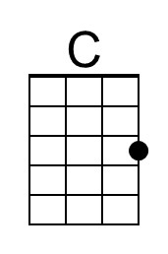 | 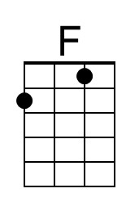 | 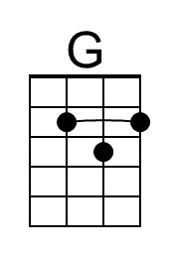 | 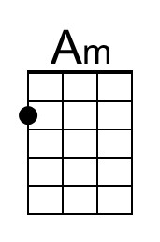 | 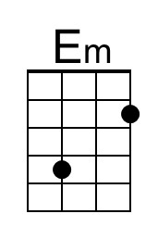
 | 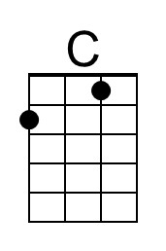 | 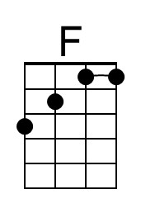 | 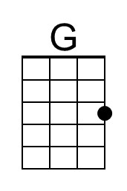 | 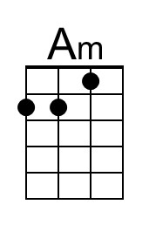 | 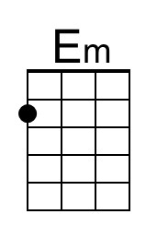

Grandma Got Run Over by a Reindeer
C07 G
(Randy Brooks, 1977) – Grandma Got Run Over By A Reindeer by Elmo & Patsy (E)
4/4 Time – 110 BPM
Intro (Two Measures) G  Chorus  G  Grandma got run over by a reindeer,  C  Walkin' home from our house Christmas Eve.  G  You can say there's no such thing as Santa.  D G F A# G  But as for me and Grandpa, we believe.  Tacet D  She'd been drinkin' too much egg nog,  G  And we'd begged her not to go,  G7 C  But she'd for-got her medi-cation,  D G  And she staggered out the door into the snow.  Em Bm  When we found her Christmas mornin,'  D G  At the scene of the attack,  G G7 C  She had hoof prints on her forehead,  D G F A# G  And incriminatin' Claus marks on her back. Chorus  Tacet D  Now we’re all so proud of Grandpa,  G  He’s been takin' this so well,  G7 C  See him in there watchin' football,  D G  Drinkin' beer and playin' cards with cousin Nell.  Em Bm  It's not Christmas without Grandma,  D G  All the family’s dressed in black.  G G7 C  And we just can't help but wonder:  D G  Should we open up her gifts or send them back?  F A# G  Spoken: SEND THEM BACK! ! Chorus | Tacet D  Now the goose is on the table.  G  And the pudding made of fig, (ahhhhh)  G7 C  And a blue and silver candles,  D  That would just have matched the hair  G  in Grandma's wig.  Em Bm  I've warned all my friends and neighbors,  D G  "Better watch out for yourselves."  G G7 C  They should never give a license,  D  To a man who drives a sleigh  G F A# G  and plays with elves. Chorus  Outro  G  Grandma got run over by a reindeer,  C  Walkin' home from our house Christmas Eve.  G  You can say there's no such thing as Santa.  D G - D - G  But as for me and Grandpa, we belie.......ve.  Spoken: MERRY CHRISTMAS!
 |  |  | 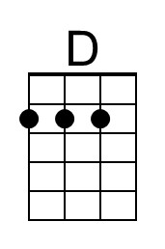 |  | 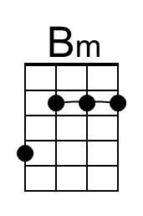
 |  |  | 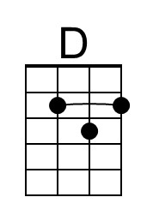 |  | 