Great Balls Of Fire (Otis Blackwell and Jack Hammer) (C)

C  You shake my nerves and you rattle my brain  F7  Too much love drives a man insane  G7 F  You broke my will - oh what a thrill  C  Goodness gracious great balls of fire  C  I laughed at love 'cause I thought it was funny  F7  You came along and you moved me honey  G7 F  I changed my mind - looking fine  C  Goodness gracious great balls of fire  Reprise:  F7 C  Kiss me baby mmmm it feels good  F7 G7  Hold me baby - Well, I want to love you like a lover should  You're fine - so kind  I'm a gonna tell the world that you're mine, mine, mine, mine.  C  I chew my nails and I twiddle my thumb  F7  I'm really nervous but it sure is fun  G7 F7  Come on baby - you drive me crazy  C  Goodness gracious great balls of fire  (Repeat from Reprise) |  |  |  |  |  |  | 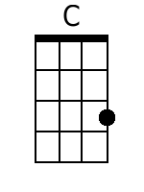
 |  |  |  |  |  |  | 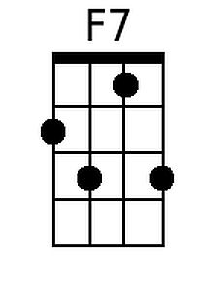
 |  |  |  |  |  |  | 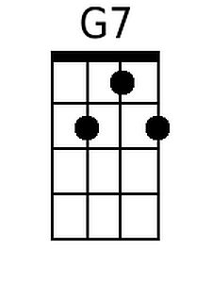
 |  |  |  |  |  |  | 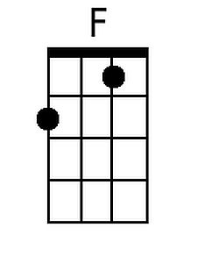
Bari
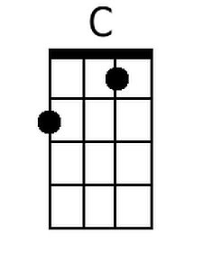 | 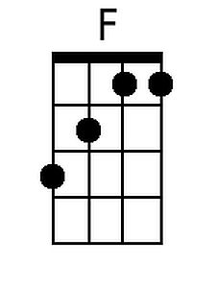 | 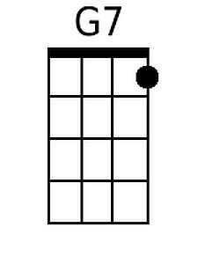 | 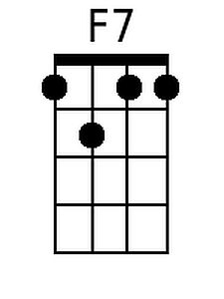

Great Balls Of Fire (Otis Blackwell and Jack Hammer) (G)

G  You shake my nerves and you rattle my brain  C7  Too much love drives a man insane  D7 C  You broke my will - oh what a thrill  G  Goodness gracious great balls of fire  G  I laughed at love 'cause I thought it was funny  C7  You came along and you moved me honey  D7 C  I changed my mind - looking fine  G  Goodness gracious great balls of fire  Reprise:  C7 G  Kiss me baby mmmm it feels good  C7 D7  Hold me baby - Well, I want to love you like a lover should  You're fine - so kind  I'm a gonna tell the world that you're mine, mine, mine, mine.  G  I chew my nails and I twiddle my thumb  C7  I'm really nervous but it sure is fun  D7 C7  Come on baby - you drive me crazy  G  Goodness gracious great balls of fire  (Repeat from Reprise) |  |  |  |  |  |  | 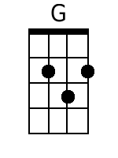
 |  |  |  |  |  |  | 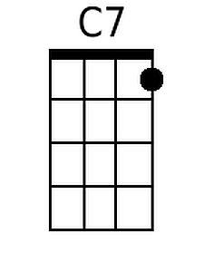
 |  |  |  |  |  |  | 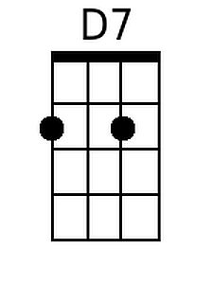
Bari
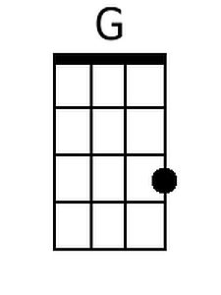 | 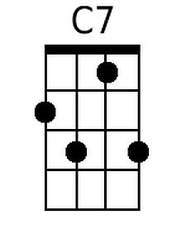 | 