**Green Green (Barry McGuire & Randy Sparks)**

**Intro: Chords for last line of chorus**

**Chorus:**



C

F

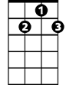

G7

Em

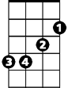

**C F**

Green, green, it's green they say

**C G7**

On the far side of the hill

**C F**

Green, green, I'm goin away

**C G7 C**

To where the grass is greener still

**Em F C**

Well, I told my Mama on the day I was born,

**F G7 C**

Don't ya cry when you see I'm gone

**Em F C**

You know there ain't no woman gonna settle me down

**F G7 C**

I just gotta be a-travelin on - a singin –

**(CHORUS)**

**Em F C**

No, there ain't no body in this whole wide world

**F G7 C**

Gonna tell me how to spend my time

**Em F C**

I'm just a good lovin rambling man

**F G7 C**

Sayin, buddy, could you spare me a dime. Hear me cryin it's a –

**(CHORUS)**

C

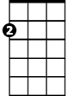

Em



F

**BARITONE**

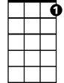

G7

**C G7 C**

To where the grass is greener still