**The Green Leaves of Summer (Dimitri Tiomkin / Paul Francis Webster)**

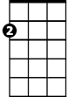

Am

E7

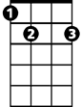

**Intro: Am E7 Am E7**

**Am E7**

A time to be reaping

**Am G**

A time to be sowing

**C**  **Dm**



G

The green leaves of summer

**B7 E7**

Are calling me h ome

**A7 Dm**

'Twas so good to be young then



C

**G7 C**

In the season of plenty

**Am B7**

Whe n the catfish were jumping

**Am E7 Am**

As high as the sky

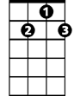

G7

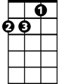

Dm

**Am E7**

A time just for planting

**Am G**

A time just for ploughing

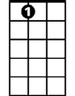

A7

**C Dm**

A time to be cou rting

**B7 E7**

A girl of your own

**A7 Dm**

'Twas so good to be young then

**G7 C**

To be close to the earth

**Am B7**

And to stand by your wife

**Am E7 Am**

At the mo-ment of birth

**Am E7**

A time to be reaping

**Am G**

A time to be sowing

**C Dm**

A time just for living

**B7 E7**

A place for to die

**Ending (2x)**

**A7 Dm**

'Twas so good to be young then

**G7 C**

To be close to the earth

**Am B7**

Now the green leaves of summer

**Am E7 Am**

Are call - ing me home

**BARITONE**



E7



Am

C



G

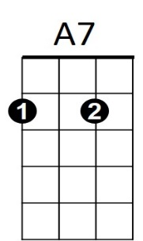

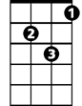

Dm

B7

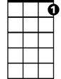

G7

**The Green Leaves of Summer (Dimitri Tiomkin / Paul Francis Webster)**



C7



Gm

F



C



Dm



A7

E7



**Intro: Dm A7 Dm A7**

**Dm A7**

A time to be reaping

**Dm C**

A time to be sowing

**F Gm**

The green leaves of summer

**E7 A7**

Are calling me home

**D7 Gm**

'Twas so g ood to be young then

**C7 F**

In the season of plenty

**Dm E7**

When the catfish were jumping

**Dm A7 Dm**

As high as the sky

**Dm A7**

A time just for planting

**Dm C**

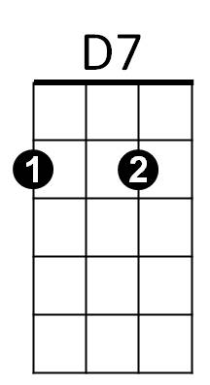A time just for ploughing

**F Gm**

A time to be courting

**E7 A7**

A girl of your own

**D7 Gm**

'Twas so good to be young then

**C7 F**

To be close to the earth

**Dm E7**

And to stand by your wife

**Dm A7 Dm**

At the mo-ment of birth

**Dm A7**

A time to be reaping

**Dm C**

A time to be sowing

**F Gm**

A time just for living

**E7 A7**

A place for to die

**Ending (2x)**

**D7 Gm**

'Twas so good to be young then

**C7 F**

To be close to the earth

**Dm E7**

Now the green leaves of summer

**Dm A7 Dm**

Are call - ing me home



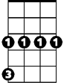

Gm



E7



D7



F



Dm

C



**BARITONE**

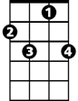

C7