Green River (John Cameron Fogerty) (E)

Intro: E7  E  Well take me back down where cool water flows yeah.  E  Let me remember things I love  E  Stoppin’ at the log where catfish bite  C  Walkin’ along the river road at night  A E7  Barefoot girls dancin’ in the moonlight  E  I can hear the bullfrog callin’ me.  E  Wonder if my ropes still hangin’ to the tree.  E  Love to kick my feet way down the shallow water.  C  Shoofly, dragonfly, get back to mother.  A E7 C A  Pick up a flat rock, skip it across green river.  E  Up at Cody’s Camp I spent my days, oh,  E  With flat car riders and cross-tie walkers  E  Old Cody Junior took me over,  C  Said, you’re gonna find the world is smouldrin'.  A E7  And if you get lost come on home to green river. |  |  |  |  |  |  | 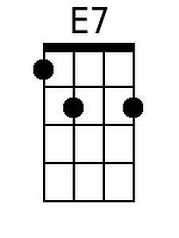
 |  |  |  |  |  |  | 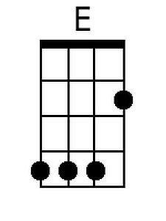
 |  |  |  |  |  |  | 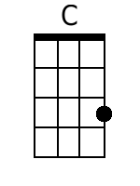
 |  |  |  |  |  |  | 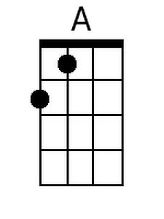
Bari
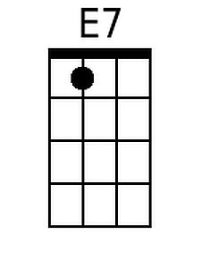 | 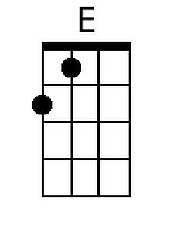 | 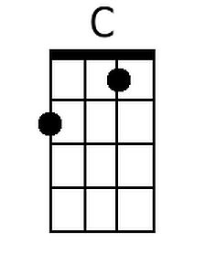 | 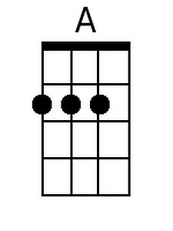

Green River (John Cameron Fogerty) (Nashville Notation)

1  Well take me back down where cool water flows yeah.  1  Let me remember things I love  1  Stoppin at the log where catfish bite  5#  Walkin along the river road at night  4 1(7)  Barefoot girls dancin in the moonlight  1  I can hear the bullfrog callin me.  1  Wonder if my ropes still hangin to the tree.  1  Love to kick my feet way down the shallow water.  5#  Shoofly, dragonfly, get back to mother.  4 1(7) 5# 4  Pick up a flat rock, skip it across green river.  1  Up at Codys Camp I spent my days, oh,  1  With flat car riders and cross-tie walkers  1  Old Cody Junior took me over,  5#  Said, youre gonna find the world is smouldrin'.  4 1(7)  And if you get lost come on home to green river. | 1 | 5# | 4 | 1(7)
 | I | V# | IV | I 7
 | A | E | D | A7
 | C | G | F | C7
 | D | A | G | D7
 | E | B | A | E7
 | F | C | Bb | F7
 | G | D | C | G7

