**Green River ( John Cameron Fogerty) Key A**

**Intro: A7**

**A**

Well take me back down where cool water flows yeah.

**A**

Let me remember things I love

F

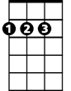

D

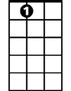

A7

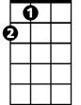

A

**A**

Stoppin at the log wh ere catfish bite

**F**

Walkin along the river road at night

**D A7**

Barefoot girls dancin in the moonlight

**A**

I can hear the bullfrog callin me.

**A**

Wonder if my ropes still hangin to the tree.

**A**

Love to kick my feet way down the shallow water.

**F**

Shoofly, dragonfly, get back to mother.

**D A7 F D**

Pick up a flat rock, skip it across green river.

**BARITONE**

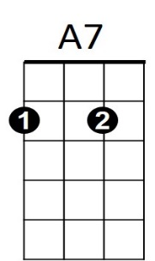



A

**A**

Up at Codys Camp I spent my days, oh,

**A**

With flat car riders and cross-tie walkers

**A**



F



D

Old Cody Junior took me over,

**F**

Said, youre gonna find the world is smouldrin’.

**D A7**

And if you get lost come on home to green river.