**Green Tambourine (Paul Leka / Shelly Pinz) Key C**

**C G F (2x)**

**C G C G F**

Drop your silver in my tambourine

F



G



C

**C G C**

Help a poor man fill his pretty dream

**Fm C**

Give me pennies I'll take anything

**Eb Bbm**

Now listen while I play,

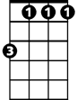

Bbm

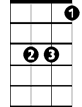

Eb

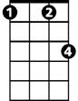

Fm

**Fm C**

My green tambourine

**C G F (2x)**

**C G C G F**

Watch the jingle jangle start to chime

**C G C G F**

Reflections of the music that is mine

**Fm C**

When you drop a coin you'll hear it sing

**Eb Bbm**

Now listen while I play,

**Fm C**

My green tambourine

**BARITONE**

**C G F (2x)**



F



G

C



**C G C G F**

Drop a dime before I walk away

**C G C G F**

Any song you want I'll gladly play

**Fm C**



Fm

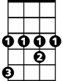

Eb

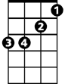

Bbm

Money feeds my music machine

**Eb Bbm**

Now listen while I play,

**Fm C**

My green tambourine

**C G F / C G F C**

**Eb Bbm (hold and let ring)**

Now listen while I play. . .

**Green Tambourine (Paul Leka / Shelly Pinz) Key G**

**G D C (2x)**

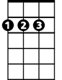

D



G



C

**BARITONE**

**G D G D C**

Drop your silver in my tambourine

**G D G**

Help a poor man fill his pretty dream

**Cm G**

Give me pennies I'll take anything

**Bb Fm**

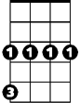

Cm



Bb



Fm

Now listen while I play,

**Cm G**

My green tambourine

**G D C (2x)**

**G D G D C**

Watch the jingle jangle start to chime

**G D G D C**

Reflections of the music that is mine

**Cm G**

When you drop a coin you'll hear it sing

**Bb Fm**

Now listen while I play,

**Cm G**

My green tambourine



D



G

C



**G D C (2x)**

**G D G D C**

Drop a dime before I walk away

**G D G D C**



Bb

Any song you want I'll gladly play



Cm



Fm

**Cm G**

Money feeds my music machine

**Bb Fm**

Now listen while I play,

**Cm G**

My green tambourine

**G D C / G D C G**

**Bb Fm (hold and let ring)**

Now listen while I play. . .