Green, Green
Ukulele.
Original Key of C.
By Barry McGuire and Randy Sparks
2/2 Time; “With a Steady Beat.”
Recorded by The New Christy Minstrels on their album Ramblin' (1963).
GCEA  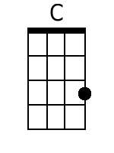  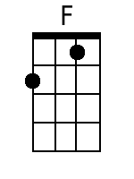  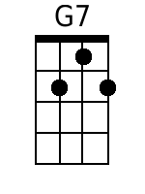  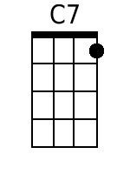  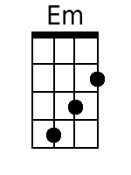  Bari  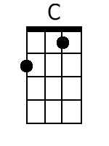  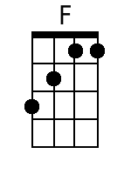  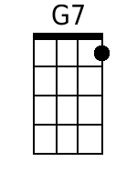  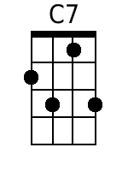  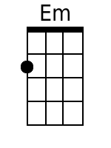 | Green, Green  By Barry McGuire and Randy Sparks  2/2 Time; Original Key of C. “With a Steady Beat.” Ukulele.  Recorded by The New Christy Minstrels on their album Ramblin' (1963).  4 Measure Introduction  Chorus  C F  Green, green, it's green they say,  C G7  On the far side of the hill;  C C7 F  Green, green, I'm goin' away  C G7 C  To where the grass is greener still.  C Em F C  1. Well, I told my mama on the day I was born  F G7 C  “Don-cha cry when you see I'm gone.  C Em F C  You know, there ain't no woman gonna settle me down  F G7 C  I just gotta be travelin' on.” A-singin' Chorus  C Em F C  2. No, there ain't no-body in this whole wide world  F G7 C  Gonna tell me how to spend my time.  C Em F C  I'm just a good-lovin' ramblin' man.  F G7 C  Say, buddy, can you spare me a dime?  Hear me cryin', it's a … Chorus  Optional Girls Verse  C Em F C  3. Loved that man with all my heart,  F G7 C  I will till the day I die.  C Em F C  I was just a stop a-long his way;  F G7 C  Never even said good-bye. Chorus  C Em F C  4. I don't care when the sun goes down,  F G7 C  Where I lay my weary head.  C Em F C  Green, green valley or a rocky road;  F G7 C  It's there I'm gonna make my bed.  C F  Green, green, it's green they say,  C G7  On the far side of the hill;  C C7 F  Green, green, I'm goin' away  C G7 C  To where the grass is greener still.  [Spoken]  Everybody, I wanna hear it now.  C F  Green, green, it's green they say,  C G7  On the far side of the hill;  C C7 F  Green, green, I'm goin' away  C G7 C  To where the grass is greener still.  [Repeat as needed for Fade out]  C G7 C  ||: To where the grass is greener still. :||

