Green, Green
Ukulele.
Key of G (Original Key of C).
GCEA  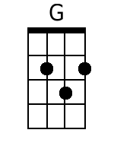  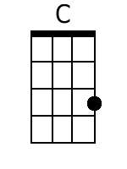  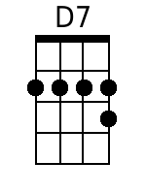  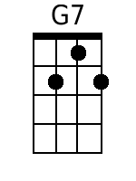  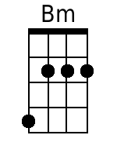  Bari  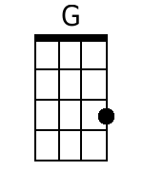  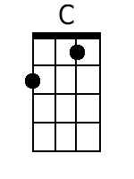  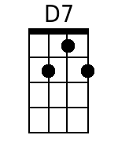  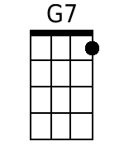  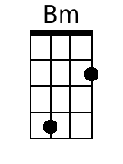 | Green, Green  By Barry McGuire and Randy Sparks  2/2 Time; Key of G (Original Key of C). “With a Steady Beat.” Ukulele.  Recorded by The New Christy Minstrels on their album Ramblin' (1963).  4 Measure Introduction  Chorus  G C  Green, green, it's green they say,  G D7  On the far side of the hill;  G G7 C  Green, green, I'm goin' away  G D7 G  To where the grass is greener still.  G Bm C G  1. Well, I told my mama on the day I was born  C D7 G  “Don-cha cry when you see I'm gone.  G Bm C G  You know, there ain't no woman gonna settle me down  C D7 G  I just gotta be travelin' on.” A-singin' Chorus  G Bm C G  2. No, there ain't no-body in this whole wide world  C D7 G  Gonna tell me how to spend my time.  G Bm C G  I'm just a good-lovin' ramblin' man.  C D7 G  Say, buddy, can you spare me a dime?  Hear me cryin', it's a … Chorus  Optional Girls Verse  G Bm C G  3. Loved that man with all my heart,  C D7 G  I will till the day I die.  G Bm C G  I was just a stop a-long his way;  C D7 G  Never even said good-bye. Chorus  G Bm C G  4. I don't care when the sun goes down,  C D7 G  Where I lay my weary head.  G Bm C G  Green, green valley or a rocky road;  C D7 G  It's there I'm gonna make my bed.  G C  Green, green, it's green they say,  G D7  On the far side of the hill;  G G7 C  Green, green, I'm goin' away  G D7 G  To where the grass is greener still.  [Spoken]  Everybody, I wanna hear it now.  G C  Green, green, it's green they say,  G D7  On the far side of the hill;  G G7 C  Green, green, I'm goin' away  G D7 G  To where the grass is greener still.  [Repeat as needed for Fade out]  G D7 G  ||: To where the grass is greener still. :||

