Greenfields (Am)
(Terry Gilkyson, Rich Dehr, and Frank Miller, 1957) (G-Tuned Ukulele)
Greenfields by The Brothers Four (1960) (Bm)
4/4 Time – Tempo = 111 BPM

Intro Last line of the verse  Am Dm Am E7  1. Once there were green fields kissed by the sun  Am Dm Am E7  Once there were valleys where rivers used to run  F G7 Em7 A7  Once there were blue skies with white clouds high a-bove  Dm7 G7 Am E7  Once they were part of an everlasting love  Am Dm Am E7 Am Em Am E7  We were the lovers who strolled through green fields  Am Dm Am E7  2. Green fields are gone now, parched by the sun  Am Dm Am E7  Gone from the valleys where rivers used to run  F G7 Em7 A7  Gone with the cold wind that swept into my heart  Dm7 G7 Am E7  Gone with the lovers who let their dreams de-part  Am Dm Am E7 Am Em Am E7  Where are the green fields that we used to roam  Bridge  F G9 Dm7 G7 C Am7  I'll never know what made you run a-way  Dm7 G9 Dm7 G7 C E7  How can I keep searching when dark clouds hide the day  Am F Dm  __ I only know there's nothing here for me  Am Dm Dm7 E7  Nothing in this wide world, left for me to see.  Am Dm Am E7  3. But I'll keep on waiting 'til you re-turn  Am Dm Am E7  I'll keep on waiting un-til the day you learn  F G7 Em7 A7  _ You can't be happy while your heart's on the roam  Dm7 G7 Am E7  __ You can't be happy un-til you bring it home  Am Dm Am E7 Am Em Am  Home to the green fields and me once a-gain. | 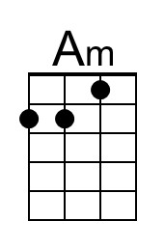 | 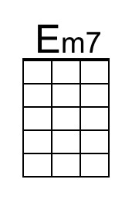
 | 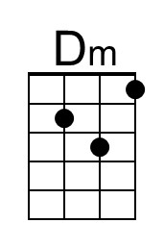 | 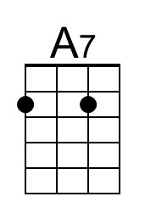
 | 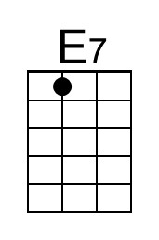 | 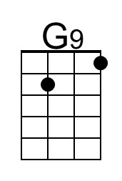
 | 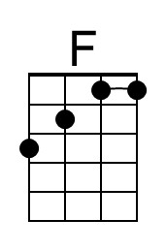 | 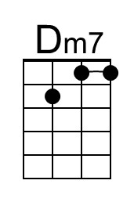
 | 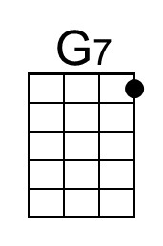 | 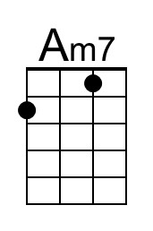
 | 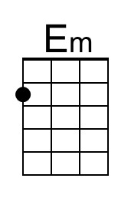

Greenfields (Em)
(Terry Gilkyson, Rich Dehr, and Frank Miller) (G-Tuned Ukulele)
Greenfields by The Brothers Four (1960) (Bm)
4/4 Time – Tempo = 111 BPM

Intro Last line of the verse  Em Am Em B7  1. Once there were green fields kissed by the sun  Em Am Em B7  Once there were valleys where rivers used to run  C D7 Bm7 E7  Once there were blue skies with white clouds high a-bove  Am7 D7 Em B7  Once they were part of an everlasting love  Em Am Em B7 Em Bm Em B7  We were the lovers who strolled through green fields  Em Am Em B7  2. Green fields are gone now, parched by the sun  Em Am Em B7  Gone from the valleys where rivers used to run  C D7 Bm7 E7  Gone with the cold wind that swept into my heart  Am7 D7 Em B7  Gone with the lovers who let their dreams de-part  Em Am Em B7 Em Bm Em B7  Where are the green fields that we used to roam  Bridge  C D9 Am7 D7 G Em7  I'll never know what made you run a-way  Am7 D9 Am7 D7 G B7  How can I keep searching when dark clouds hide the day  Em C Am  __ I only know there's nothing here for me  Em Am Am7 B7  Nothing in this wide world, left for me to see.  Em Am Em B7  3. But I'll keep on waiting 'til you re-turn  Em Am Em B7  I'll keep on waiting un-til the day you learn  C D7 Bm7 E7  _ You can't be happy while your heart's on the roam  Am7 D7 Em B7  __ You can't be happy un-til you bring it home  Em Am Em B7 Em Bm Em  Home to the green fields and me once a-gain. |  | 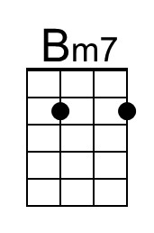
 | 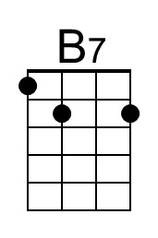 | 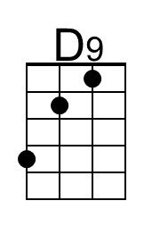
 | 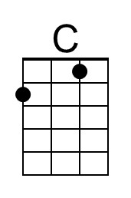
 | 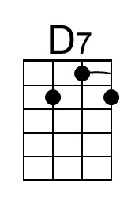
 | 