**Greenfields (Terry Gilkyson, Rich Dehr, and Frank Miller, 1956)**

**4/4 Time - Key: A Minor - "Moderately, with a beat"**

**Intro The last line of the verse.**

**Am Dm Am E7**

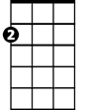

Am

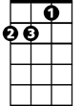

Dm

E7

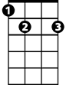

Once there were green fields kissed by the sun

**Am Dm Am E7**

Once there were valleys where rivers used to run

**F G7 Em7 A7**

Once there were blue skies with white clouds high a-bove

**Dm G7 Am E7**

Once they were part of an everlasting love

**Am Dm Am E7 Am Em Am E7**

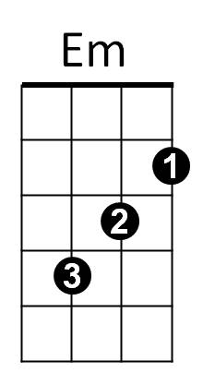We were the lovers who strolled through green fields

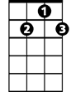

G7

Em7

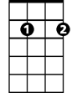

F



**Am Dm Am E7**

Green fields are gone now, parched by the sun

**Am Dm Am E7**

Gone from the valleys where rivers used to run

**F G7 Em7 A7**

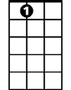

A7



C

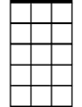

Am7

Gone with the cold wind that swept into my heart

**Dm G7 Am E7**

Gone with the lovers who let their dreams de-part

**Am Dm Am E7 Am Em Am E7**

Where are the green fields that we used to roam

**F G7 Dm G7 C Am7**

I'll never know what made you run a-way

**BARITONE**

**Dm G7 Dm G7 C E7**

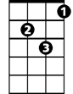

Dm



Am



Em7



F

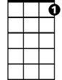

G7

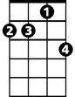

Am7



E7

How can I keep searching when dark clouds hide the day

**Am F Dm**

I only know there's nothing here for me

**Am Dm E7**

Nothing in this wide world, left for me to see

**Am Dm Am E7**



Em

But I'll keep on waiting 'til you re-turn

**Am Dm Am E7**

I'll keep on waiting un-til the day you learn

**F G7 Em7 A7**

You can't be happy while your heart's on the roam

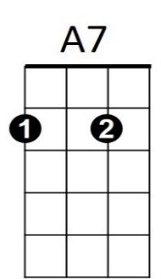**Dm G7 Am E7**

C



You can't be happy un-til you bring it home

**Am Dm Am E7 Am Em Am**

Home to the green fields and me - once a-gain

**Greenfields (Terry Gilkyson, Rich Dehr, and Frank Miller, 1956)**

**4/4 Time - Key: E Minor - "Moderately, with a beat"**

**Intro The last line of the verse.**

**Em Am Em B7**



Am

Em

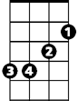

Once there were green fields kissed by the sun

**Em Am Em B7**

Once there were valleys where rivers used to run

**C D7 Bm7 E7**

Once there were blue skies with white clouds high above

**Am D7 Em B7**

Once they were part of an everlasting love

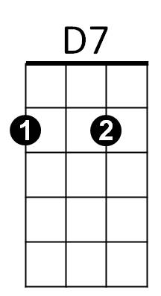**Em Am Em B7 Em Bm Em B7**

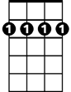

Bm7



C

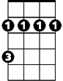

Bm

We were the lovers who strolled through green fields

**Em Am Em B7**

Green fields are gone now, parched by the sun

**Em Am Em B7**

Gone from the valleys where rivers used to run

**C D7 Bm7 E7**



G

Em7



E7



Gone with the cold wind that swept into my heart

**Am D7 Em B7**

Gone with the lovers who let their dreams de-part

**Em Am Em B7 Em Bm Em B7**

Where are the green fields that we used to roam

**Bridge**

**C D7 Am D7 G Em7**

**BARITONE**

I'll never know what made you run a-way



Em

**Am D7 Am D7 G B7**

B7



Am

How can I keep searching when dark clouds hide the day

**Em C Am**

I only know there's nothing here for me

**Em Am Am B7**

Nothing in this wide world, left for me to see

C



D7

Bm7



E7

**Em Am Em B7**

But I'll keep on waiting 'til you re-turn

**Em Am Em B7**

I'll keep on waiting un-til the day you learn

**C D7 Bm7 E7**

You can't be happy while your heart's on the roam

Bm



Em7



G

**Am D7 Em B7**

You can't be happy un-til you bring it home

**Em Am Em B7 Em Bm Em**

Home to the green fields and me once a-gain