Greenfields (Am)
(Terry Gilkyson, Rich Dehr, and Frank Miller)

Intro: Last line of the verse with all chords.  Am Dm Am E7  1. Once there were green fields kissed by the sun  Am Dm Am E7  Once there were valleys where rivers used to run  F G7 Em7 A7  Once there were blue skies with white clouds high above  Dm7 G7 Am E7  Once they were part of an everlasting love  Am Dm Am E7 Am Em Am E7  We were the lovers who strolled through green fields  Am Dm Am E7  2. Green fields are gone now, parched by the sun  Am Dm Am E7  Gone from the valleys where rivers used to run  F G7 Em7 A7  Gone with the cold wind that swept into my heart  Dm7 G7 Am E7  Gone with the lovers who let their dreams de-part  Am Dm Am E7 Am Em Am E7  Where are the green fields that we used to roam |  |  |  |  |  | 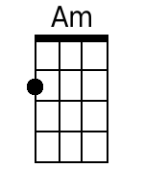 | 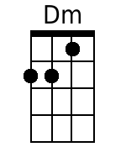
 |  |  |  |  |  | 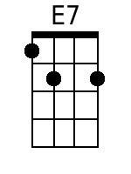 | 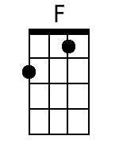
 |  |  |  |  |  | 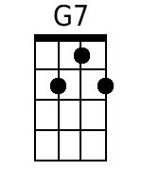 | 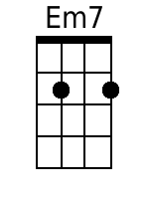
 |  |  |  |  |  | 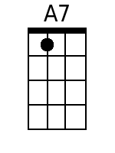 | 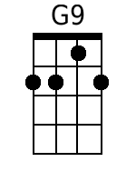
 |  |  |  |  |  | 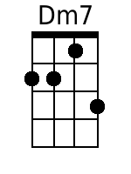 | 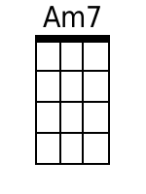
 |  |  |  |  |  | 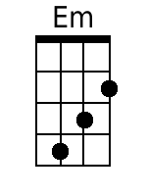
Baritone
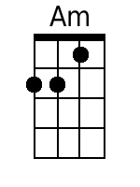 | 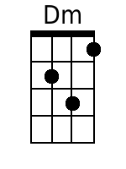 | 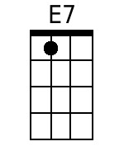 | 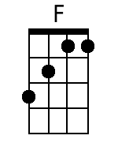 | 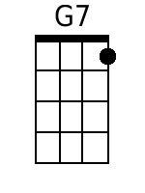 | 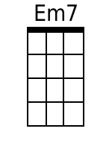
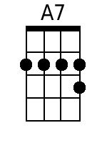 | 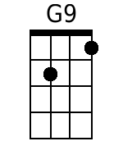 | 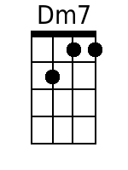 | 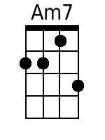 | 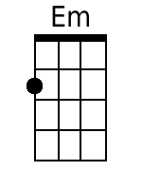

Greenfields (Am) – Page 2
Bridge
F G9 Dm7 G7 C Am7
I'll never know what made you run a-way
Dm7 G9 Dm7 G7 C E7
How can I keep searching when dark clouds hide the day
Am F Dm
I only know there's nothing here for me
Am Dm Dm7 E7
Nothing in this wide world, left for me to see.

Am Dm Am E7
3. But I'll keep on waiting 'til you re-turn
Am Dm Am E7
I'll keep on waiting un-til the day you learn
F G7 Em7 A7
You can't be happy while your heart's on the roam
Dm7 G7 Am E7
You can't be happy un-til you bring it home
Am Dm Am E7 Am Em Am
Home to the green fields and me once a-gain.

Greenfields (Dm)
(Terry Gilkyson, Rich Dehr, and Frank Miller)

Intro: Last line of the verse with all chords.  Dm Gm Dm A7  1. Once there were green fields kissed by the sun  Dm Gm Dm A7  Once there were valleys where rivers used to run  Bb C7 Am7 D7  Once there were blue skies with white clouds high above  Gm7 C7 Dm A7  Once they were part of an everlasting love  Dm Gm Dm A7 Dm Am Dm A7  We were the lovers who strolled through green fields  Dm Gm Dm A7  2. Green fields are gone now, parched by the sun  Dm Gm Dm A7  Gone from the valleys where rivers used to run  Bb C7 Am7 D7  Gone with the cold wind that swept into my heart  Gm7 C7 Dm A7  Gone with the lovers who let their dreams de-part  Dm Gm Dm A7 Dm Am Dm A7  Where are the green fields that we used to roam |  |  |  |  |  | 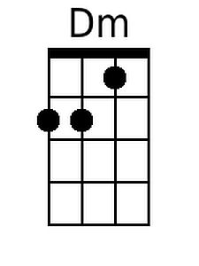 | 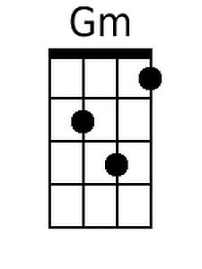
 |  |  |  |  |  | 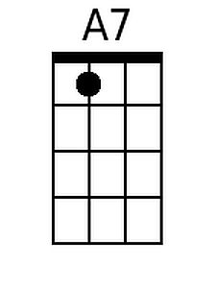 | 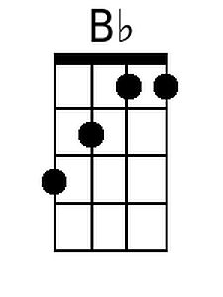
 |  |  |  |  |  | 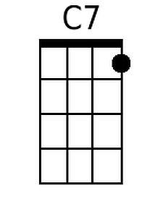
 |  |  |  |  |  | 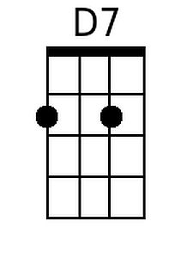 | 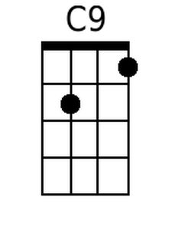
 |  |  |  |  |  | 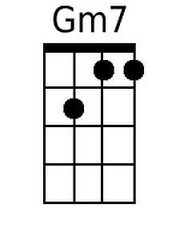 | 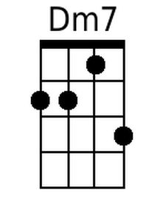
 |  |  |  |  |  | 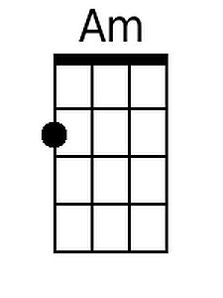
Baritone
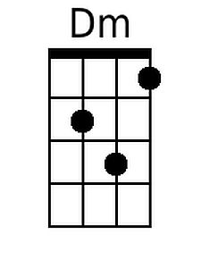 | 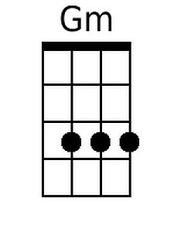 | 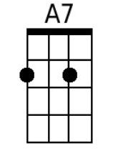 | 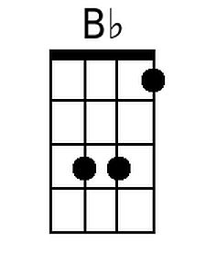 | 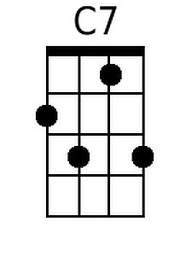 | 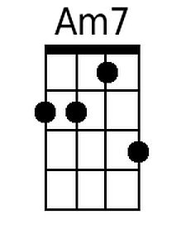
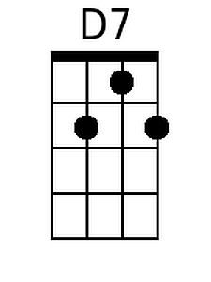 | 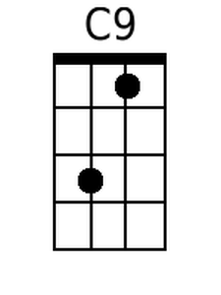 | 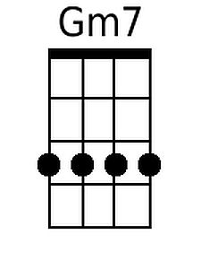 | 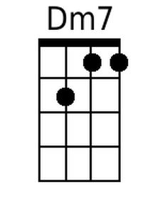 | 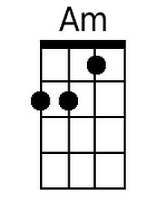

Greenfields (Dm) – Page 2
Bridge
Bb C9 Gm7 C7 F Dm7
I'll never know what made you run a-way
Gm7 C9 Gm7 C7 F A7
How can I keep searching when dark clouds hide the day
Dm Bb Gm
I only know there's nothing here for me
Dm Gm Gm7 A7
Nothing in this wide world, left for me to see.

Dm Gm Dm A7
3. But I'll keep on waiting 'til you re-turn
Dm Gm Dm A7
I'll keep on waiting un-til the day you learn
Bb C7 Am7 D7
You can't be happy while your heart's on the roam
Gm7 C7 Dm A7
You can't be happy un-til you bring it home
Dm Gm Dm A7 Dm Am Dm
Home to the green fields and me once a-gain.

Greenfields (Em)
(Terry Gilkyson, Rich Dehr, and Frank Miller)

Intro: Last line of the verse with all chords.  Em Am Em B7  1. Once there were green fields kissed by the sun  Em Am Em B7  Once there were valleys where rivers used to run  C D7 Bm7 E7  Once there were blue skies with white clouds high above  Am7 D7 Em B7  Once they were part of an everlasting love  Em Am Em B7 Em Bm Em B7  We were the lovers who strolled through green fields  Em Am Em B7  2. Green fields are gone now, parched by the sun  Em Am Em B7  Gone from the valleys where rivers used to run  C D7 Bm7 E7  Gone with the cold wind that swept into my heart  Am7 D7 Em B7  Gone with the lovers who let their dreams de-part  Em Am Em B7 Em Bm Em B7  Where are the green fields that we used to roam |  |  |  |  |  | 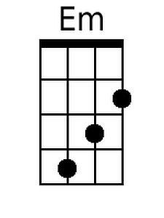
 |  |  |  |  |  | 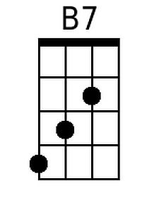 | 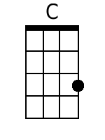
 |  |  |  |  |  |  | 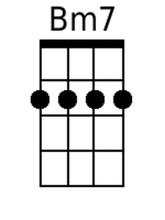
 |  |  |  |  |  | 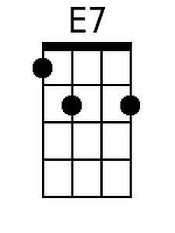 | 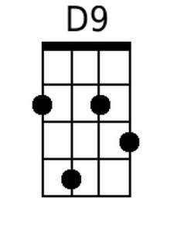
 |  |  |  |  |  |  | 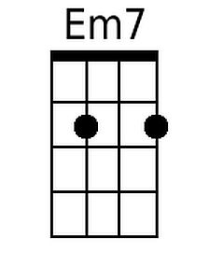
 |  |  |  |  |  | 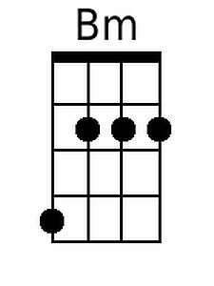
Baritone
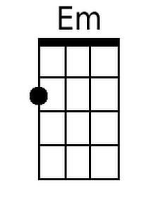 |  | 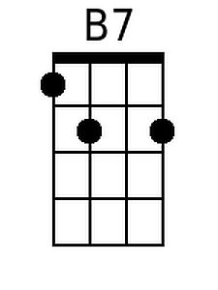 | 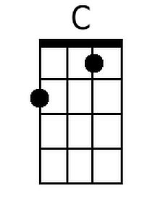 |  | 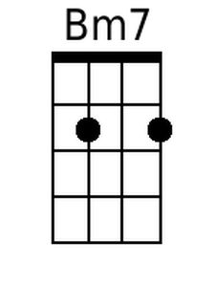
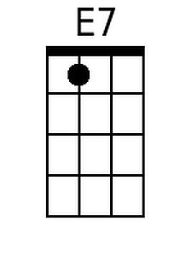 | 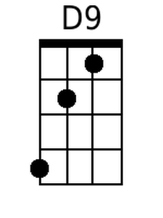 |  | 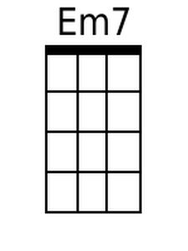 | 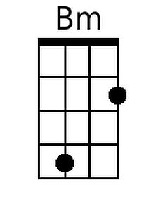

Greenfields (Em) – Page 2
Bridge
C D9 Am7 D7 G Em7
I'll never know what made you run a-way
Am7 D9 Am7 D7 G B7
How can I keep searching when dark clouds hide the day
Em C Am
I only know there's nothing here for me
Em Am Am7 B7
Nothing in this wide world, left for me to see.

Em Am Em B7
3. But I'll keep on waiting 'til you re-turn
Em Am Em B7
I'll keep on waiting un-til the day you learn
C D7 Bm7 E7
You can't be happy while your heart's on the roam
Am7 D7 Em B7
You can't be happy un-til you bring it home
Em Am Em B7 Em Bm Em
Home to the green fields and me once a-gain.

