Greenfields (Am)
(Terry Gilkyson, Rich Dehr, and Frank Miller)

Intro: Last line of the verse with all chords.  Am Dm Am E7  1. Once there were green fields kissed by the sun  Am Dm Am E7  Once there were valleys where rivers used to run  F G7 Em7 A7  Once there were blue skies with white clouds high above  Dm7 G7 Am E7  Once they were part of an everlasting love  Am Dm Am E7 Am Em Am E7  We were the lovers who strolled through green fields  Am Dm Am E7  2. Green fields are gone now, parched by the sun  Am Dm Am E7  Gone from the valleys where rivers used to run  F G7 Em7 A7  Gone with the cold wind that swept into my heart  Dm7 G7 Am E7  Gone with the lovers who let their dreams de-part  Am Dm Am E7 Am Em Am E7  Where are the green fields that we used to roam  Bridge  F G9 Dm7 G7 C Am7  I'll never know what made you run a-way  Dm7 G9 Dm7 G7 C E7  How can I keep searching when dark clouds hide the day  Am F Dm  I only know there's nothing here for me  Am Dm Dm7 E7  Nothing in this wide world, left for me to see. |  |  |  |  |  |  | 
 |  |  |  |  |  |  | 
 |  |  |  |  |  |  | 
 |  |  |  |  |  | 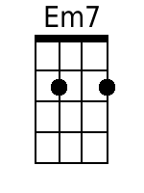 | 
 |  |  |  |  |  | 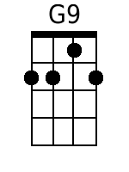 | 
 |  |  |  |  |  | 
Baritone
 |  |  |  |  | 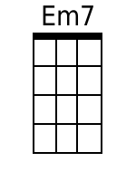
 | 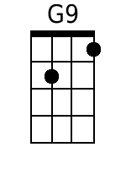 |  | 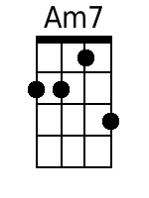 | 

Greenfields (Am) – Page 2

Am Dm Am E7
3. But I'll keep on waiting 'til you re-turn
Am Dm Am E7
I'll keep on waiting un-til the day you learn
F G7 Em7 A7
You can't be happy while your heart's on the roam
Dm7 G7 Am E7
You can't be happy un-til you bring it home
Am Dm Am E7 Am Em Am
Home to the green fields and me once a-gain.

