**Greensleeves (Traditional)**

**Intro: Chords for last line verse**

F

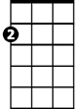

Am



G

**Am G**

Alas my love you do me wrong,

**F E7**

To cast me off dis-courteously;

**Am G**

And I have loved you oh so long,

**F E7 Am Dm Am**

Delighting in your com – pa - ny.

E7

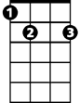

C

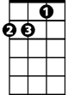

Dm

**Chorus:**

**C G**

Greensleeves was my delight,

**Am E7**

Greensleeves, my heart of gold

**C G**

Greensleeves was my heart of joy

**Am E7 Am Dm Am**

And who but my lady Gre – en - sleeves.

**Am G**

I have been ready at your hand,

**F E7**

To grant whatever thou would'st crave;

**BARITONE**

**Am G**



G



Am



F

I have waged both life and land,

**F E7 Am Dm Am**

Your love and goodwill for to have.

**(CHORUS)**

C

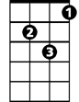

Dm

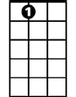

E7

**Am G**

Thy petticoat of slender white,

**F E7**

With gold embroidered gorgeously;

**Am G**

Thy petticoat of silk and white,

**F E7 Am Dm Am**

And these I bought gla – ad - ly.

**(CHORUS)**