H A double L – O – Double U –Double E-N spells Halloween
To the tune of Camille SainteSaens La Danse Macabre

Intro to “Danse Macabre:” C5 (hammer on C# note)
Cm, Bb, Ab, G chord progression

Cm Bb Ab G D7 G
H - A - Double L- O - Double U- Double E- N spells Halloween
Cm Bb Ab G D7 Cm
H - A - Double L -O - Double U- Double E- N Spells Halloween

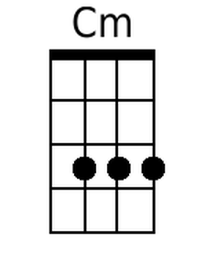 | 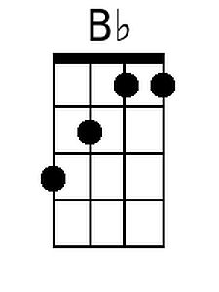 | 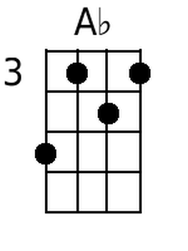 | 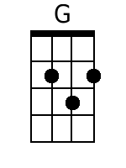 | 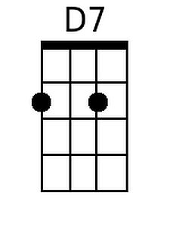
Baritone
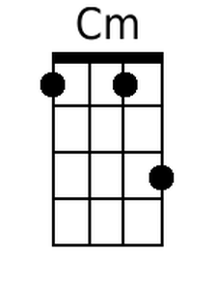 | 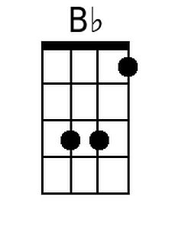 | 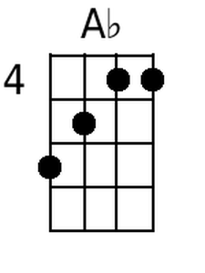 | 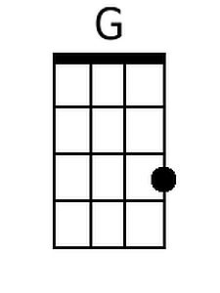 | 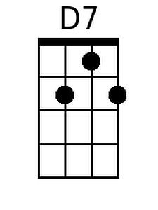

In Jenny’s version, Gm

Gm Gm7 Eb D A7 D
H - A - Double L- O - Double U- Double E- N spells Halloween
Gm Gm7 Eb D A7 Gm
H - A - Double L- O - Double U- Double E- N spells Halloween

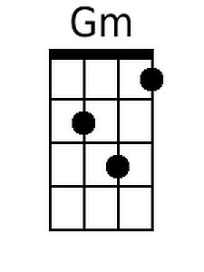 | 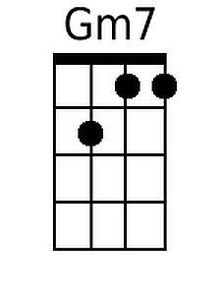 | 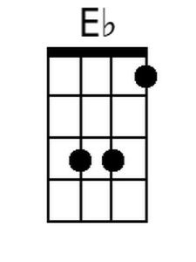 | 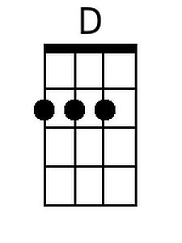 | 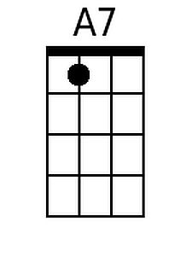
Baritone
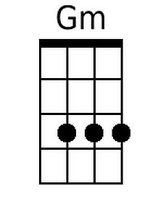 | 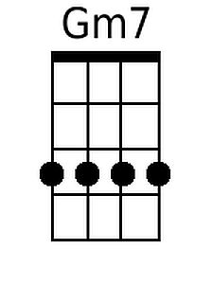 | 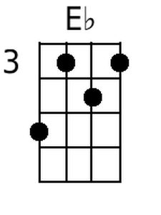 | 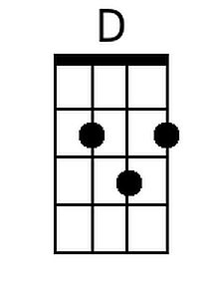 | 