Hallelujah (Leonard Cohen) (C) (12/8 Time)
Hallelujah by Leonard Cohen

Intro: C Am C Am  C Am  Well I've heard there was a secret chord,  C Am  That David played and it pleased the Lord,  F G C G  But you don't really care for music, do ya?  C F G  It goes like this, the 4th, the 5th,  Am F  the minor fall and the major lift,  G E7 Am  The baffled king com - posing halle - lujah,  Chorus  F Am  Halle - lujah, halle - lujah,  F C G C G  halle - lujah, halle lu--- --- jah.  C Am  Your faith was strong but you needed proof,  C Am  You saw her bathing on the roof,  F G C G  Her beauty and the moonlight over - threw ya,  C F G  She tied you to her kitchen chair,  Am F  She broke your throne and she cut your hair,  G E7 Am  And from your lips she drew the halle – lujah, Chorus |  |  | C Am  You say I took the name in vain  C Am  I don't even know the name  F G C G  But if I did, well really, what's it to you?  C F G  There's a blaze of light in every word  Am F  It doesn't matter which you heard  G E7 Am  The holy or the broken halle – lujah. Chorus  C Am  I did my best, it wasn't much,  C Am  I couldn't feel so I tried to touch,  F G C G  I've told the truth, I didn't come to fool ya.  C F G  And even though it all went wrong,  Am F  I'll stand before the Lord of Song,  G E7 Am  With nothing on my tongue but halle - lujah,  Chorus (2x)  Note: Some performers substitute Em for E7 in the last line of the verses.  The verses and their order follow the version recorded for the 1984 album, “Various Positions.” |  |  | 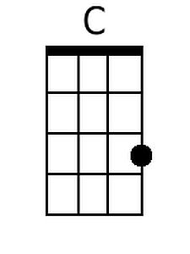
 |  |  |  |  |  | 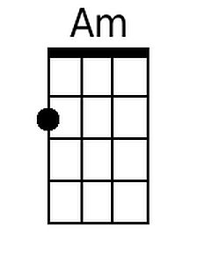
 |  |  |  |  |  | 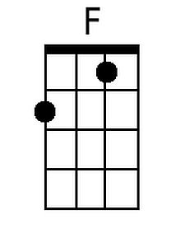
 |  |  |  |  |  | 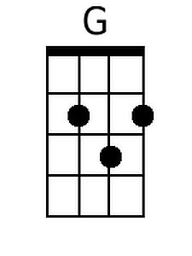
 |  |  |  |  |  | 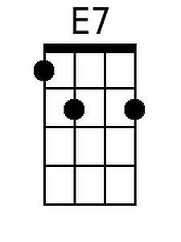
 |  |  |  |  |  | 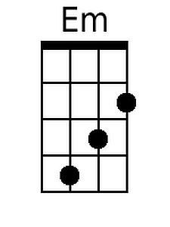
Bari
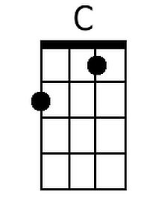 | 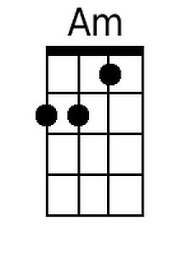 | 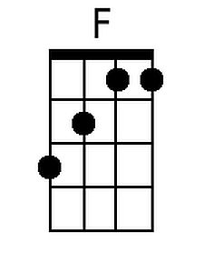 | 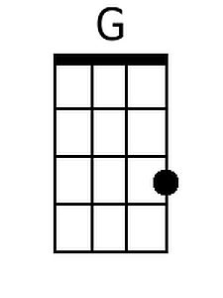 | 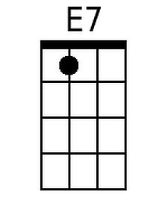 | 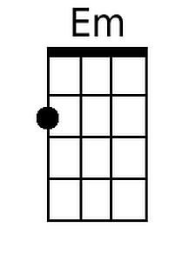

Hallelujah (Leonard Cohen) (G) (12/8 Time)
Hallelujah by Leonard Cohen

Intro: G Em G Em  G Em  Well I've heard there was a secret chord,  G Em  That David played and it pleased the Lord,  C D G D  But you don't really care for music, do ya?  G C D  It goes like this, the 4th, the 5th,  Em C  the minor fall and the major lift,  D B7 Em  The baffled king com - posing halle - lujah,  Chorus  C Em  Halle - lujah, halle - lujah,  C G D G D  halle - lujah, halle lu--- --- jah  G Em  Your faith was strong but you needed proof,  G Em  You saw her bathing on the roof,  C D G D  Her beauty and the moonlight over - threw ya,  G C D  She tied you to her kitchen chair,  Em C  She broke your throne and she cut your hair,  D B7 Em  And from your lips she drew the halle - lujah, Chorus |  |  | G Em  You say I took the name in vain  G Em  I don't even know the name  C D G G  But if I did, well really, what's it to ya?  G C D  There's a blaze of light in every word  Em C  It doesn't matter which you heard  D B7 Em  The holy or the broken halle – lujah. Chorus  G Em  I did my best, it wasn't much,  G Em  I couldn't feel so I tried to touch,  C D G D  I've told the truth, I didn't come to fool ya.  G C D  And even though it all went wrong,  Em C  I'll stand before the Lord of Song,  D B7 Em  With nothing on my tongue but halle - lujah, Chorus (2x)  Note: Some performers substitute Bm for B7 in the last line of the verses.  The verses and their order follow the version recorded for the 1984 album, “Various Positions.”
 |  |  |  |  |  | 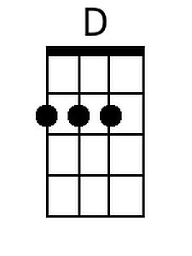
 |  |  |  |  |  | 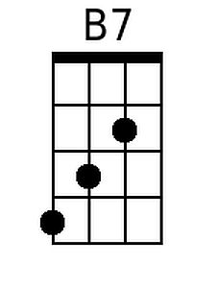
 |  |  |  |  |  | 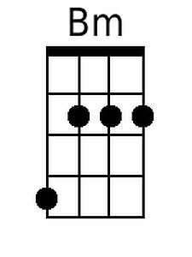
Bari
 |  |  | 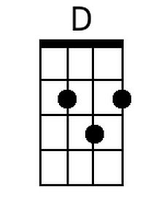 | 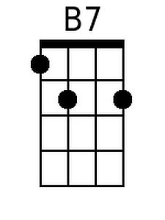 | 