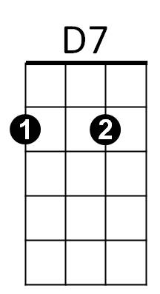**Hanalei Moon (Bob Nelson) Key C**



C

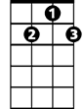

G7

**VAMP: D7 G7 C**

**C A7 D7**

When you see Hana lei by moonlight

**G7 C G7**

You will be in Heaven by the sea

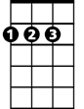

D

F

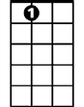

A7

**C A7 D7**

Every breeze, every wave will whisper

**G7 C G7**

You are mine don't ever go a-way

**C A7 D7**

Hanalei, Hanalei moon



G

E7

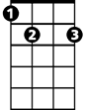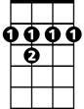

B7

**G7 F C G7**

Is lighting beloved Kauaʻi

**C A7 D7**

Hanalei, Hanalei moon

**G7 C A7**

Aloha nō wau iā ʻoe

**D B7 E7**

**BARITONE**

When you see Hanalei by moonlight

C



D7

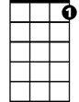

G7

**A7 D A7**

You will be in Heaven by the sea

**D B7 E7**

Every breeze, every wave will whisper

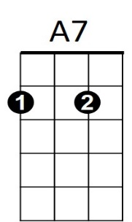 **A7 D A7**



D



F

You are mine don't ever go a-way

**D B7 E7**

Hanalei, Hanalei moon

**A7 G D A7**

Is lighting beloved Kauaʻi

B7



G



E7

**D B7 E7**

Hanalei, Hanalei moon

**A7 D**

Aloha nō wau iā ʻoe

**A7 D VAMP: E7 A7 D**

Aloha nō wau iā ʻoe

**Hanalei Moon (Bob Nelson) Key F**

F



C7



G7

**VAMP: G7 C7 F**

**F D7 G7**

When you see Hana lei by moonlight

**C7 F C7**

You will be in Heaven by the sea



Bb

**F D7 G7**



C

Every breeze, every wave will whisper

**C7 F C7**

You are mine don't ever go a-way

**F D7 G7**

Hanalei, Hanalei moon



A7

E7



G

**C7 Bb F C7**

Is lighting beloved Kauaʻi

**F D7 G7**

Hanalei, Hanalei moon

**C7 F D7**

Aloha nō wau iā ʻoe

**G E7 A7**

**BARITONE**

When you see Hanalei by moonlight

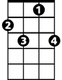

C7



G7



F

**D7 G D7**

You will be in Heaven by the sea

**G E7 A7**

Every breeze, every wave will whisper

**D7 G D7**

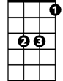

Bb

C



D7

You are mine don't ever go a-way

**G E7 A7**

Hanalei, Hanalei moon

**D7 C G D7**

Is lighting beloved Kauaʻi



G



E7

**G E7 A7**

Hanalei, Hanalei moon

**D7 G**

Aloha nō wau iā ʻoe

**D7 G VAMP: A7 D7 G**

Aloha nō wau iā ʻoe

**Hanalei Moon (Bob Nelson) Key G**

**VAMP: A7 D7 G**



D



G



A7

E7



C



B7

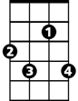

F#7

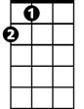

A

**G E7 A7**

When you see Hana lei by moonlight

**D7 G D7**

You will be in Heaven by the sea

**G E7 A7**

Every breeze, every wave will whisper

**D7 G D7**

You are mine don't ever go a-way

**G E7 A7**

Hanalei, Hanalei moon

**D7 C G D7**

Is lighting beloved Kauaʻi

**G E7 A7**

Hanalei, Hanalei moon

**D7 G E7**

Aloha nō wau iā ʻoe

**A F#7 B7**

**BARITONE**

When you see Hanalei by moonlight



G



D7

**E7 A E7**

You will be in Heaven by the sea

**A F#7 B7**

Every breeze, every wave will whisper

**E7 A E7**



A



E7

You are mine don't ever go a-way

C



**A F#7 B7**

Hanalei, Hanalei moon

**E7 D A E7**

Is lighting beloved Kauaʻi



D



F#7

B7



**A F#7 B7**

Hanalei, Hanalei moon

**E7 A**

Aloha nō wau iā ʻoe

**E7 A VAMP: B7 E7 A**

Aloha nō wau iā ʻoe