Happy Days Theme Song (Charles Fox & Norman Gimbel, 1974)
Happy Days Theme Song – Version 1 – Key of C

C Am  Sunday, Monday, Happy Days,  Dm G  Tuesday, Wednesday, Happy Days,  E7 Am  Thursday, Friday, Happy Days,  F G F G  The weekend comes, the cycle hums,  F G F  Ready to race to you.  C Am  __ These days are ours . . .  F G  __ Happy and free. (Oh Happy Days)  C Am  __ These days are ours . . .  F G  __ Share them with me. (Oh Baby)  C C7  Goodbye grey sky, hello blue,  F  'Cause nothing can hold me  E - Eb - D (Walkdown is optional)  When I hold you.  D D7  Feels so right it can't be wrong,  G G7  Rockin' and rollin' all week long. |  |  |  |  | Optional Instrumental (8 Measures)  C | Am | Dm | G | (2x)  C Am  Sunday, Monday, Happy Days,  Dm G  Tuesday, Wednesday, Happy Days,  E7 Am  Thursday, Friday, Happy Days,  F G F G  Satur-day, what a day,  F G  Groovin' all week with you.  C Am  __ These days are ours . . .  F G  __ Share them with me. (Oh Happy Days)  C Am  __ These days are ours . . .  F G  __ Happy and free. (Oh Baby)  C Am F  __ These Happy Days are yours and mine . . .  G  __ These Happy Days are yours and . . .  F G7 ↓ ↓ C  My Happy Days.
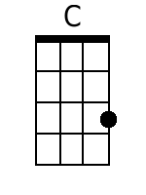 | 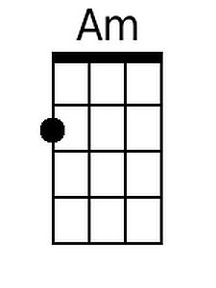 | 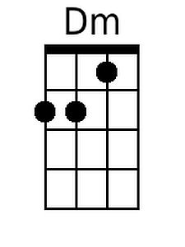 | 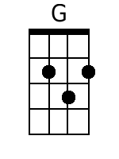 | 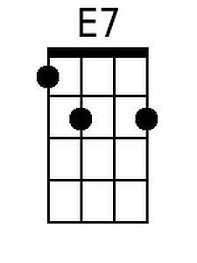 |  | 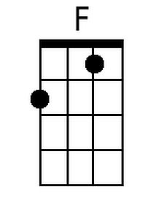 | 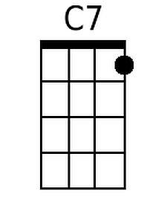
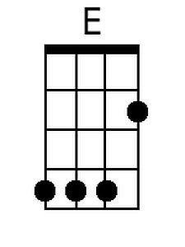 | 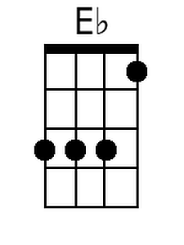 | 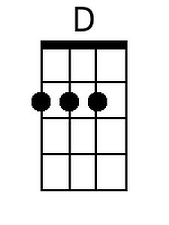 | 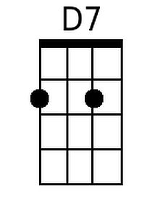 | 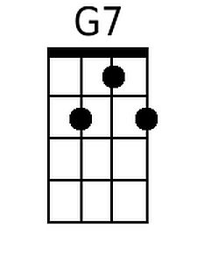
Baritone
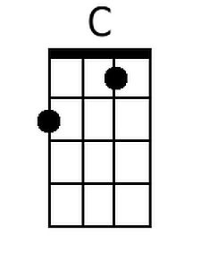 | 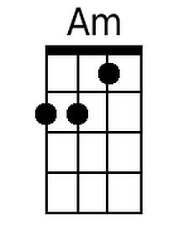 | 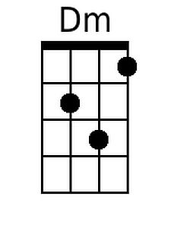 | 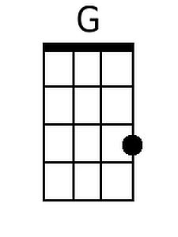 | 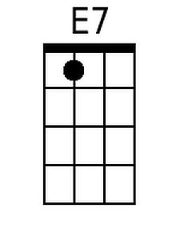 |  | 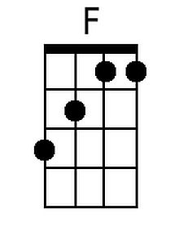 | 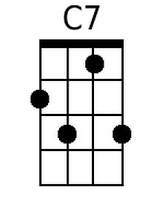
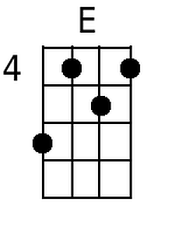 | 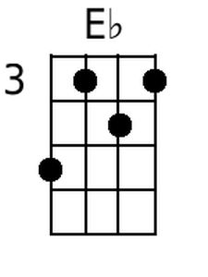 | 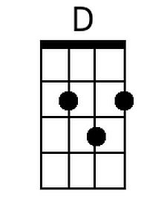 | 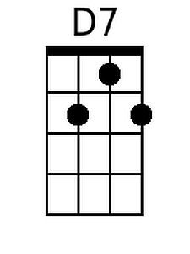 | 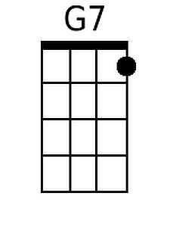

Happy Days Theme Song (Charles Fox & Norman Gimbel, 1974)
Happy Days Theme Song – Version 1 – Key of G

G Em  Sunday, Monday, Happy Days,  Am D  Tuesday, Wednesday, Happy Days,  B7 Em  Thursday, Friday, Happy Days,  C D C D  The weekend comes, the cycle hums,  C D C  Ready to race to you.  G Em  __ These days are ours . . .  C D  __ Happy and free. (Oh Happy Days)  G Em  __ These days are ours . . .  C D  __ Share them with me. (Oh Baby)  G G7  Goodbye grey sky, hello blue,  C  'Cause nothing can hold me  B - Bb - A (Walkdown is optional)  When I hold you.  A A7  Feels so right it canC't be wrong,  D D7  Rockin' and rollin' all week long. |  |  |  |  | Optional Instrumental (8 Measures)  G | Em | Am | D | (2x)  G Em  Sunday, Monday, Happy Days,  Am D  Tuesday, Wednesday, Happy Days,  B7 Em  Thursday, Friday, Happy Days,  C D C D  Satur-day, what a day,  C D  Groovin' all week with you.  G Em  __ These days are ours . . .  C D  __ Share them with me. (Oh Happy Days)  G Em  __ These days are ours . . .  C D  __ Happy and free. (Oh Baby)  G Em C  __ These Happy Days are yours and mine . . .  D  __ These Happy Days are yours and  C D7 ↓ ↓ G  My Happy Days.
 | 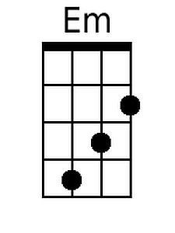 |  |  | 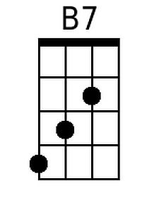
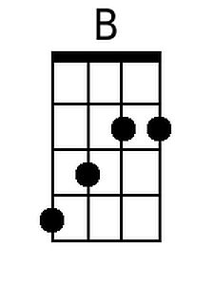 | 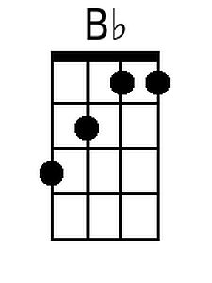 | 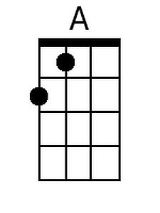 | 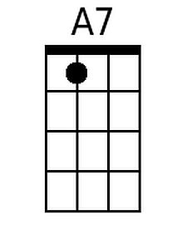
Baritone
 | 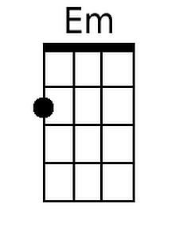 |  |  | 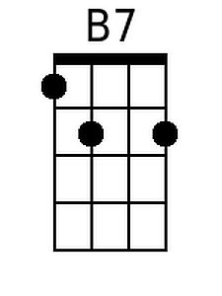
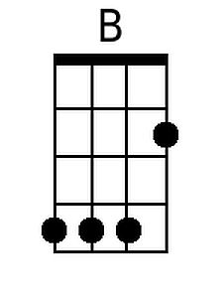 | 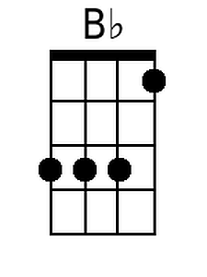 | 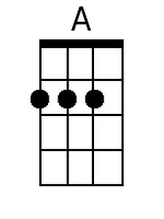 | 