Happy Days (Norman Gimbel & Charles Fox, 1974)
Happy Days by Pratt & McClain (1976 Recording) – Key of C

Intro  C Am  Sunday, Monday, happy days.  Dm G  Tuesday, Wednesday, happy days.  E Am  Thursday, Friday, happy days.  F G F G  Satur-day, what a day,  F F# G  Rockin' all week with you.  Chorus  C Am F  These days are ours . . .  F G  Won't you be mine?  (oh, happy days)  C Am F  These days are ours . . .  F G  Oh, please be mine.  (oh, happy days)  Outro (Repeat 4x)  C Am F  These happy days are yours and mine . . .  F G  Won't you be mine? (oh, happy days) |  |  |  |  | C  1. Hello sunshine, goodbye rain.  F  She's wearing my school ring on her chain.  D  She's my steady, I'm her man.  G  I'm gonna love her all I can. Chorus  C  2. Gonna cruise her around the town,  F  Show everybody what I found.  D  Rock and roll with all my friends,  G  Hopin' the music never ends. Chorus  Instrumental of Chorus  Repeat Intro & Chorus  C  3. Goodbye gray sky, hello blue,  F  'Cause nothing can hold me when I hold you.  D  Feels so right, can't be wrong,  G  A-rockin' and rollin' all week long. Chorus  Repeat Verse 1
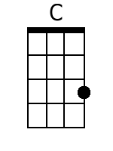 | 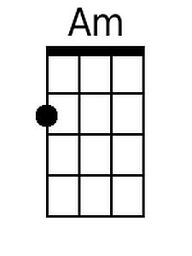 | 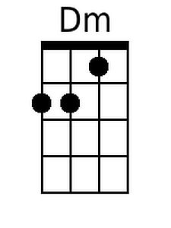 | 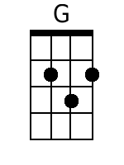 | 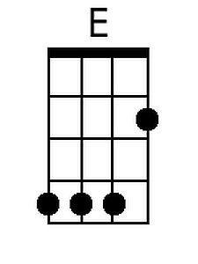 |  | 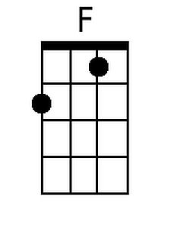 | 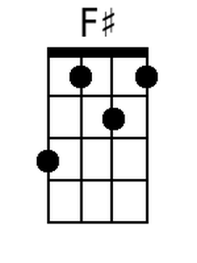 | 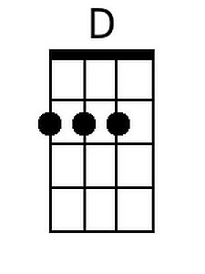
Baritone
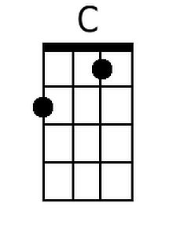 | 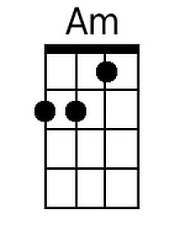 | 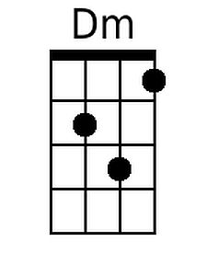 | 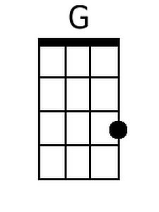 | 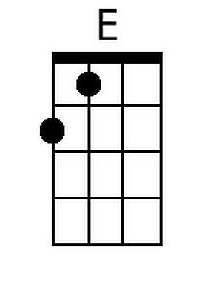 |  | 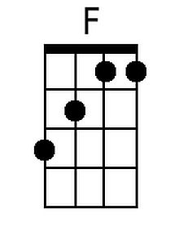 | 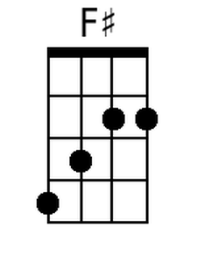 | 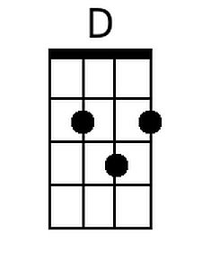

Happy Days (Norman Gimbel & Charles Fox, 1974)
Happy Days by Pratt & McClain (1976 Recording) – Key of G

Intro  G Em  Sunday, Monday, happy days.  Am D  Tuesday, Wednesday, happy days.  B Em  Thursday, Friday, happy days.  C D C D  Satur-day, what a day,  C C# D  Rockin' all week with you.  Chorus  G Em C  These days are ours . . .  C D  Won't you be mine?  (oh, happy days)  G Em C  These days are ours . . .  C D  Oh, please be mine.  (oh, happy days)  Outro (Repeat 4x)  G Em C  These happy days are yours and mine . . .  C D  Won't you be mine? (oh, happy days) |  |  |  |  | G  1. Hello sunshine, goodbye rain.  C  She's wearing my school ring on her chain.  A  She's my steady, I'm her man.  D  I'm gonna love her all I can. Chorus  G  2. Gonna cruise her around the town,  C  Show everybody what I found.  A  Rock and roll with all my friends,  D  Hopin' the music never ends. Chorus  Instrumental of Chorus  Repeat Intro & Chorus  G  3. Goodbye gray sky, hello blue,  C  'Cause nothing can hold me when I hold you.  A  Feels so right, can't be wrong,  D  A-rockin' and rollin' all week long. Chorus  Repeat Verse 1
 | 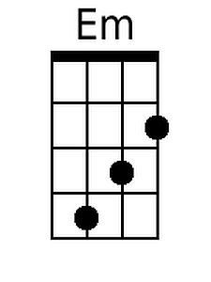 |  |  | 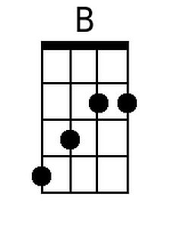 |  |  | 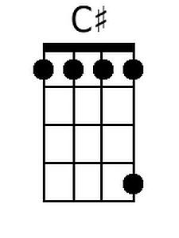 | 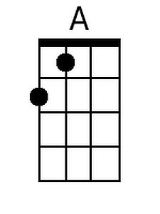
Baritone
 | 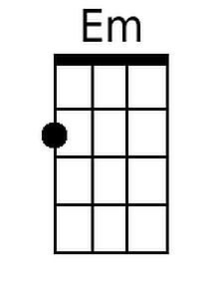 |  |  | 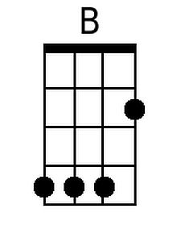 |  |  | 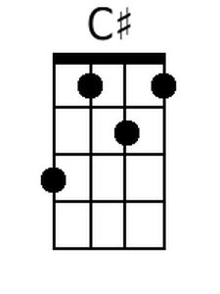 | 