Happy Days Are Here Again (Milton Ager & Jack Yellen, 1929) (C)
From the 1930 musical “Chasing Rainbows”

Intro: G7 C↓ C↓ F↓ F↓ C↓ (G7 transition)  (happy days are here a - gain)  Chorus:  C  Happy days are here again  G7 C  The skies above are clear again  G G7  Let us sing a song of cheer again  C F C G7↓  Happy days are here a-gain.  C  Altogether shout it now  G7 C  There's no one who can doubt it now  G G7  So let's tell the world a-bout it now  C F C↓↓  Happy days are here again  E B7 E  Your cares and troubles are gone  Dm7↓ G D7 G7  There'll be no more from now on from now on  Repeat from Top  Outro:  C F C↓ G7↑↓ C↓  Happy days are here a-gain! |  |  |  |  |  |  |  | 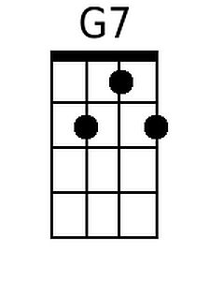
 |  |  |  |  |  |  |  | 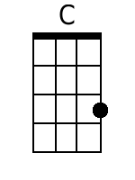
 |  |  |  |  |  |  |  | 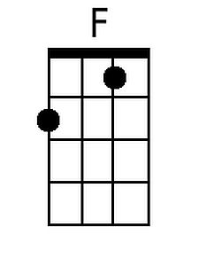
 |  |  |  |  |  |  |  | 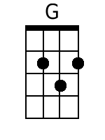
 |  |  |  |  |  |  |  | 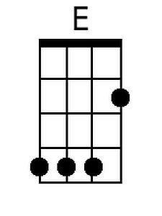
 |  |  |  |  |  |  |  | 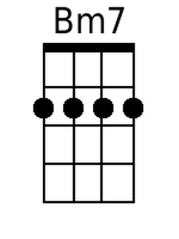
 |  |  |  |  |  |  |  | 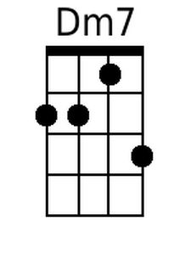
 |  |  |  |  |  |  |  | 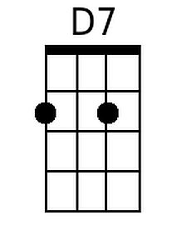
Baritone
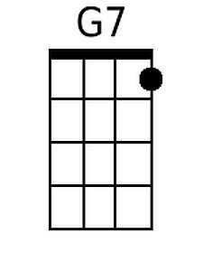 | 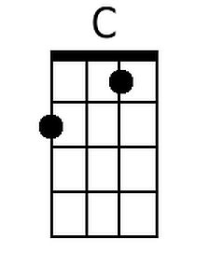 | 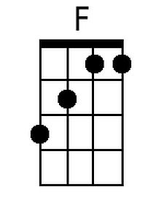 | 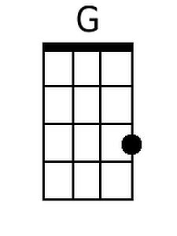 | 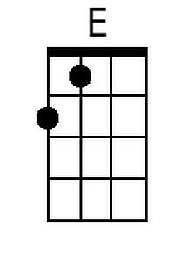 | 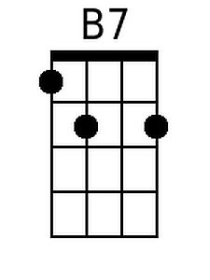 | 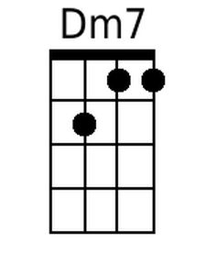 | 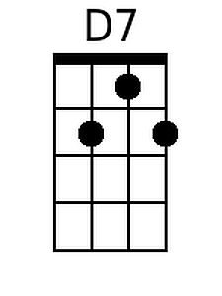

Happy Days Are Here Again (Milton Ager & Jack Yellen, 1929) (G)
From the 1930 musical “Chasing Rainbows”

Intro: D7 G↓ G↓ C↓ C↓ G↓ (D7 transition)
(happy days are here a - gain)

Chorus:
G
Happy days are here again
D7 G
The skies above are clear again
D D7
Let us sing a song of cheer again
G C G D7↓
Happy days are here a-gain.

G
Altogether shout it now
D7 G
There's no one who can doubt it now
D D7
So let's tell the world a-bout it now
G C G↓↓
Happy days are here again

B F#7 B
Your cares and troubles are gone
Am7↓ D A7 D7
There'll be no more from now on from now on

Repeat from Top

Outro:
G C G↓ D7↑↓ G↓
Happy days are here a-gain!

 |  |  |  |  |  |  |  | 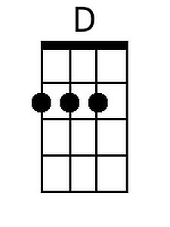
 |  |  |  |  |  |  |  | 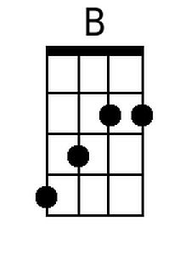
 |  |  |  |  |  |  |  | 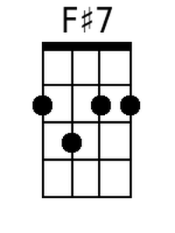
 |  |  |  |  |  |  |  | 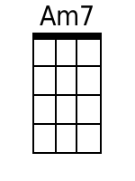
 |  |  |  |  |  |  |  | 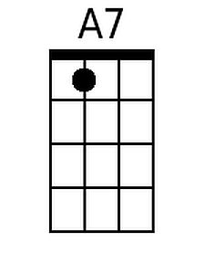
Baritone
 |  |  | 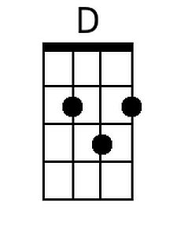 | 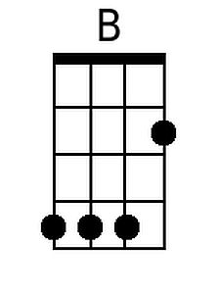 |  | 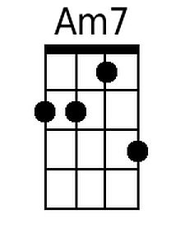 | 