Happy Days Theme Song (Charles Fox & Norman Gimbel, 1974)
Happy Days Theme Song – Key of C

Intro: C / / D / C / / D / C / / / / / D /
du d du d dudud d

C Am  Sunday, Monday, Happy Days,  Dm G  Tuesday, Wednesday, Happy Days,  E7 Am  Thursday, Friday, Happy Days,  F G F G  The weekend comes, the cycle hums,  F G  Ready to race to you.  C Am F  These days are ours . . .  F G C  Happy and free.  (Oh Happy Days)  C Am F  These days are ours . . .  F G C  Share them with me.  (Oh Happy Days)  C C7  Goodbye grey sky, hello blue,  F  'Cause nothing can hold me  F E D  When I hold you.  D D7  Feels so right it can't be wrong,  G G7  Rockin' and rollin' all week long. |  |  |  |  | C Am  Sunday, Monday, Happy Days,  Dm G7  Tuesday, Wednesday, Happy Days,  E7 Am  Thursday, Friday, Happy Days,  F G F G  Saturday, what a day,  F G  Groovin’ all week with you.  C Am F  These days are ours . . .  F G  Share them with me. (Oh Happy Days)  C Am F  These days are ours . . .  F G  Happy and free. (Oh Happy Days)  C Am F G C  These Happy Days are yours and mine . . .  C Am F G  These Happy Days are yours and my . . .  G7 / / C /  Happy Days.
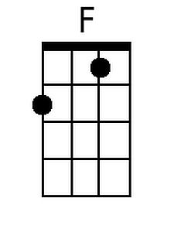 | 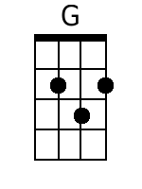 | 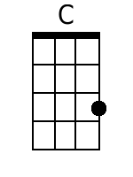 | 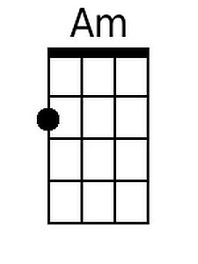 | 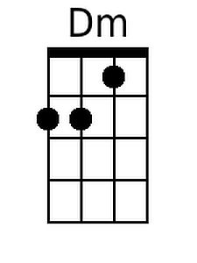 |  | 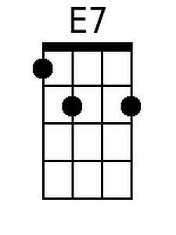 | 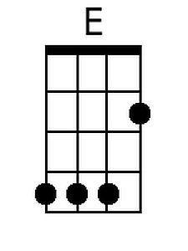 | 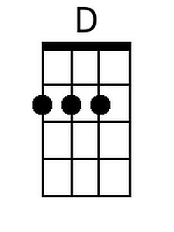 | 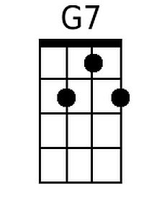
Baritone
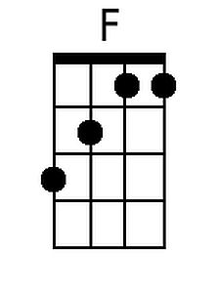 | 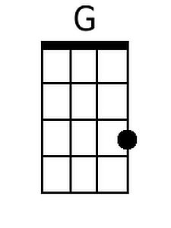 | 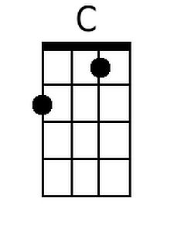 | 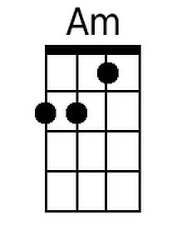 | 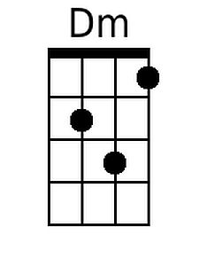 |  | 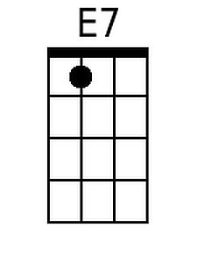 | 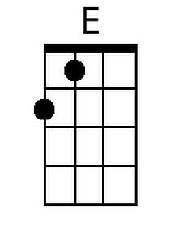 | 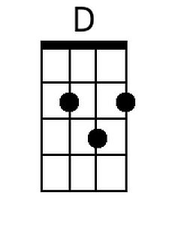 | 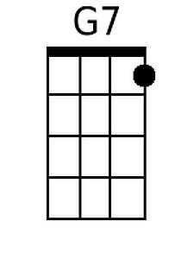

Happy Days Theme Song (Charles Fox & Norman Gimbel, 1974)
Happy Days Theme Song – Key of G

Intro: F / / G / F / / G / F / / / / / G /
du d du d dudud d

G Em  Sunday, Monday, Happy Days,  Am D  Tuesday, Wednesday, Happy Days,  B7 Em  Thursday, Friday, Happy Days,  C D C D  The weekend comes, the cycle hums,  C D  Ready to race to you  G Em C  These days are ours . . .  C D  Happy and free.  (Oh Happy Days)  G Em C  These days are ours . . .  C D  Share them with me.  (Oh Happy Days)  G G7  Goodbye grey sky, hello blue,  C  'Cause nothing can hold me  C – B – A  When I hold you.  A A7  Feels so right it can't be wrong,  D D7  Rockin' and rollin' all week long. |  |  |  |  | G Em  Sunday, Monday, Happy Days,  Am D  Tuesday, Wednesday, Happy Days,  B7 Em  Thursday, Friday, Happy Days,  C D C D  Saturday, what a day,  C D  Groovin’ all week with you  G Em C  These Happy Days . . .  D G  Are yours and mine (Oh Happy Days)  G Em C  These Happy Days . . .  D G  Are yours and mine (Oh Happy Days)  G Em C  These Happy Days are yours and my . . .  D7 / / G/  Happy Days.
 |  |  | 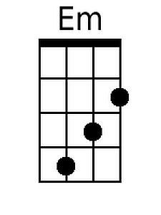 |  |  | 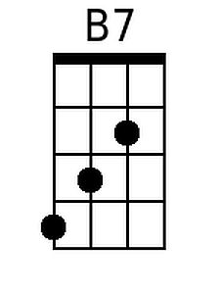 | 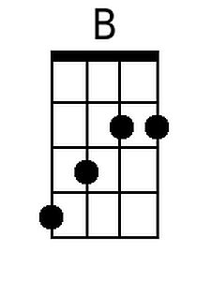 | 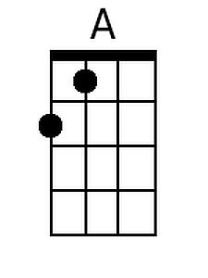 | 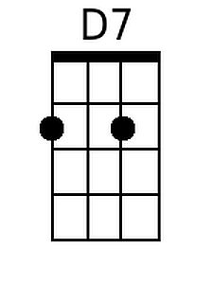
Baritone
 |  |  | 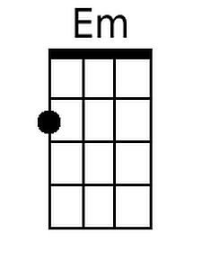 |  |  | 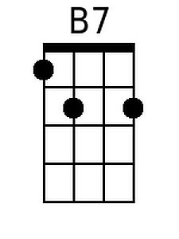 | 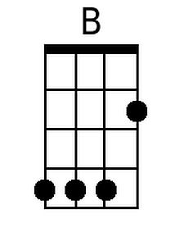 | 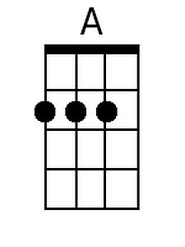 | 