
Happy Holiday – It’s The Holiday Season
C69 C
(Irving Berlin, 1942; Kay Thompson, 1945) Happy Holiday-It’s The Holiday Season, A. Williams

Intro (2x) | C Dm | G C |  C Dm  Happy Holiday - Happy holiday,  G C  While the merry bells keep ringing  Dm G C  May your every wish come true  C Dm  Happy Holiday - Happy holiday,  G C  May the calendar keep bringing  Dm G C  Happy holi-days to you  C  It's the holiday season  Dm G Dm G  And Santa Claus is coming round  Dm G Em A7  The Christmas snow is white on the ground  Dm G Em A7  When old Santa gets into town  Dm G C  He'll be coming down the chimney, down  Dm G C  He'll be coming down the chimney, down  C  It's the holiday season  Dm G Dm G  And Santa Claus has got a toy  Dm G Em A7  For every good girl and good little boy  Dm G Em A7  He's a great big bundle of joy  Dm G C  When he’s coming down the chimney, down  Dm G C  When he’s coming down the chimney, down  Bridge  F C F C  He'll have a big fat pack upon his back  F C F C  And lots of goodies for you and me  F C F C  So leave a peppermint stick for old St. Nick  D7 G  Hanging on the Christmas tree | C  It's the holiday season  Dm G Dm G  With the whoop-de-do and hickory dock  Dm G Em A7  And don't forget to hang up your sock  Dm G Em A7  'Cause just exactly at twelve o'clock  Dm G C  He'll be coming down the chimney, down  Dm G C  He'll be coming down the chimney, down  Repeat Bridge  C  It's the holiday season  Dm G Dm G  With the whoop-de-do and dickory dock  Dm G Em A7  And don't forget to hang up your sock  Dm G Em A7  'Cause just exactly at twelve o'clock  Dm G  He'll be coming down the chimney,  Dm G  Coming down the chimney,  Dm G C G  Coming down the chimney, down!  C Dm  Happy Holiday - Happy Holiday  G C  While the merry bells keep ringing.  Dm G C  Happy Holida-ay to you.
 | 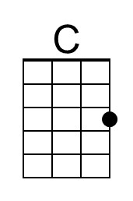 | 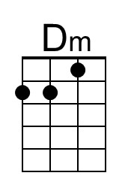 | 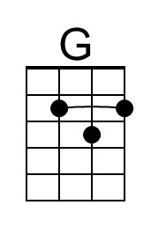 | 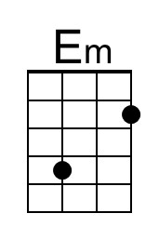 | 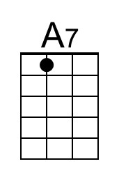
 | Baritone
 | 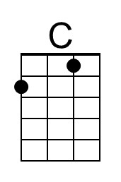 | 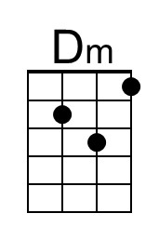 | 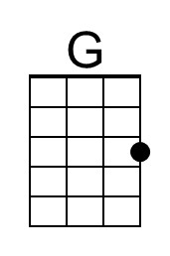 | 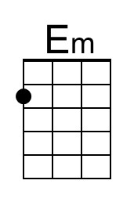 | 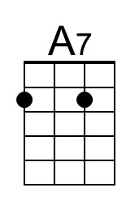

Happy Holiday – It’s The Holiday Season
C69 G
(Irving Berlin, 1942; Kay Thompson, 1945) Happy Holiday-It’s The Holiday Season, A. Williams

Intro (2x) | G Am | D G |  G Am  Happy Holiday - Happy holiday,  D G  While the merry bells keep ringing  Am D G  May your every wish come true  G Am  Happy Holiday - Happy holiday,  D G  May the calendar keep bringing  Am D G  Happy holi-days to you  G  It's the holiday season  Am D Am D  And Santa Claus is coming round  Am D Bm E7  The Christmas snow is white on the ground  Am D Bm E7  When old Santa gets into town  Am D G  He'll be coming down the chimney, down  Am D G  He'll be coming down the chimney, down  G  It's the holiday season  Am D Am D  And Santa Claus has got a toy  Am D Bm E7  For every good girl and good little boy  Am D Bm E7  He's a great big bundle of joy  Am D G  When he’s coming down the chimney, down  Am D G  When he’s coming down the chimney, down  Bridge  C G C G  He'll have a big fat pack upon his back  C G C G  And lots of goodies for you and me  C G C G  So leave a peppermint stick for old St. Nick  A7 D  Hanging on the Christmas tree | G  It's the holiday season  Am D Am D  With the whoop-de-do and hickory dock  Am D Bm E7  And don't forget to hang up your sock  Am D Bm E7  'Cause just exactly at twelve o'clock  Am D G  He'll be coming down the chimney, down  Am D G  He'll be coming down the chimney, down  Repeat Bridge  G  It's the holiday season  Am D Am D  With the whoop-de-do and dickory dock  Am D Bm E7  And don't forget to hang up your sock  Am D Bm E7  'Cause just exactly at twelve o'clock  Am D  He'll be coming down the chimney,  Am D  Coming down the chimney,  Am D G D  Coming down the chimney, down!  G Am  Happy Holiday - Happy Holiday  D G  While the merry bells keep ringing.  Am D G  Happy Holida-ay to you.
 |  | 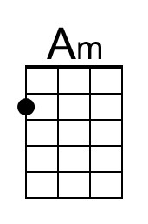 | 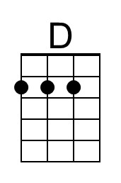 | 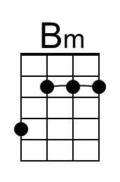 | 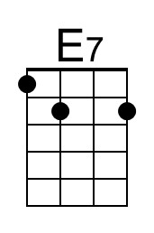
 | Baritone
 |  | 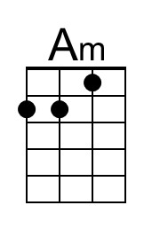 | 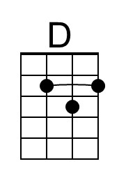 | 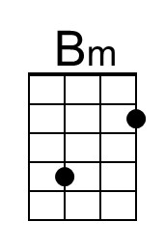 | 