**Happy Holidays (Irving Berlin)**

**C Dm**



C

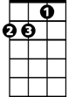

Dm

Happy Holiday - Happy holiday,

**G C**

While the merry bells keep ringing

**Dm G C**

May your every wish come true

Em

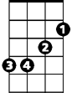

G

**C Dm**

Happy Holiday - Happy holiday,

**G C**

May the calendar keep bringing

**Dm G C**

Happy holi-days to you

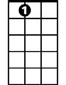

A7

**C**

It's the holiday season

**Dm G Dm G**

And Santa Claus is coming round

**Dm G Em A7**

The Christmas snow is white on the ground

**Dm G Em A7**

F



When old Santa gets into town

**Dm G C**

He'll be coming down the chimney, down

**Dm G C**

He'll be coming down the chimney, down

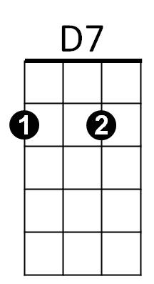 **C**

It's the holiday season

**Dm G Dm G**

And Santa Claus has got a toy

**Dm G Em A7**

For every good girl and good little boy

**Dm G Em A7**

He's a great big bundle of joy

**Dm G C**

When he’s coming down the chimney, down

**BARITONE**

**Dm G C**

C



When he’s coming down the chimney, down

**Bridge:**

**F C F C**

He'll have a big fat pack upon his back

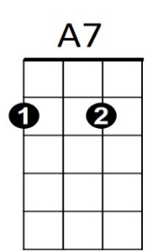**F C F C**



F

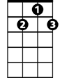

D7

And lots of goodies for you and me

**F C F C**

So leave a peppermint stick for old St. Nick

**D7 G**

Hanging on the Christmas tree

**C**

It's the holiday season

**Dm G Dm G**

With the whoop-de-do and hickory dock

**Dm G Em A7**

And don't forget to hang up your sock

**Dm G Em A7**

'Cause just exactly at twelve o'clock

**Dm G C**

He'll be coming down the chimney, down

**Dm G C**

He'll be coming down the chimney, down

**(Bridge)**

**C**

It's the holiday season

**Dm G Dm G**

With the whoop-de-do and dickory dock

**Dm G Em A7**

And don't forget to hang up your sock

**Dm G Em A7**

'Cause just exactly at twelve o'clock

**Dm G**

He'll be coming down the chimney,

**Dm G**

Coming down the chimney,

**Dm G C G**

Coming down the chimney, down!

**C Dm**

Happy Holiday - Happy Holiday

**G C**

While the merry bells keep ringing

**Dm G C**

Happy Holida-ay to you!

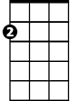

Em

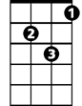

Dm



G