**Happy Trails to You (Dale Evans, 1951)**



C

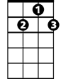

G7

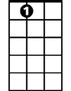

A7

**C A7 G7**

Happy trails to you until we meet again

**G7 Eb C**

Happy trails to you, keep smiling until then

**C7 F**

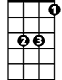

Eb

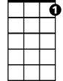

C7

F



who cares about the clouds when we're together

**A7 D G7**

Just sing a song and bring the sunny weather

**C A7 Dm G7 C**

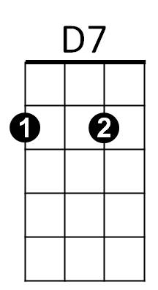Happy tra ils to you till we meet a gain

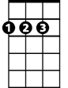

D

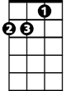

Dm

**F D7**

Some trails are happy ones,

**G**

Others are blue.

**C C7**

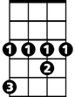

Ab

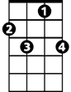

F7

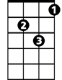

Gm



Bb

It's the way you ri de the trail that counts,

**F**

Here's a happy one for you.

**F D7 C7**

**BARITONE**

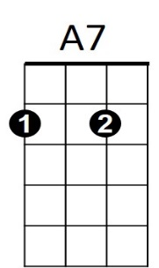Happy trails to you until we m eet again



G7

C

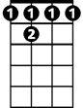

F 7

**C7 Ab F**

Happy trails to you, keep smiling until then

**F7 Bb**

who cares about the clouds when we're together

**D7 G C7**



Eb



F



C7

Just sing a song and bring the sunny weather

**F D7 Gm C7 F**

Happy trails to you till we meet a gain

**F D7 Gm C7 F**

Happy trails to you till we meet a gain



Bb



F 7



D



Dm



D7

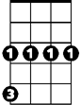

Gm

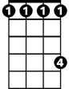

Ab