**Hark the Herald Angels Sing**



C

C 30

**Intro: Last line of verse**

**C G**

Hark the herald angels sing

**C F C G C**

"Glory to the new born King

**D7**

F



Peace on earth and mercy mild

**G D7 G**

God and sinners recon-ciled"

**C G7 C**

Joyful all ye nations rise_

**C G7 C**



G

Join the triumph of the skies

**F A7 Dm A7 Dm**

With an-gelic host pro-claim

**G7 C G C**

"Christ is born in Beth-le-hem"

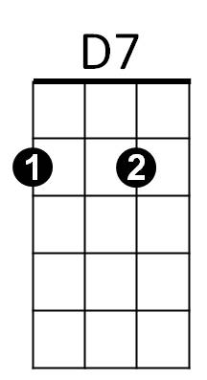**F A7 Dm A7 Dm**

Hark the herald an - gels sing

**G7 C G7 C**

"Glory to the new born King"

**C G**

Christ, by highest heaven adored;

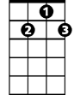

G7

**C F C G C**

Christ the everlasting Lord;

**D7**

Late in time behold him come,

**G D7 G**

Offspring of the favored one.

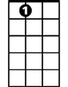

A7

**C G7 C**

Veiled in flesh, the Godhead see;

**C G7 C**

Hail the incarnate Die-ty

**F A7 Dm A7 Dm**

Pleased as man with men to dwell,

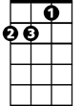

Dm

**G7 C G C**

Jesus, our Emman-u-el

**F A7 Dm A7 Dm**

Hark the herald an - gels sing

**G7 C G7 C**

"Glory to the new born King"

**C G**

Hail! the heaven-born Prince of Peace.

**C F C G C**

Hail the son of Righteousness

**D7**

Light and life to all He brings,

**G D7 G**

Risen with healing in His wings

**C G7 C**

Mild He lays His glory by,

**C G7 C**

Born that man no more may die

**F A7 Dm A7 Dm**

Born to raise the sons of earth,

**G7 C G C**

Born to give them second birth

**F A7 Dm A7 Dm**

Hark the herald an - gels sing

**G7 C G7 C**

"Glory to the new born King"

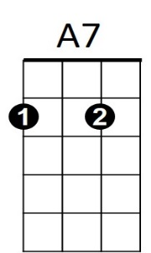



F

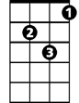

Dm



D7

C

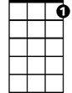

G7



G

**BARITONE**