**Harvest Moon (Neil Young) Key C**

**Intro: G Em Gmaj7 Em 4x**

**C G G Em Gmaj7 Em (2x)**

Come a little bit closer - Hear what I have to say

**C G G Em Gmaj7 Em (2x)**

Just like children sleepin - We could dream this night away.

**C G G Em Gmaj7 Em (2x)**

But there’s a full moon risin – Let’s go dancin in the light

**C G**

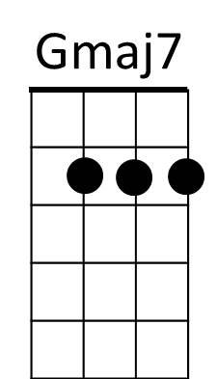We know where the music’s playin - Let s go out and feel the night.



G

Em

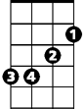

**G Em Gmaj7 Em (2x)**

**Chorus:**

**C D**

Because I’m still in love with you

**Am**



C

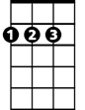

D

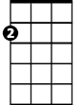

Am

I want to see you dance again

**C D**

Because I’m still in love with you

**G G Em Gmaj7 Em (2x)**

On this harvest moon.

**C G G Em Gmaj7 Em (2x)**

When we were strangers - I watched you from afar

**C G G Em Gmaj7 Em (2x)**

When we were lovers - I loved you with all my heart.

**C G G Em Gmaj7 Em (2x)**

But now its gettin late - And the moon is climbin high

**C G G Em Gmaj7 Em (2x)**

I want to celebrate - See it shinin in your eye.

**(Chorus)**

**G Em Gmaj7 Em (2x)**

**BARITONE**

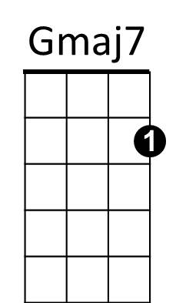

C

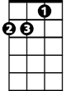

Am



D



Em



G

**Harvest Moon (Neil Young) Key F**

**Intro: C Am Cmaj7 Am 4x**

**F C C Am Cmaj7 Am (2x)**

Come a little bit closer - Hear what I have to say

**F C C Am Cmaj7 Am (2x)**

Just like children sleepin - We could dream this night away.

**F C C Am Cmaj7 Am (2x)**

But there’s a full moon risin – Let’s go dancin in the light

**F C**

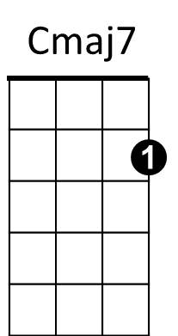We know where the music’s playin - Let s go out and feel the night.



G



Dm

F



Am



C

**C Am Cmaj7 Am (2x)**

**Chorus:**

**F G**

Because I’m still in love with you

**Dm**

I want to see you dance again

**F G**

Because I’m still in love with you

**C C Am Cmaj7 Am (2x)**

On this harvest moon.

**F C C Am Cmaj7 Am (2x)**

When we were strangers - I watched you from afar

**F C C Am Cmaj7 Am (2x)**

When we were lovers - I loved you with all my heart.

**F C C Am Cmaj7 Am (2x)**

But now its gettin late - And the moon is climbin high

**F C C Am Cmaj7 Am (2x)**

I want to celebrate - See it shinin in your eye.

**(Chorus)**

**C Am Cmaj7 Am (2x)**

**BARITONE**

C



Am



Cmaj7



F



G

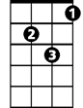

Dm

**Harvest Moon (Neil Young) Key Bb**

**Intro: F Dm Fmaj7 Dm 4x**

**Bb F F Dm Fmaj7 Dm (2x)**

Come a little bit closer - Hear what I have to say

**Bb F F Dm Fmaj7 Dm (2x)**

Just like children sleepin - We could dream this night away.

**Bb F F Dm Fmaj7 Dm (2x)**

But there’s a full moon risin – Let’s go dancin in the light

**Bb F**

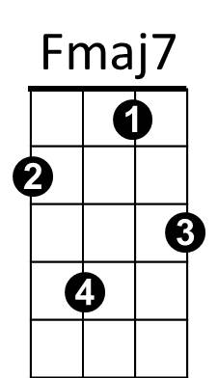We know where the music’s playin - Let s go out and feel the night.



Bb



C



Gm



Dm

F



**F Dm Fmaj7 Dm (2x)**

**Chorus:**

**Bb C**

Because I’m still in love with you

**Gm**

I want to see you dance again

**Bb C**

Because I’m still in love with you

**F F Dm Fmaj7 Dm (2x)**

On this harvest moon.

**Bb F F Dm Fmaj7 Dm (2x)**

When we were strangers - I watched you from afar

**Bb F F Dm Fmaj7 Dm (2x)**

When we were lovers - I loved you with all my heart.

**Bb F F Dm Fmaj7 Dm (2x)**

But now its gettin late - And the moon is climbin high

**Bb F F Dm Fmaj7 Dm (2x)**

I want to celebrate - See it shinin in your eye.

**(Chorus)**

**F Dm Fmaj7 Dm (2x)**

**BARITONE**

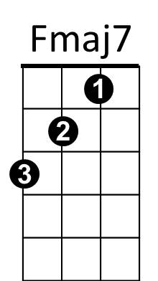



Dm

C



F

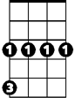

Gm

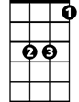

Bb

**Harvest Moon (Neil Young) Key G**

**Intro: D Bm Dmaj7 Bm 4x**

**G D D Bm Dmaj7 Bm (2x)**

Come a little bit closer - Hear what I have to say

**G D D Bm Dmaj7 Bm (2x)**

Just like children sleepin - We could dream this night away.

**G D D Bm Dmaj7 Bm (2x)**

But there’s a full moon risin – Let’s go dancin in the light

**G D**

We know where the music’s playin - Let s go out and feel the night.

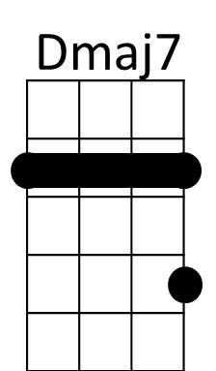**D Bm Dmaj7 Bm (2x)**

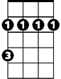

Bm



D

**Chorus:**

**G A**

Because I’m still in love with you

**Em**



G

Em

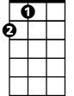

A

I want to see you dance again

**G A**

Because I’m still in love with you

**D D Bm Dmaj7 Bm (2x)**

On this harvest moon.

**G D D Bm Dmaj7 Bm (2x)**

When we were strangers - I watched you from afar

**G D D Bm Dmaj7 Bm (2x)**

When we were lovers - I loved you with all my heart.

**G D D Bm Dmaj7 Bm (2x)**

But now its gettin late - And the moon is climbin high

**G D D Bm Dmaj7 Bm (2x)**

I want to celebrate - See it shinin in your eye.

**(Chorus)**

**D Bm Dmaj7 Bm (2x)**

**BARITONE**



Em

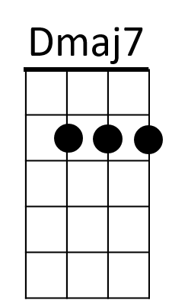



A



G

Bm



D