**Have You Ever Seen the Rain (John Fogardy)**

**Intro: Am F C G C**

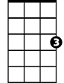

C



G

F

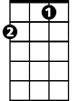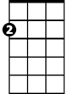

Am

**C**

Someone told me long ago

**G**

There's a calm before the storm, I know

**C**

It's been coming for some time

**C**

When it's over, so they say

**G**

It'll rain a sunny day, I know

**C**

Shining down like water

**Chorus:**

**F G C Am G**

I wanna know - Have you ever seen the rain

**F G C Am G**

I wanna know - Have you ever seen the rain

**F G C**

Coming down on a sunny day

**C**

**BARITONE**

Yesterday and days before



G

C

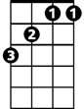

F

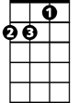

Am

**G**

Sun is cold and rain is hard, I know

**C**

Been that way for all my time

**C**

'Til forever on it goes

**G**

Through the circle fast and slow, I know

**C**

And it can't stop, I wonder

**(Chorus) 2x**

**End: G C**