Have You Ever Seen the Rain (John Fogardy) (G)

Intro: Em C G D G  G  Someone told me long ago  D  There's a calm before the storm, I know  G  It's been coming for some time  G  When it's over, so they say  D  It'll rain a sunny day, I know  G  Shining down like water  Chorus:  C D G Em D  I wanna know - Have you ever seen the rain  C D G Em D  I wanna know - Have you ever seen the rain  C D G  Coming down on a sunny day  G  Yesterday and days before  D  Sun is cold and rain is hard, I know  G  Been that way for all my time  G  'Til forever on it goes  D  Through the circle fast and slow, I know  G  And it can't stop, I wonder  (Chorus) (2x)  End: D G | 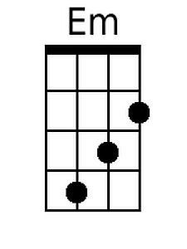 | 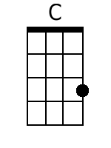
 | 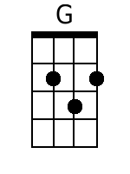 | 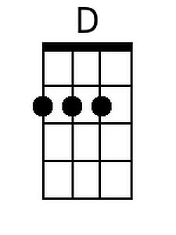
 | Bari
 | 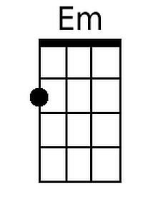 | 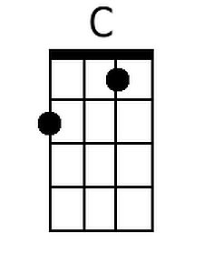
 | 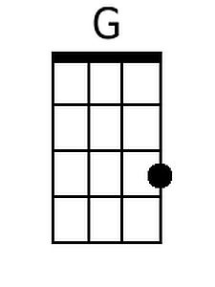 | 